Name:_________________________ Period:______

Artist’s Reflection: Blind Contour Drawing

Circle the elements of art that you used in your drawing:

Line Shape Color Texture Space Value Form

Circle the principles of art that you used in your drawing:

Balance Movement Rhythm Contrast Emphasis Unity Pattern

What kinds of emotions are your portrait expressing?
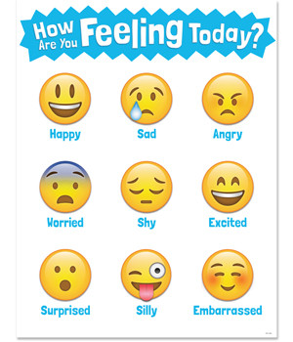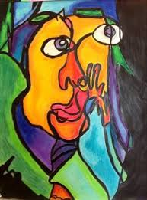

What parts of your portrait are the most funny or humorous?

What are two things you would change about your drawing?

