Canopic Jar Worksheet Name:________________________ Period:______

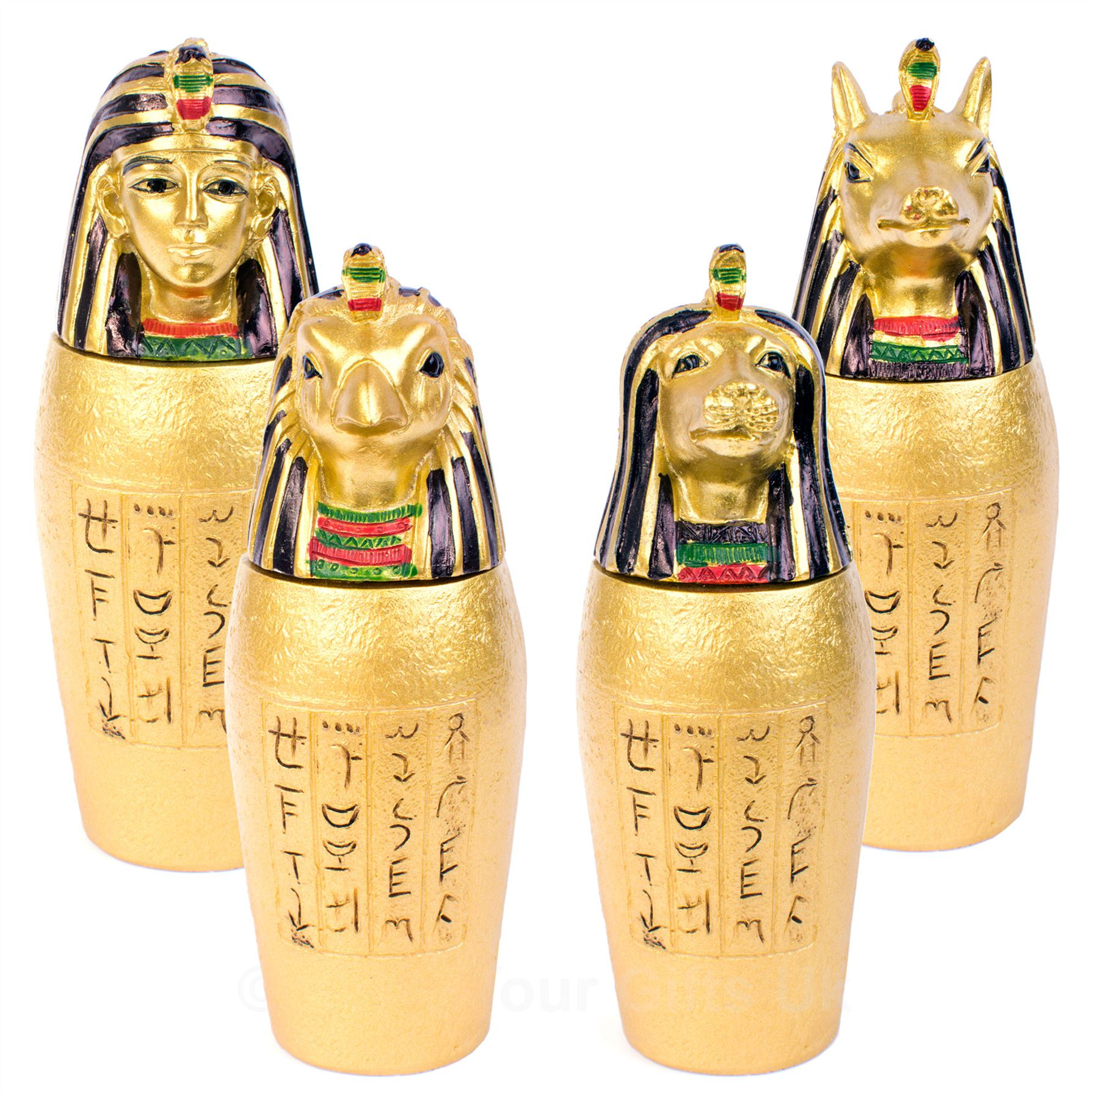

Canopic Jar: a covered urn used to store the removed organs (stomach, intestines, lungs, and liver) of mummified pharaohs. These would presented as gifts to the pharaoh when he entered the afterlife. The lids have animal heads, which represented the spirits that protected the pharaoh’s organs.

Assignment:
- create a canopic jar with your name written in hieroglyphs on the front.
- Sculpt the head of your favorite animal, or a protective spirit animal
- Create a small sculpture of a symbol of who you are that you want your favorite animal to protect

List three of your favorite animals and three words that animal represents using this website: https://www.whats-your-sign.com

- ________________________________________________________________________
- ________________________________________________________________________
- ________________________________________________________________________

Write your name in hieroglyphs (remember, the words are written vertically):

Make three drawings of your spirit animal with the mini sculpture of your symbol:
Jar size with animal head: roughly 5”x10”
Symbolic mini-sculpture: 3”x4”

