Lesson Plan Title: Character Design Length:

Note: Before you plan and write art experiences; pre-assess your students based on the proposed concepts, enduring understandings, and objectives of the unit/lesson(s). You may also gather this information from (previous) teachers, by reviewing already completed art work, consulting curriculum materials, etc., to get a better understanding of what content students already know and what they will need to know to be successful.

Pre-Assessment:
This will need to be done prior to teaching your lesson. Outline the method you will use to determine the skill/knowledge level of your students based on the concepts/enduring understandings/objectives of the lesson. (Hint: turn these into questions.) Be specific in describing what you would recognize as proficient skill/knowledge.
- What is concept art, why is it important, and how is it used in the professional art world?
- What is character design?
- What is a character design silhouette? Why is it important for creating a strong character design?
- What is a gesture drawing?
- What is the boxes and cylinders figure drawing approach?
- How many heads tall is the average human figure?

Performance:
What will students accomplish as a result of this lesson? This can be presented to students in the form of a story. In this narrative the students take on a role and create a learning product about a specific topic for a certain audience. (RAFT – Role / Audience / Format / Topic)
N/A

Concepts:
List the big ideas students will be introduced to in the lesson. These ideas are universal, timeless and transferrable. Examples of concepts used in art might include: Composition, Patterns, Technique, Rhythm, Paradox, Influence, Style, Force, Culture, Space/Time/Energy, Line, Law/Rules, Value, Expressions, Emotions, Tradition, Symbol, Movement, Shape, Improvisation, and Observation Look for concepts in the standards, content specific curriculum, etc.
Style, Gesture, Shape

Enduring Understanding (s):
Enduring Understandings show a relationship between two or more concepts; connected with an active verb. The best enduring understandings not only link two or more concepts; but demonstrate why this relationship is important. Like concepts, they are timeless, transferrable and universal.
The emotional expression of an artist’s work are based on the style and gesture of important shapes.

Standards: (All lessons should address all standards.)
1. Observe and Learn to Comprehend
2. Envision and Critique to Reflect
3. Invent and Discover to Create
4. Relate and Connect to Transfer

Objectives/Outcomes/Learning Targets:
Objectives describe a learning experience with a condition → behavior (measurable) → criterion. Aligned to: Bloom’s – Standards – GLEs - Art learning and, when appropriate, Numeracy, Literacy and Technology. Should be written as: Objective. (Bloom’s: _____ - Standard: _____ - GLE: _____ -Art learning: _____ -Numeracy, Literacy, and/or Technology)
Objective 1: After watching a video on how to design a good character, students will be able to analyze the personality of various famous characters based on their costume design, action pose/gestural silhouette, and facial expression.
- Blooms: Analyze
- Standard: Relate and Connect to Transfer
- GLE: The work of art scholars impacts how art is viewed today.
- Art Learning: History and Culture
- Literacy: Writing down answers from the critique worksheet to answer questions about the example. character designs

Objective 2: After learning how to analyze good character design, students will be able to create thumbnail sketches and a backstory for their original character using the character design planning worksheet.
- Blooms: Create
- Standard: Observe and Learn to Comprehend
- GLE: Visual art has inherent characteristics and expressive features
- Art Learning: Ideation
- Literacy: Character Design Planning Worksheet (written parts)

Objective 3: After receiving a demonstration on gesture drawing and box/cylinder figure drawing, students will be able to create a final drawing for their character design using graphite, pen and ink, and/or acrylic wash.
- Blooms: Create
- Standard: Invent and Discover to Create
- GLE: Demonstrate competency in traditional and new media
- Art Learning: Materials and techniques, expressive features and inherent characteristics
- Numeracy: drawing accurate bilateral proportion, learning how to draw foreshortened shapes turning in space

Objective 4: After finishing their project, students will evaluate the strengths/areas of growth for their work and three other artists using the character design critique worksheet.
- Blooms: Evaluate
- Standard: Envision and Critique to Reflect
- GLE: Reflective strategies are used to understand the creative process.
- Art Learning: Critical Reflection
- Literacy: character design critique worksheet

Differentiation:
Explain specifically how you have addressed the needs of exceptional students at both end of the skill and cognitive scale. Describe the strategies you will use for students who are already proficient and need growth beyond what you have planned for the rest of the class, as well as modifications for students with physical and/or cognitive challenges. Students must still meet the objectives.

Differentiation:  (Multiple means for students to access content and multiple modes for student to express understanding.) | Access (Resources and/or Process) | Expression (Products and/or Performance)
 | ESL  - Heavy simplification and rewording for worksheet instructions and all other worksheets  - Allowing cultural influence—student can use reference photos for video games and tv shows from home country  - Letting the student have permission to be conservative or explore character expressions based on cultural values  - Subtitles on the videos  Sp. Ed.  - Higher-functioning: draw a superhero with a specific power and an illustration to go with it  - Nonverbal/low-functioning: practice drawing the figure and creating an animal from imagination (get help from the para on this)  - Working with markers or colored pencils rather than graphite (unless the student is high-functioning enough to work with those materials)—make sure the grips work  High Functioning Autism  - Making instructions visual. Breaking things down into smaller steps. Not overloading information on one page.  - Allow creative freedom to some extent.  - Work on pushing student out of comfort zone, especially if the student is used to drawing anime (but make sure that it’s a win-win situation). | ESL  - Student can have the option to critique other students’ work that are either ESL or English speaking  - Verbal or other accommodations when it comes to talking about the creative process (talk with ESL teacher about specific accommodations).  Sp. Ed.  - Just drawing one cartoony gesture drawing. Still have them practice drawing the gesture and simplified human figure.  - Critique: Having the student identify colors and emotions within the poses.  High Functioning Autism  - No heavy differentiation on scale, unless the student has a slower or faster work ethic. Let the student be the guide for full creative control.
Extensions for depth and complexity: | Access (Resources and/or Process) | Expression (Products and/or Performance)
 | GT  - Really push anatomical accuracy with advanced, atelier realism skills  - Push gestural confidence, where there is not a lot of sketchy lines (fluid strokes made only one time)  - Focus on artistic research regarding technical skills and conceptual idea so that the student can set personal goals for technical improvement.  - Professional presentation: student presents the work as if he/she/they were presenting it to an organization (depends on the artist’s career goals)  ADHD  - Using checkmarks to get the project done if focus is a huge issue. Make an agreement with the student and checking in to see how they’re doing (let them guide the conversation). Let it be a learning experience for their own temperament.  - Providing space in accordance with an IEP that will enable them to work in a low distraction environment.  - Put student in a seat with other students that are quiet and hard working. Do not put them near the super chatty kids. | GT  - If students want to go into AP studio, they will have to think about planning a background (though it’s optional). Having a character engaged with a background makes the piece feel more complete. Student could also make a separate drawing with a background going into AP studio.  - Pushing the rendering process with technical realism.  - Pushing the originality of the design, potentially presenting it as a professional mock-up.  - If student wanted to work with color in a different medium he/she they was skilled at (such as photoshop), they are welcome to try that.  ADHD  - Pay attention to the details of the students’ work (rushed paint strokes vs. tight, small details). Have them create a design that works for their temperament and focus—would it be more beneficial for them to work larger and looser or would it be better for them to have tighter details and have more focus? It will ultimately depend on the student.

Literacy:
List terms (vocabulary) specific to the topic that students will be introduced to in the lesson and describe how literacy is integrated into the lesson.
Vocabulary Words:
- Concept Art: a form of illustration used to convey an idea for use in films, video games, animation, comic books, or other media before it’s put into final product. It’s also used to show the project’s progress to client’s and investors, directors, and clients.
- Character Design: a drawing used to standardize the appearance, pose, and gesture of a character in animation, comics, and video games.
- Gesture Drawing: a loose drawing that depicts the action of a pose.

Literacy Integration:
- Ideation Worksheet: Students fill out a worksheet to help them define their characters’ identities and their poses for gesture drawing.
- Critique Worksheet: filling out answers for other student artists as well as their own character designs.

Materials:
Must be grade level appropriate. List everything you will need for this lesson, including art supplies and tools. (These are the materials students will use.) List all materials in a bulleted format.
- Pen/ink
- Pencil/graphite
- 15”x20” illustration board or sulfite paper
- Sketchbook paper

Resources:

List all visual aids and reference material (books, slides, posters, etc. Be specific; include title, artist, etc. Make reference to where the material can be found. (These are the resources used by the teacher to support/develop the lesson.) List all resources in a bulleted format.
Videos:

What Makes a Good Character Design: https://www.youtube.com/watch?v=euTe191sAWg&t=219s
Gym Leader Design Analysis: Kanto: https://www.youtube.com/watch?v=vYNRYfqOTBs
Draw with Me: Teen Titans Go!: https://www.youtube.com/watch?v=n41YEfPnoxI
Figure Drawing: Gesture: https://www.youtube.com/watch?v=xbE0vYgng00&t=128s
How to Start a Figure Drawing: https://www.youtube.com/watch?v=54DBUIFJoUw
How to Draw Dynamic Poses: Action, Foreshortening, Construction, and More: https://www.youtube.com/watch?v=qupJLS5f8as
How to Draw the Human Figure: Body Construction Tutorial: https://www.youtube.com/watch?v=w2fKxNDsXuw
Beginner Figure Drawing (7 of 10): Measurement for Proportion: https://www.youtube.com/watch?v=hWzth8u2ReM

Website:
27 Top Character Design Tips: https://www.creativebloq.com/character-design/tips-5132643

Reference Photos from Western Cartoons, Video Games, and Anime:
Western Cartoons:
- Johnny Bravo
- Daffy Duck
- Ed, Edd, n Eddy
- Batman: The Animated Series
- WB Frog (Looney Tunes)
- Hey Arnold
- Kim Possible
- Eustace (Courage the Cowardly Dog)
- Samurai Jack and Haku
- Spiderman in various action poses
- Wreck It Ralph concept sketches
- Superhero silhouettes (goal being to ask students to determine the superhero based on their silhouettes and poses)

Anime
- Beerus (DBZ)
- Gold Experience Requiem and Crazy Diamond (Jojo’s Bizzare Adventure)
- Saber and Berserker (Fate Stay Night series)
- Ruby and Weiss (RWBY)
- Sailor Moon
- Kamina (Gurren Lagann)
- Omnimon (Digimon)
- Hisoka (Hunter x Hunter)
- Levi (Attack on Titan)
- Dandy, Meow, and QT (Space Dandy)

Video Games
- Link, Zelda, and Sheik (Legend of Zelda and Super Smash Bros. Ultimate)
- Inklings (Splatoon)
- Journey concept art
- Bloater zombie (The Last of Us)
- Lucina and Elise (Fire Emblem series)
- Cloud (Final Fantasy)
- Hollow Knight
- Various characters from Shovel Knight
- Bosses from Furi

Preparation:
What do you need to prepare for this experience? List steps of preparation in a bulleted format.
Teacher example: one realistic pose and one gestural cartoony pose (with six gestures)
- Thumbnail sketches and final project examples—try to use the same character for each one

Setting up teacher website with resources

Make sure students have ample sketchbook paper in either a sketchbook or a binder.

Get a survey of students that want to use paper vs. illustration board or watercolor paper (if they want to do a light acrylic wash)

Get reference images and worksheets prepared accordingly.

Safety:

Be specific about the safety procedures that need to be addressed with students. List all safety issue in a bulleted format.
No safety issues. However, students are required to make sure their designs are school-appropriate.

Action to motivate/Inquiry Questions:
Describe how you will begin the lesson to stimulate student’s interest. How will you pique their curiosity and make them interested and excited about the lesson? What inquiry questions will you pose? Be specific about what you will say and do to motivate students and get them thinking and ready to participate. Be aware of the varying range of learning styles/intelligences of your students. Some ideas might include: telling a story, posing a series of questions, role-playing, etc.
Introduce the project.
- Pre-assess vocabulary words (character design and concept art) and why this type of art is important.
- Watch video--What Makes a Good Character Design: https://www.youtube.com/watch?v=euTe191sAWg&t=219s
- Discussion about silhouettes: good character design must have a good silhouette. This means that the character can use all of its defining features, but the viewer can still identify the character and what his/her/their personality is. Show superhero silhouette and have the students identify which superheroes are which and how they can tell.
- Group Discussion: Analyzing characteristics of a character design (compare Zelda and Sheik). Zelda and Sheik are essentially the same character. What do their costumes, gestures/action poses, and facial expressions tell us about their personalities and their fighting styles?
- Gallery Walk Activity: students are given a character design analysis sheet and have to analyze the qualities of the design.
- Johnny Bravo, Aku, Kamina, Weiss, The Scale (Furi), Inkling
- Students will be given fifteen minutes total to analyze at least three of these designs.
- Group discussion: pick one character from each genre and have the students talk about what they noticed.

Ideation/Inquiry:
Ideation is the creative process of generating, developing, and communicating new ideas, where an idea is understood as a basic element of thought that can be visual, concrete or abstract. List and describe inquiry questions and processes you will engage students in to help them develop ideas and plans for their artwork.
Students will fill out a character design planning worksheet:

Circle or highlight the options you’re choosing for your project:

Materials | Technical Presentation | Conceptual Presentation
Option 1: Graphite or pen/ink shading on drawing paper  Option 2: a light wash of acrylic paint with pen/ink or graphite on illustration board | Option 1: Create one realistic character.  *Note: a background is optional, but highly recommended if you plan to include this piece for your AP Studio portfolio. If you choose this option and still want to have a background, I will only give you feedback on the character design and critique your background for AP Studio.  Option 2: Create a simplified, cartoonish character with at least six different gesture drawings on a blank background. | Option 1: Create a mythical creature that relates to a natural or manmade element (wind, water, fire, earth, thunder/electricity, steel, etc.)  Option 2: Create a superhero or video game character (arcade fighting, JRPG, etc.) with special abilities, costumes, and weapons  Option 3: Create a character that represents the mascot of a business (such as a skater or energy drink company) or sports team (must be an original design)  Option 4: Create a proposal for your own video game character (must get approved by Ms. N)

Artistic Research

Insert at least 3-4 images that reference the drawing style and poses that inspire your character. This could be from cartoons, anime, comics, movies, posters, ads, etc.

Character Questionnaire

- Name of your character:
- Gender (all gender identities are welcome and acceptable):
- Age:
- Physical appearance:
- What features make your character unique or stand out (body or clothing)?
- Describe your character’s clothing/costume (textures, style, color, etc.):
- How would you describe your character’s personality?
- How does your character’s personality affect the way he/she/they/it moves? Use adjectives to describe your character’s poses. Or draw small doodles of the way you picture your character moving.
- Does your character have any special powers or abilities? If so, describe what they are.
- Does your character have a backstory? If so, explain.
- What movie, comic, TV show, video game, or business franchise universe would your character most likely be part of?

Thumbnail Sketches Part 1:

You have two ways to approach this part.

Option 1: Draw your character with a front, side, and back profile.

Option 2: Draw three different character designs based on the conceptual theme you picked out.

Thumbnail Sketches Part 2:

If you chose the realistic character approach, make three gesture/action poses your character would make. Circle the one that you would like to use for your final project.

If you chose the cartoony character approach, make nine gesture/action poses your character would make. Circle six of your favorite poses that you would like to use for your final project.

Note: Do not worry about drawing specific character details for this part. Just focus on the gesture. Really think about planning positive and negative space in your poses.

Instruction:
Give a detailed account (in bulleted form) of what you will teach. Be sure to include approximate time for each activity and instructional methodology: skills, lecture, inquiry, etc. Include motivation and ideation/inquiry where appropriate; including what student will understand as a result of the art experience

Week 1 | Instruction - The teacher will... (Be specific about what concepts, information, understandings, etc. will be taught.) Identify instructional methodology. KNOW (Content) and DO (Skill)  Day 1  Introduce the project.  - Pre-assess vocabulary words (character design and concept art) and why this type of art is important.  - Watch video--What Makes a Good Character Design: https://www.youtube.com/watch?v=euTe191sAWg&t=219s  - Discussion about silhouettes: good character design must have a good silhouette. This means that the character can use all of its defining features, but the viewer can still identify the character and what his/her/their personality is. Show superhero silhouette and have the students identify which superheroes are which and how they can tell.  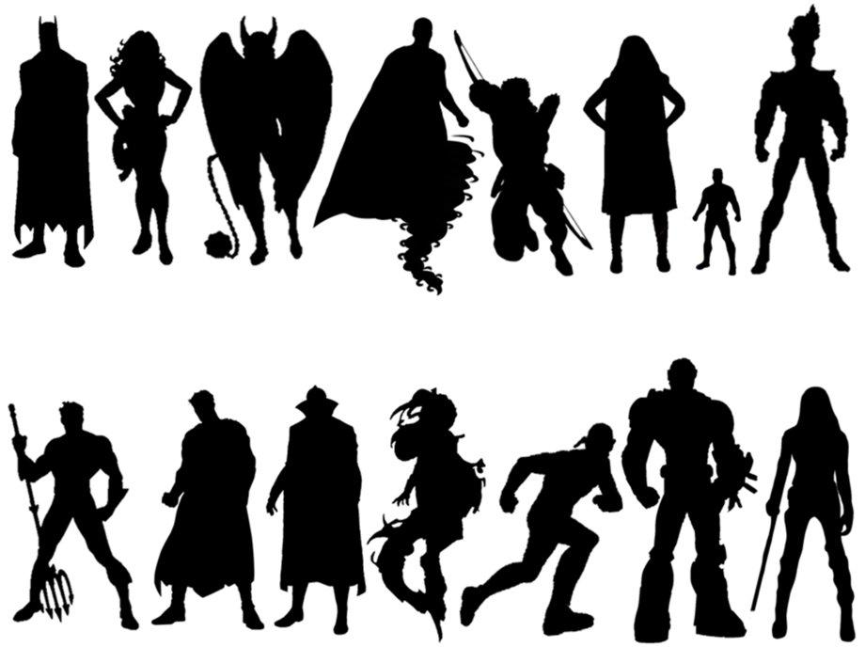  - Group Discussion: Analyzing characteristics of a character design (compare Zelda and Sheik). Zelda and Sheik are essentially the same character. What do their costumes, gestures/action poses, and facial expressions tell us about their personalities and their fighting styles?  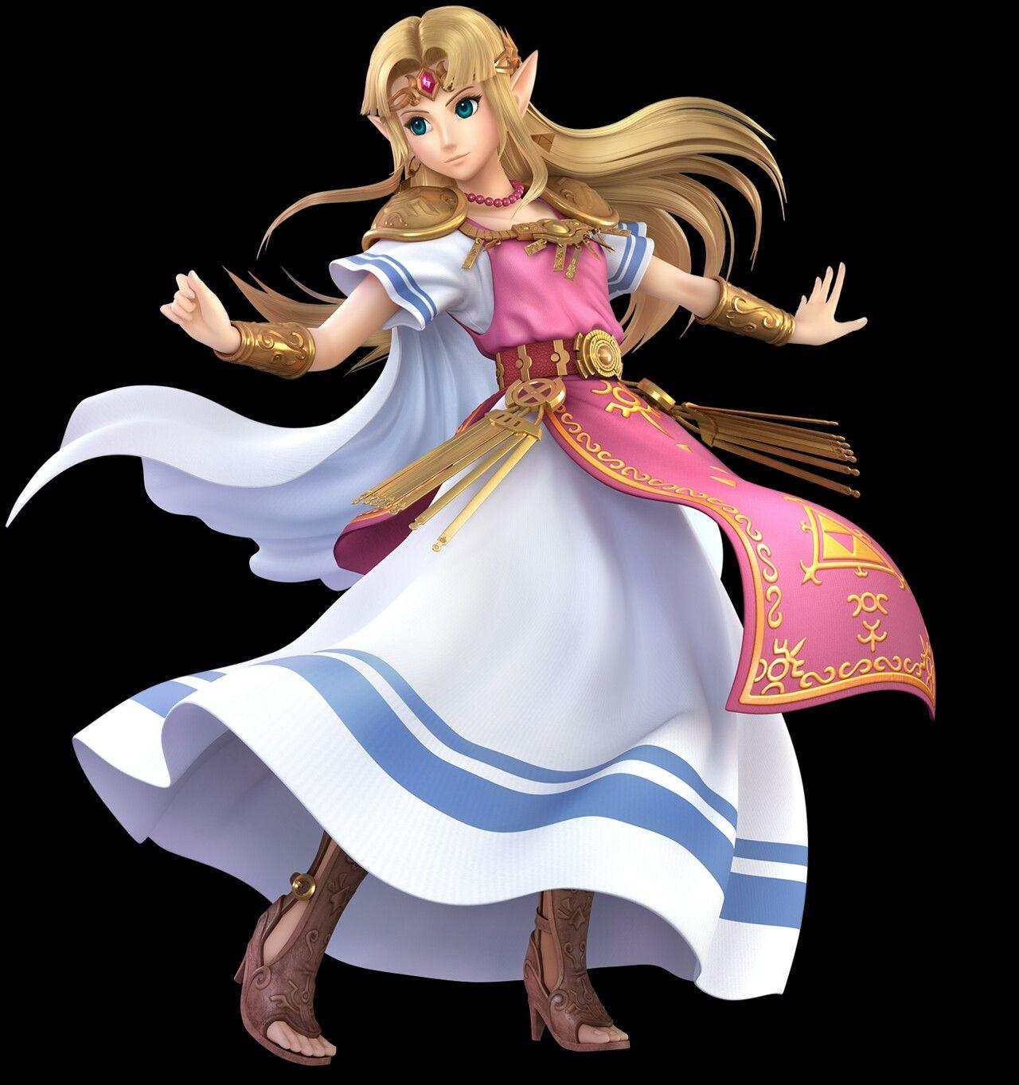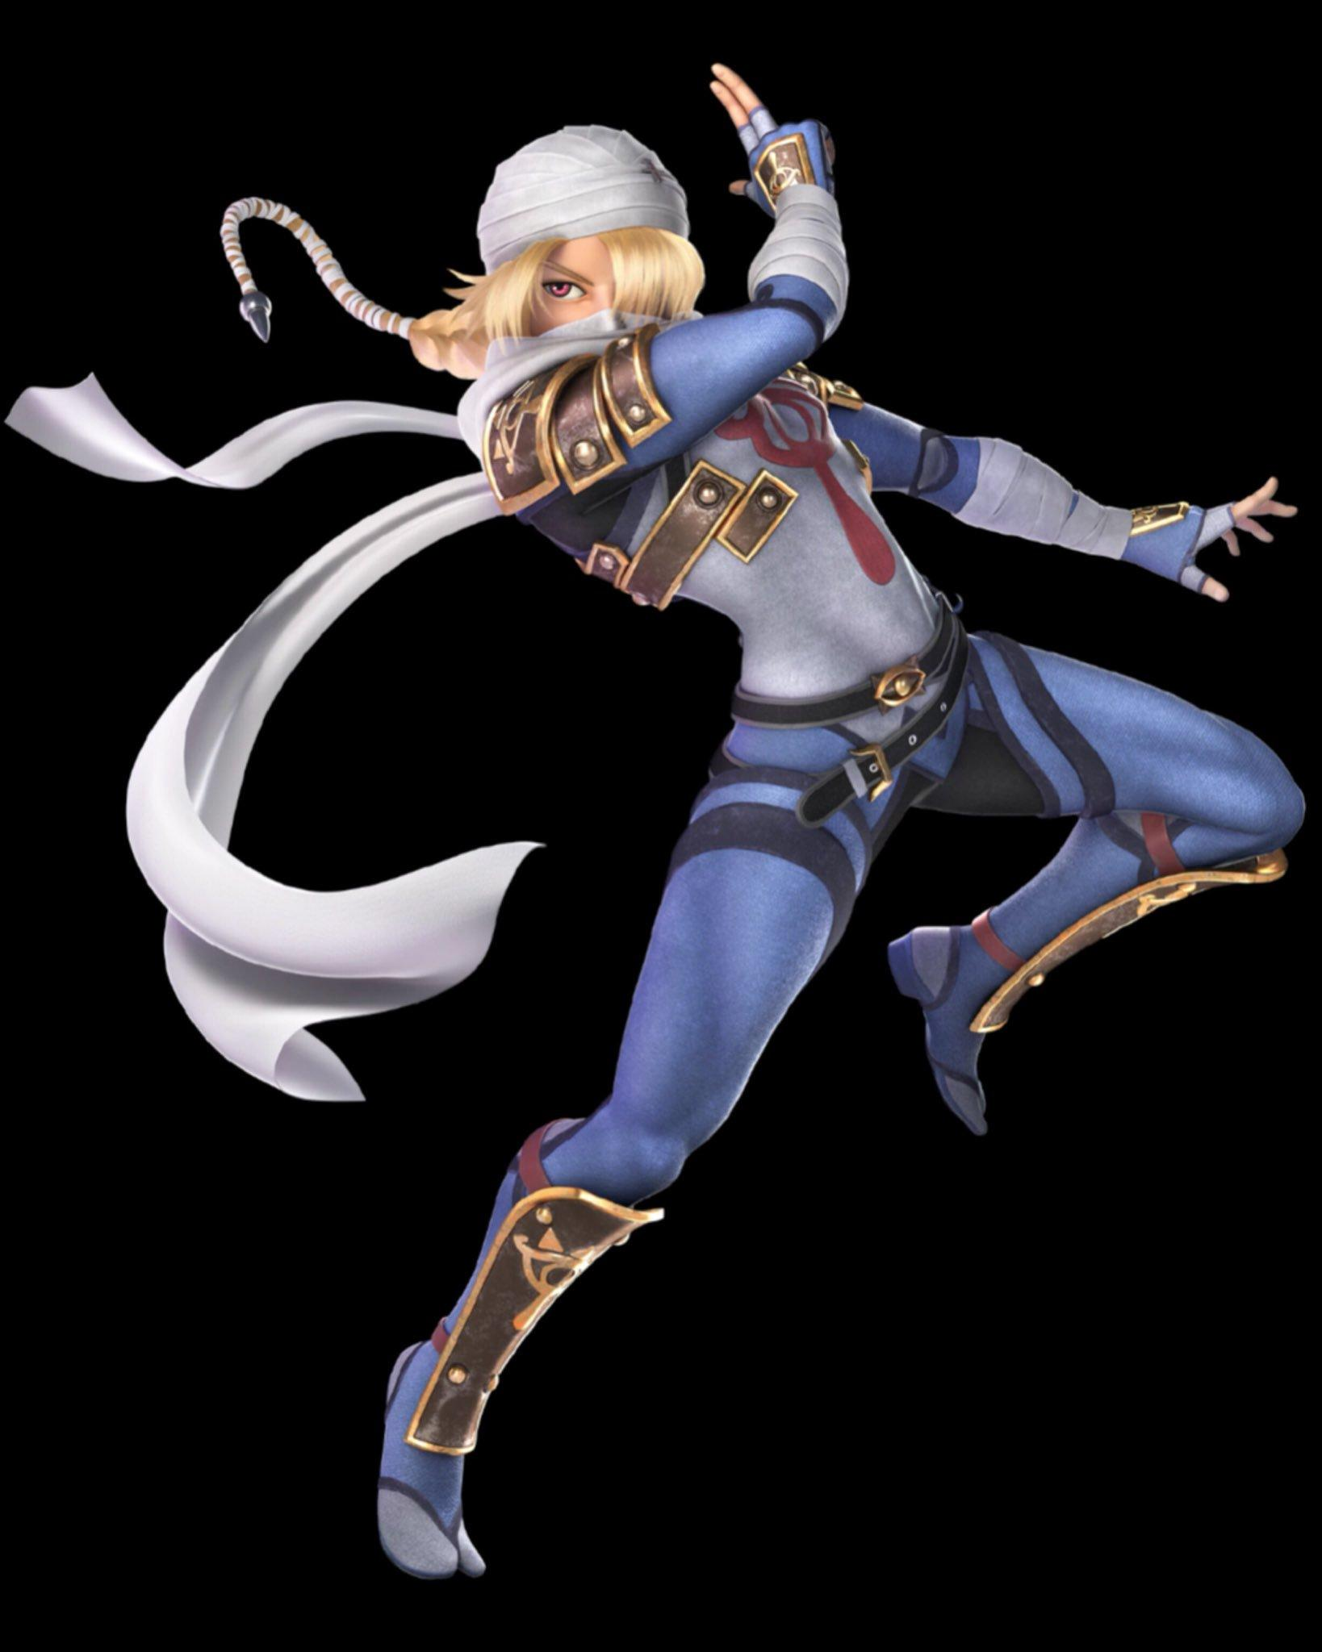  - Gallery Walk Activity: students are given a character design analysis sheet and have to analyze the qualities of the design.  - Johnny Bravo, Aku, Kamina, Weiss, The Scale (Furi), Inkling  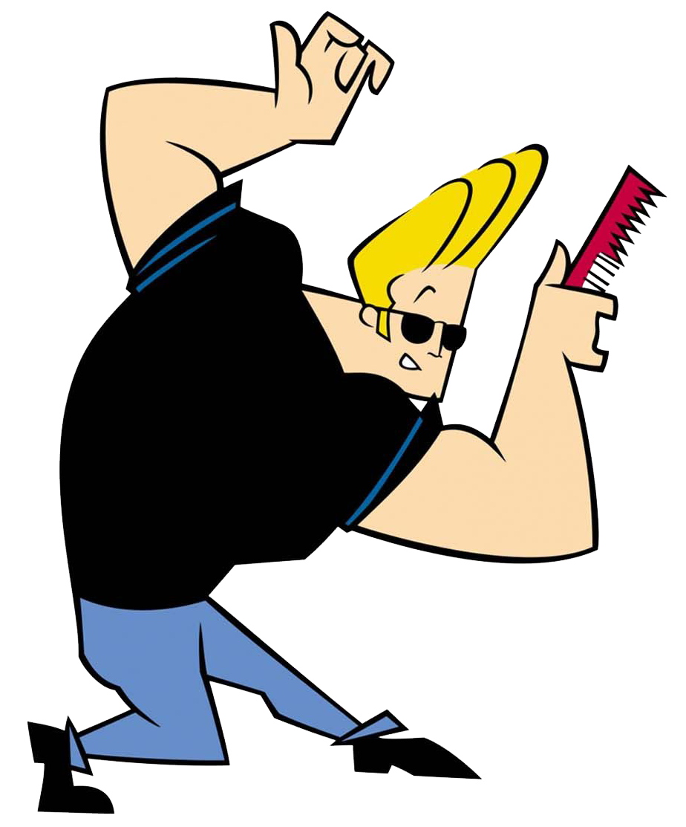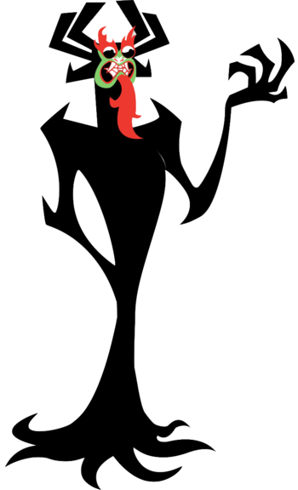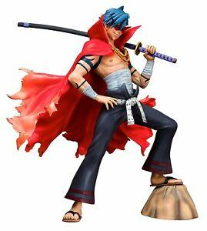  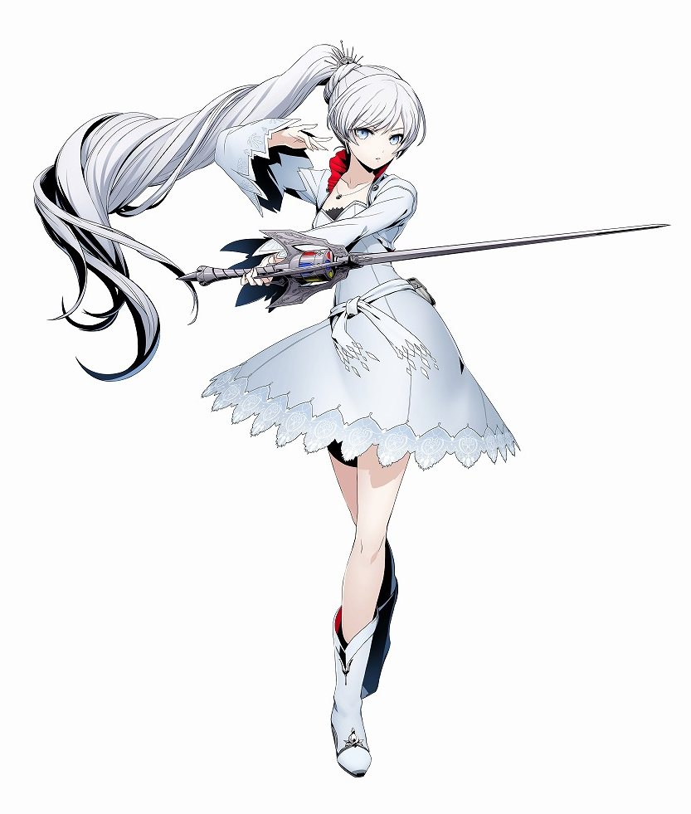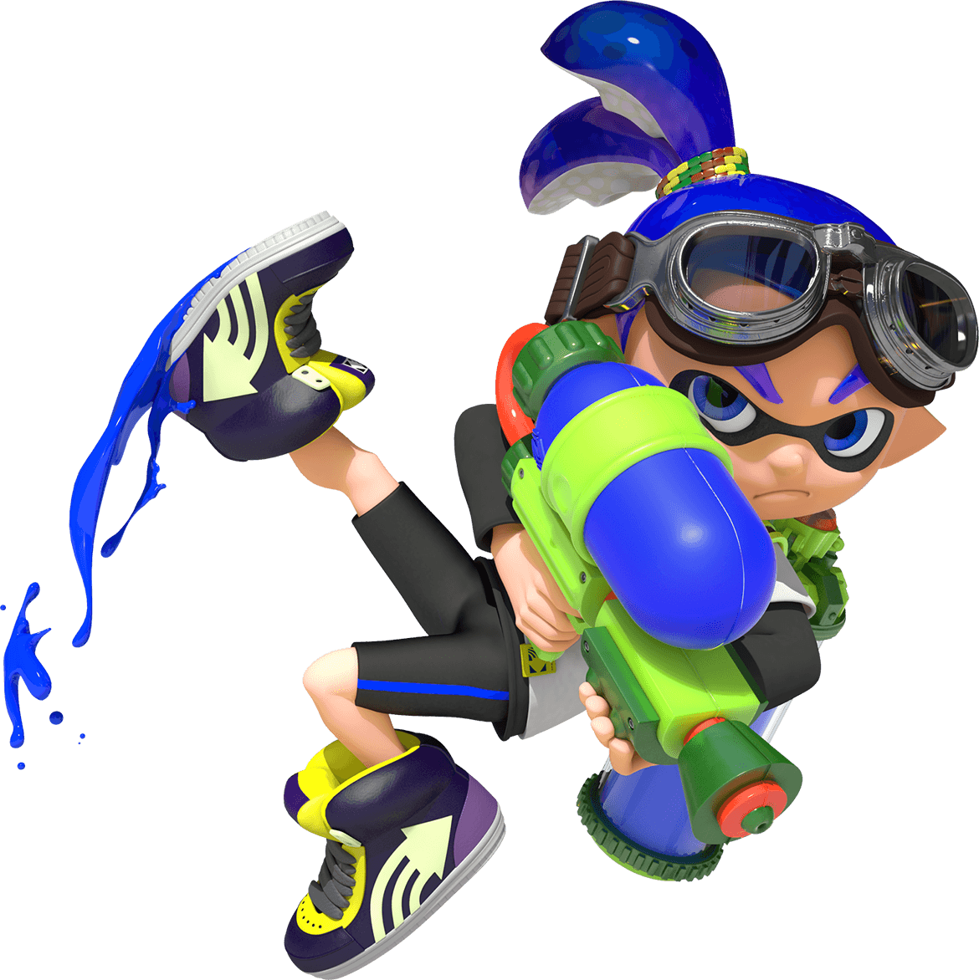  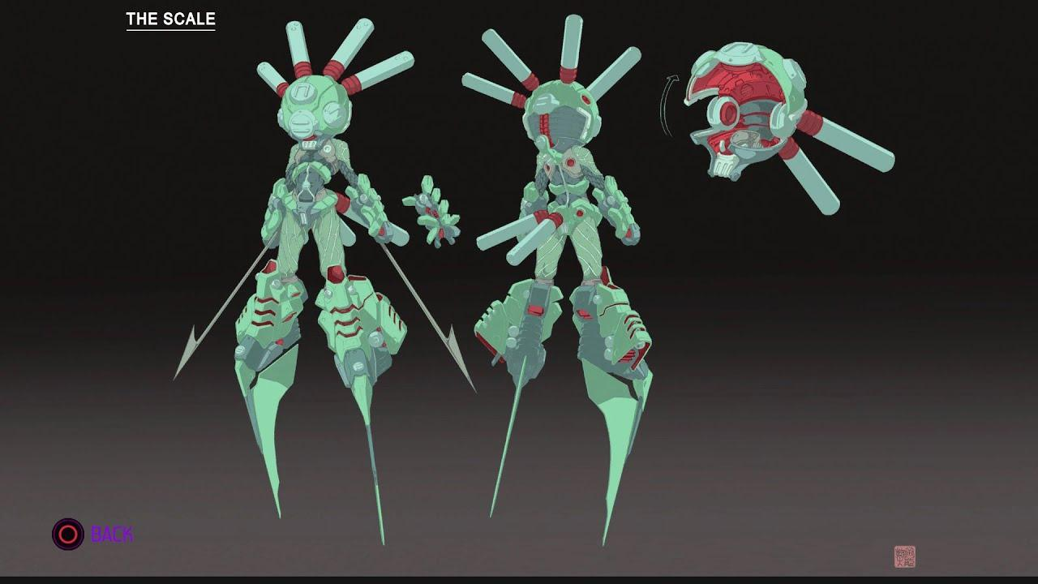  - Students will be given fifteen minutes total to analyze at least three of these designs.  - Group discussion: pick one character from each genre and have the students talk about what they noticed.  - Students should turn in their papers when they are done so I can review them.  Day 2  Gesture Drawing Demonstration:  - Ask students what they think a gesture drawing is and why it’s so important to figure drawing.  - Gesture drawing is less about details and more about the expression of the pose. It’s the basic skeleton that helps people plan out the details of their final drawing.  - The key is to be loose. There is no wrong way to do a gesture drawing. However, the key is to draw it quickly.  - Different approaches: stick figures, bean shape model, and geometric (model all three for the students with thirty second poses).  - Have a student volunteer to model and do a pose. Do the drawing in thirty seconds on a white board and model it for the students. Do this three times with each pose style.  Work Time:  - Students draw two minutes for three different poses. Show the work and talk about strengths and struggles.  - Shorten it to one minute, then thirty seconds. Do this as many times as the class can handle it.  - Give students lots of paper to work. The drawings shouldn’t be small. Otherwise, it will limit their gestural expression.  - Have student models trade off getting into different poses.  - If students get bored with the gesture drawing process, challenge them to render their drawings with more detail (extend the gesture drawings for longer sessions so that the students can work on details). Also, gage interest to see if students want to move on to learn more about boxes and cylinders figure drawing.  - At the end of class, give the students a chance to compare all of their drawings, discuss how their drawings changed based on the speed they were required to draw, and what they struggled with.  Day 3  First half of class: more gesture drawing practice  - Ten minutes total: three 2 min, two 1 min, four 30 sec.  - Students should mark which drawings happened during which timeframe (30 sec, 1 min, 2 min)  - Either students could model the pose or I could project images of different character designs that the students can copy  Demonstration: constructing the figure  - Ask students how tall the figure is (7 heads). Have them draw out a basic outline of the figure and give them a sheet that breaks down the anatomical proportions.  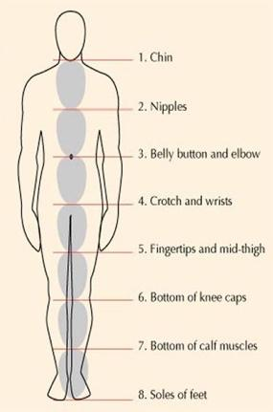  - Pick a character design from the reference examples and break the character down into boxes and cylinders from the gesture drawing (do this drawing in advance)  - Discuss foreshortening and how shapes are squashed or moved to create foreshortening (use reference photos)—advanced drawing technique. Discuss that there is a video that talks in greater depth about foreshortening.  Work Time  - Give students two images. Time them to do a gesture drawing, then have them lay out boxes and cylinders. Walk around and give constructive feedback.  - While students are drawing, have reference images for boxes and cylinder drawings from the teacher website on display.  Clean-up  - Putting pencils and sketchbook paper away in cubbies  Day 4  First half of class: more boxes and cylinders drawing (two poses should last twenty minutes).  - Two minutes for gesture drawing; eight minutes for the boxes and cylinders  - Ask students if they need more time.  Demonstration on how to make a fully realized figure from the boxes approach.  - Use a student volunteer to help demonstrate nuanced curves of different body parts.  - Use the reference photos to support that.  - With character design, students have the freedom to stylize their designs and not necessarily make it true to life. However, the more detailed the design is, the more compelling the character design will be. Always have references from real life to support your designs.  - Talk about sighting and measuring as well, making sure that the angles line up with different body parts. This is the key to realism.  Work Time  - Bring both images back up and have the students work on refining their anatomical styles. Have them choose one or both of their drawings, depending on the speed of their work. Host a demo for students that are feeling lost or stuck and gather at a table.  - Beginner Figure Drawing (7 of 10): Measurement for Proportion: https://www.youtube.com/watch?v=hWzth8u2ReM. Students could potentially watch this video if they are feeling stuck about the sighting/measuring process. Ask if there should be a waiver for students to sign if there is partial nudity in that video (censored).  Clean-Up  - Put pencil and paper away in cubbies  Day 5  Demonstration on drawing hand:  - Draw the action line.  - Draw a mitten  - Draw action lines for individual fingers.  - Draw cylinders for fingers and boxes for hands.  Option 1: Project the image on the screen and have students draw.  Option 2: Print out images for different hands and have students rotate the pictures at their table groups if there are tech issues.  When doing the gesture drawing, have them start with one hand and then move to two hands that are gesturing together.  Break down the anatomical details of the hand to make it appear more realistic.  - If students feel lost, they can also trace their own hands and mark where the knuckles are.  - Look at cartoon references and look at how simplified or detailed the hands are.  - Refer to resources from lesson 1 that talk about this process.  Demonstration on drawing feet:  - Draw the action line.  - Draw ballet slipper silhouette.  - Separate the silhouette into various wedges: heel, toes, and center of foot.  When doing the gesture drawing, have them start with one hand and then move to two hands that are gesturing together.  Break down the anatomical details of the foot to make it appear more realistic.  - Do drawing for the front and sides of the feet so students see what they look like.  - Reference superhero feet and ninja feet from Naruto as examples of gestural feet.  At the end of class, survey students to see how they feel about their process and whether they need another day to practice.  Clean-Up:  Check with students to see if they need more time or extra work days on the project. They can have up to 1-2 workdays (depending on the need, one for the demonstration and one for the final project), but they have to earn it with good behavior and focused work ethic. | Learning – Students will... i.e.: explore ideation by making connections,  comparing, contrasting; synthesize possibilities for each painting technique; etc. (Be specific about what will be the intended result of the instruction as it relates to learning.) UNDERSTAND | Time  2 min.  14 min.  4 min.  5 min.  15 min.  10 min. (3 min. per character analysis)  5 min.  40 min.  5 min.  10 min.  10 min.  5 min.  20 min.  5 min.  20 min.  10 min.  15 min.  5 min.  20 min.  20 min.  5 min.  5 min.
Week 2 | Day 1  Introduce the lesson more thoroughly.  Give students the character design planning worksheet. The rest of class time will be spent working on that entire packet. Show teacher example with my sketch. Have a discussion with students on what they think the characteristics are based on just the image alone (provide the worksheet for guiding questions).  Work Time  - If students are finished with the packet, they can continue practicing figure drawing using the resources that they used.  Clean-Up  - Before students leave, ask them if they need a review on working with pen and ink.  Day 2  Work  - Finish up the worksheet and sketches. Begin working on final project.  - If students need a review on graphite (soft shading) or pen/ink use, set up table teaching demos for students that are interested while giving other students the space to work on their projects.  Clean-Up  Day 3  Work Day  Clean-Up  Day 4  Work Day  Clean-Up  Day 5  Work Day  Clean-Up  Goal: Figure drawing is completely finished and outline. Shading has begun. If students want to paint a light acrylic wash for colors, then they can begin that process too. |  | 5 min.  5 min.  35 min.  5 min.  45 min.  5 min.  45 min.  5 min.  45 min.  5 min.  45 min.  5 min.
Week 3 and 4 | Day 1  Work Day  Clean-Up  Goal: 20% drawing finished.  Day 2  Work Day  Clean-Up  Goal: 40% drawing finished.  Day 3  Work Day  Clean-Up  Goal: 60% drawing finished.  Day 4  Work Day  Clean-Up  Goal: 80% drawing finished.  Day 5  Work Day  Clean-Up  Check with students to see if they need more time or extra work days on the project. They can have up to 1-2 workdays (depending on the need, one for the demonstration and one for the final project), but they have to earn it with good behavior and focused work ethic.  Goal: 100% drawing finished.  Day 1  Critique Day  Students will number off randomly and meet at their assigned table groups. Students will switch to those groups and bring their projects with them.  Students will fill out a critique worksheet for at least three artists at their table, passing their projects around to different people.  Students fill out a worksheet about what they think their strengths and challenges were with figure drawing and character design. When students are finished, they can fill out the feedback form.  Feedback on lesson and Ms. N’s lecture (separating it between thumbnail worksheet, technical demonstration, and final project). |  | 45 min.  5 min.  45 min.  5 min.  45 min.  5 min.  45 min.  5 min.  45 min.  5 min.  20 min. (5 min. total for critique worksheet and 5 min. for getting into groups)  10 min.  20 min.

Student reflective/inquiry activity:
Sample questions and activities (i.e. games, gallery walk, artist statement, interview) intended to promote deeper thinking, reflection and refined understandings precisely related to the grade level expectations. How will students reflect on their learning? A participatory activity that includes students in finding meaning, inquiring about materials and techniques and reflecting about their experience as it relates to objectives, standards and grade level expectations of the lesson.)
Students will number off randomly and meet at their assigned table groups. Students will switch to those groups and bring their projects with them.

Students will fill out a critique worksheet for at least three artists at their table, passing their projects around to different people.
- What kind of digital media do you think this character belongs in? Circle answer. Movie, Video Game, Cartoon Show, Sports/Business Branding
- What genre or environment do you picture this character living in? How do the costume or physical details of the character indicate that to you?
- Based on the character’s costume and body gesture, what kind of personality do you think he/she/they has?
- What are some design strengths with this character? Talk about physical appearance, costume design, action pose (silhouette and positive/negative space), and emotional expression.
- What suggestions could you make to improve this character’s design? Look at the list in the previous question.

Students fill out a worksheet about what they think their strengths and challenges were with figure drawing and character design. When students are finished, they can fill out the feedback form.
Figure Drawing Skills

- What did you enjoy about figure drawing, or what do you think are your drawing strengths?
- What frustrated you about figure drawing? What kind of extra support did you wish you had from me?

Character Design

- What did you enjoy about character design? What do you think were you strengths (technical or conceptual planning)?
- What frustrated you about the character design process? What would you want to change about your character design? What kind of extra support did you wish you had from me?

Feedback on lesson and Ms. N’s lecture (separating it between thumbnail worksheet, technical demonstration, and final project).

Post-Assessment (teacher-centered/objectives as questions):  Have students achieved the objectives and grade level expectations specified in your lesson plan? | Post-Assessment Instrument:  How well have students achieved the objectives and grade level expectations specified in your lesson plan? Include your rubric, checklist, rating scale, etc.
Can students analyze the personality of various famous characters based on their costume design, action pose/gestural silhouette, and facial expression?  Can students create thumbnail sketches and a backstory for their original character using the character design planning worksheet?  Can students create a final drawing for their character design using graphite, pen and ink, and/or acrylic wash?  Can students evaluate the strengths/areas of growth for their work and three other artists using the character design critique worksheet? | 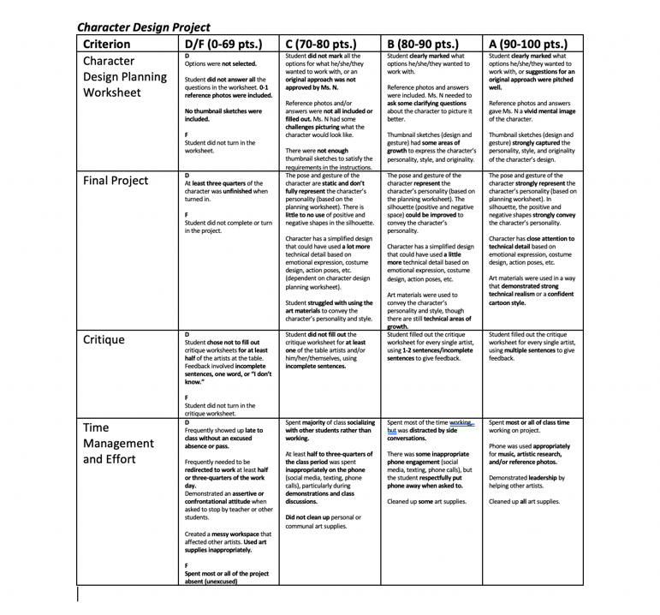

Self-Reflection:
After the lesson is concluded write a brief reflection of what went well, what surprised you, and what you would do differently. Specifically address: (1) To what extent were lesson objectives achieved? (Utilize assessment data to justify your level of achievement.) (2) What changes, omissions, or additions to the lesson would you make if you were to teach again? (3)What do you envision for the next lesson? (Continued practice, reteach content, etc.)
Strengths
Process
- Successfully demonstrated how to draw body positioning, forms, and clothing
- Conceptually, there was a lot of creative freedom and there were different options for the scale and style of the work
- There was a lot of creative freedom, but there was enough structure to give students a sense of direction for what they need to get done
Product
- New kind of project that students wouldn’t have been typically exposed to
- Students could learn about correct anatomy but not necessarily feel pressured to make their character look realistic
Critique

Classroom Management
- Expectations for the project were very clear
- Checks in on projects in a way that is helpful but not too overbearing

Areas of Growth

Process
- Discussion on how to draw eyes, ears, and hair
- Demo different facial expressions
- Put more steps in between creating the character and designing the character. Have the students design their character in many different ways. Have them experiment a bit. You could also have each student pick a theme for their characters randomly.
- Approve the thumbnails and make sure they are detailed enough.

Product
- Require a background (some students wanted a background and others didn’t)
- I feel like ways that it could improve is have less restrictions on what we were planning to do and broadening how simple or complex we make our character in a style we could choose and to have broader rubix. The two options could stay, but only as suggestions. Also hopefully backgrounds are not required.

Critique

Classroom Management

Appendix: Include all handouts, prompts, written materials, rubrics, etc. that will be given to students.

8/9/15 Fahey

