Lesson Plan Title: Landscape in the Style of a Famous Artist Length: 5 days

Note: Before you plan and write art experiences; pre-assess your students based on the proposed concepts, enduring understandings, and objectives of the unit/lesson(s). You may also gather this information from (previous) teachers, by reviewing already completed art work, consulting curriculum materials, etc., to get a better understanding of what content students already know and what they will need to know to be successful.

Pre-Assessment:
This will need to be done prior to teaching your lesson. Outline the method you will use to determine the skill/knowledge level of your students based on the concepts/enduring understandings/objectives of the lesson. (Hint: turn these into questions.) Be specific in describing what you would recognize as proficient skill/knowledge.
Art History and Culture:
- Create inquiry questions based on art learnings (working together as a group, even though everyone fills out their own sheets)

Questions
History and Culture
- What time period do you think this art was made?
- What does the style of the art tell you about the artist’s personality?
Materials and Techniques
- What artistic tools or materials were used to create this art?
Expressive Features/Inherent Characteristics
- Write down three adjectives to describe the artist’s work.
- What do all the paintings by this artist have in common?
- How does the art make you feel when you look at it?

Performance:
What will students accomplish as a result of this lesson? This can be presented to students in the form of a story. In this narrative the students take on a role and create a learning product about a specific topic for a certain audience. (RAFT – Role / Audience / Format / Topic)
Role: Artist
Audience: Their peers
Format: Oil pastel drawings
Topic: Illustration based on texture and style of professional artists

Concepts:
List the big ideas students will be introduced to in the lesson. These ideas are universal, timeless and transferrable. Examples of concepts used in art might include: Composition, Patterns, Technique, Rhythm, Paradox, Influence, Style, Force, Culture, Space/Time/Energy, Line, Law/Rules, Value, Expressions, Emotions, Tradition, Symbol, Movement, Shape, Improvisation, and Observation Look for concepts in the standards, content specific curriculum, etc.
Style, Influence, History

Enduring Understanding (s):
Enduring Understandings show a relationship between two or more concepts; connected with an active verb. The best enduring understandings not only link two or more concepts; but demonstrate why this relationship is important. Like concepts, they are timeless, transferrable and universal.
The style of an artist’s work can be influenced by observing and recreating the work of other artists in history.

Standards: (All lessons should address all standards.)
1. Observe and Learn to Comprehend
2. Envision and Critique to Reflect
3. Invent and Discover to Create
4. Relate and Connect to Transfer

Objectives/Outcomes/Learning Targets:
Objectives describe a learning experience with a condition → behavior (measurable) → criterion. Aligned to: Bloom’s – Standards – GLEs - Art learning and, when appropriate, Numeracy, Literacy and Technology. Should be written as: Objective. (Bloom’s: _____ - Standard: _____ - GLE: _____ -Art learning: _____ -Numeracy, Literacy, and/or Technology)
Objective 1: After studying the work of the professional artist at their table groups, students will be able to infer what the artist’s work is about and how it was created using the inquiry sheet.
- Standard: Relate and Connect to Transfer
- GLE: Historical time periods and cultural settings are interpreted in works of art
- Blooms: Analyze
- Art Learning: Art history and culture
- Literacy: inquiry sheet

Objective 2: After looking at small texture studies of each professional artist’s work, students will be able to sketch replications of each artist’s textural sample using oil pastels.
- Standard: Observe and Learn to Comprehend
- GLE: Artists and viewers determine artistic intent by comparing and contrasting the characteristics and expressive features of art.
- Blooms: apply
- Art Learning: Materials and techniques, Ideation
- Numeracy: copying patterns and textures, understands repetition and visual points of harmony/symmetry

Objective 3: After completing their textural study and doing preliminary sketches, students will be able to create a landscape based on the style of their table artist.
- Standard: Invent and Discover to Create
- GLE: Materials and processes can be used in traditional, unique, and inventive ways
- Blooms: create
- Art Learning: Expressive features/Inherent characteristics
- Numeracy/Literacy: copying patterns and textures, understands repetition and visual points of harmony/symmetry, proportions in a landscape

Objective 4: After answering artist statement questions about their work, students will be able to analyze the similarities and differences of their work with their professional artist’s work in a group discussion activity.
- Standard: Envision and Critique to Reflect
- GLE: The processes and philosophies of art and design inform interpretations in works of art.
- Blooms: Analyze
- Art Learning: Critical reflection
- Literacy: artist’s statement questions

Differentiation:
Explain specifically how you have addressed the needs of exceptional students at both end of the skill and cognitive scale. Describe the strategies you will use for students who are already proficient and need growth beyond what you have planned for the rest of the class, as well as modifications for students with physical and/or cognitive challenges. Students must still meet the objectives.

Differentiation:  (Multiple means for students to access content and multiple modes for student to express understanding.) | Access (Resources and/or Process) | Expression (Products and/or Performance)
 | ESL  - Artist’s Presentation: Make instructions visual (have a teacher sample of how it’s done); have a teacher example of how to do the project; keep the ESL students together to station teach (unless the class is predominantly ESL); or have students work together with native English speakers that can include them in the group; have inquiry worksheet written in Spanish; provide a matching words bank (adjectives) with visuals for ESL students that have some basic English  - Demonstration/Instructions: Have visual step-by-step on a printed sheet with simplified instructions; sit next to students and demonstrate it for them live and have them do it with you  - Note: Not all kids will be Spanish speakers. Think about how you would accommodate to all students. Probably would still do station teaching and one-on-one meetings (private meetings)  Sp.Ed.  - Artist’s Presentation: have the students identify the elements of design in the art of their table groups (keep it simple, like Picasso, Haring, O’Keeffe and maybe Van Gogh) with visual cues related to each one (could be shape, color, line, and maybe texture, with more detailed labels so students can point to them)  - Demonstration/Instructions: see differentiation on materials—the focus would be more on repetition and texture—either use artists at the tables or come up with an artist that is more patterend and sensory-friendly  - Critique: they can stand with the group during the critique to feel engaged and participate; can do a sensory reward with the para while the students are doing the critique activity  High Functioning Autism/Asperger’s  - Artist’s Presentation: working alone vs. working with a group; freedom to choose which group they want to work with; having to stand with the group that he/she is associated with even if they don’t do much group interactions (depends on social goals of the student)  - Demonstration/Instructions: being aware of noise level; making sure things are described in simple, concrete terms; one-on-one check-ins for understanding of instructions (literal processing and black/white instruction)  - Critique: written responses if there is social insecurity about sharing in front of the group; meeting one-on-one with pictures of students with professional artists as an analysis (working on emotional safety with small and large groups) | ESL  - There’s not really much differentiation in terms of the concept and materials, though teacher might need to explain what the term “illustration” means; have lots of one-on-one meetings  - Artist’s Statement: simple words to describe project in English; freedom to write project down in Spanish (more expression); verbal discussion about work if writing is more challenging  - Critique: there’s no verbal participation when the students present their work in front of the class; take pictures of the students’ work with professional artist and have them analyze the work as a small group with the teacher (more processing time); guided worksheet that is in Spanish or English—give them the chance to write down their answers in simple words during the presentation or at least to help them follow along (make sure there are visuals)  Sp.Ed.  - Materials/Techniques: give students large crayons based on the color schemes of the artists  - Concept: have them work with a simple texture in repetitive patterns (like Van Gogh) with breaks to draw their own thing; para can draw template for divided cubist shapes for the students to color in (Picasso and Haring)—works on the fine motor skills with coloring  - Depending on the level of functioning with the students, they can work with peers that can help be assistants  High Functioning Autism/Asperger’s  - Materials and Techniques: make sure materials are sensory friendly and accommodate to high levels of detail; give them a chance to play with the material before working with it officially on the project  - Concept: freedom to go with a certain direction, or provide structure for students that need a little more direction (like an animal they can reference)
Extensions for depth and complexity: | Access (Resources and/or Process) | Expression (Products and/or Performance)
Extensions for depth and complexity: | GT  - Working one-on-one with students that are curious about doing more technically challenging recreations (particularly with da Vinci)  - Cutting squares from art that are more challenging or give them choice to pick parts that are more technically challenging  ADHD/Hyperactive  - Present the information in chunks during demonstrations (not longer than 4-5 min.)  - Give more instructions as they work  - Fidgets  - Stand up at the drafting board when they work  - Give them tedious instructions that they can’t rush through  - Flexibility about students that are tired from sensory overwhelm  - Headphones  - Ball up yarn as a redirect  - Think about redirects more than punishments (proximity, appropriate touching, sitting down at the table)  - Goal: get them to sit in a normal class and function  Other (Group Differentiation for Hyperactivity and High Anxiety)  - Clarity on noise level—hold them accountable for a whisper—do a visual dial; artists in the circle  - Shorter demonstrations, more one-on-one meetings  - Consequences based on the reward of chattiness  - Segmenting when it’s appropriate to talk  - Having a hand signal students can do when noise level is too loud—having them take accountability for their own noise level  - Preview/Review with students with high anxiety when they enter the classroom; unpacking strategies at the end of the day—could also do this with whole group  - Use the talking ball when students are sharing during the demonstration  - Discussing what talking looks like during specific tasks (preview/review) so that students have accountability for polite chatter  - For students that blurt constantly out of turn: cannot participate in discussions, give fidget to help listen but take it away as punishment if behavior continues  - Worst case scenario: take the project away and assign a simpler project for the students | GT  - give them more detail-oriented materials  - give them freedom to design illustration and answer/guide technical questions  - let them continue their designs on bigger paper or longer strips  ADHD/Hyperactive  - Tell them to slow down if they’re speeding up—find more detail  - Encouraging out of the box thinking (3-D concept)  - Materials differentiation for slowing down (especially for adding technical detail)  Other (Group Differentiation for Hyperactivity)  - One-on-one meetings with each students  - Time for sharing student work

Literacy:
List terms (vocabulary) specific to the topic that students will be introduced to in the lesson and describe how literacy is integrated into the lesson.
Vocabulary:
- Landscape: a work of art about a scene in nature

Literacy integration:
- Inquiry sheet about table artists
- Artist’s statement—two sentences describing their work

Materials:
Must be grade level appropriate. List everything you will need for this lesson, including art supplies and tools. (These are the materials students will use.) List all materials in a bulleted format.
- Oil pastels
- Pencils
- Paper—9”x12” and 9”x6”

Resources:

List all visual aids and reference material (books, slides, posters, etc. Be specific; include title, artist, etc. Make reference to where the material can be found. (These are the resources used by the teacher to support/develop the lesson.) List all resources in a bulleted format.
Leonardo da Vinci--Renaissance
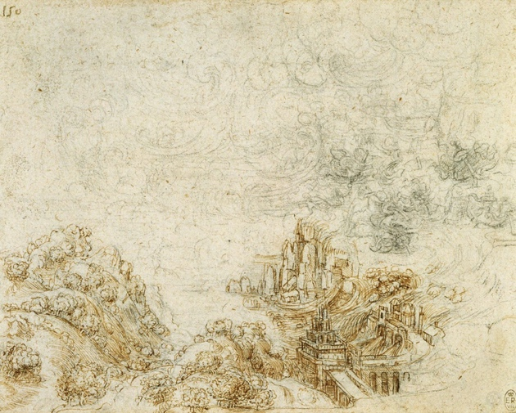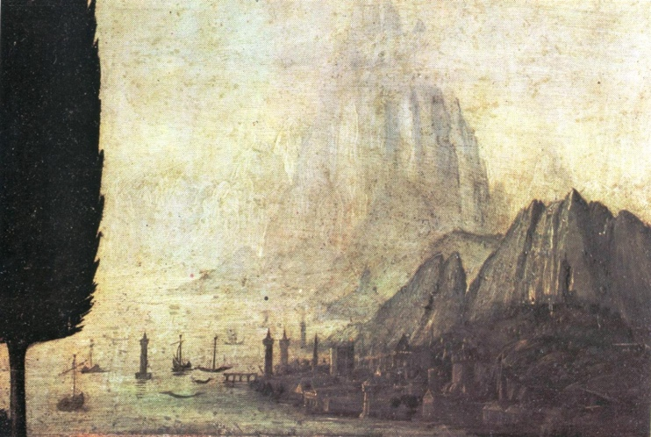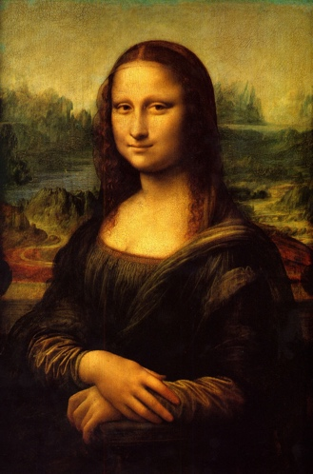

Vincent Van Gogh—post-impressionism
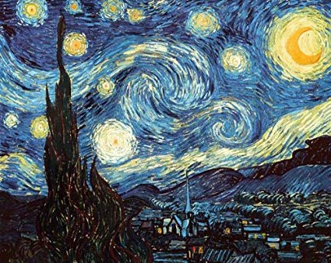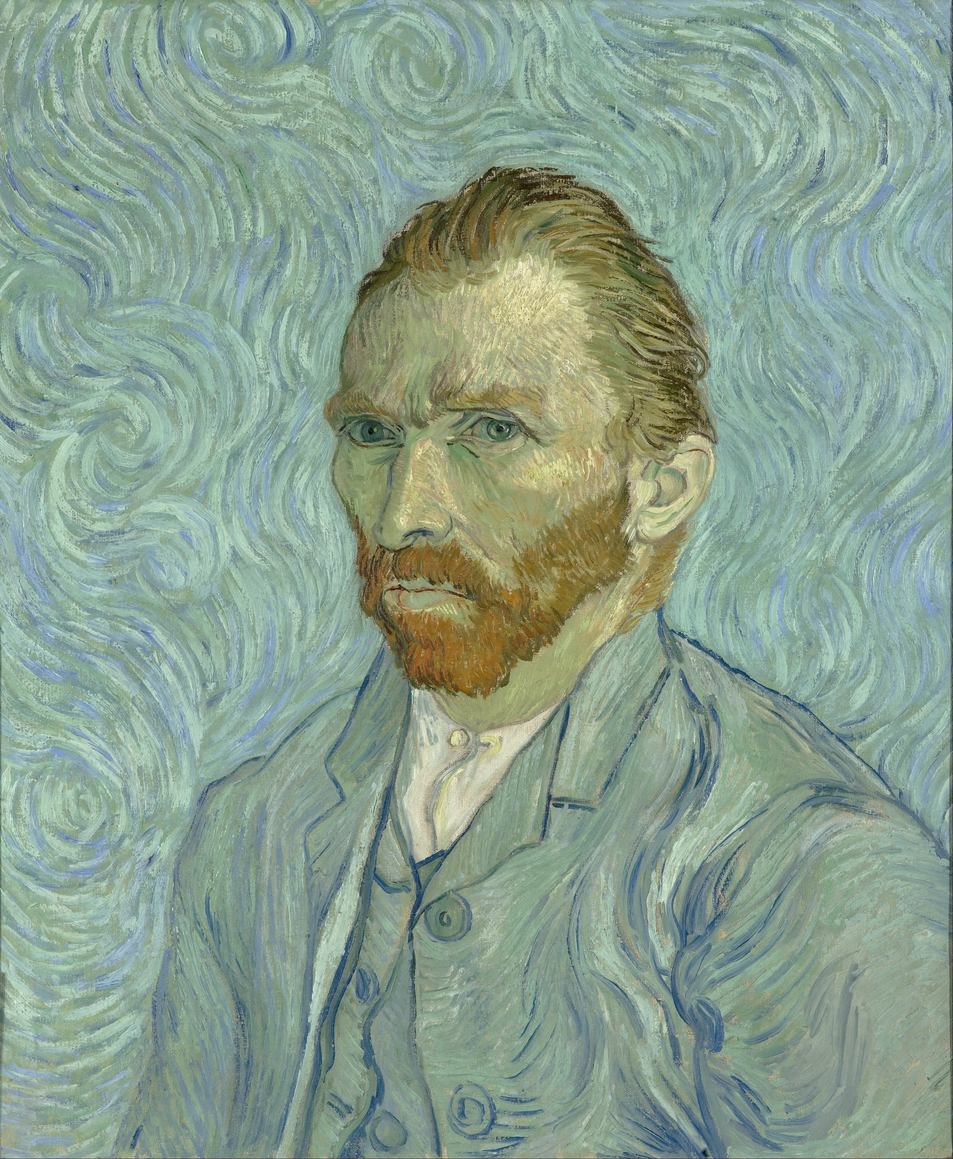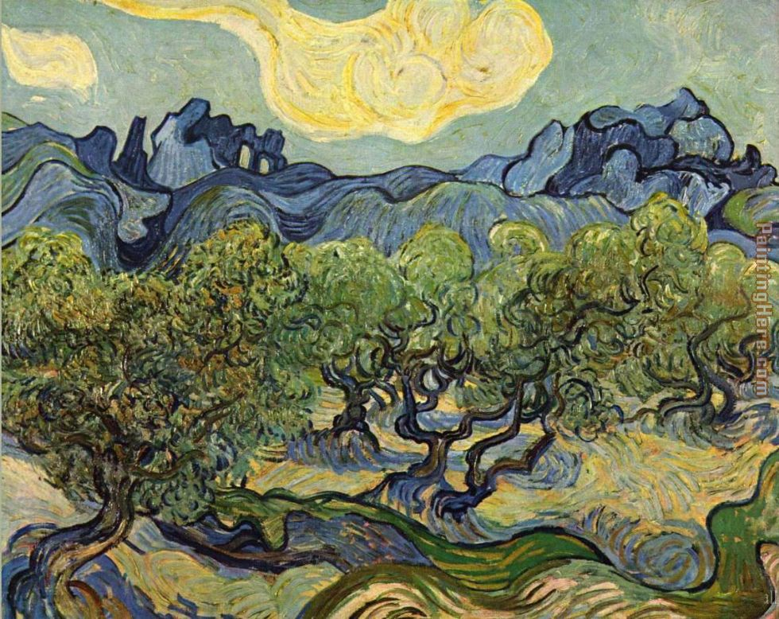

Pablo Picasso--Cubism
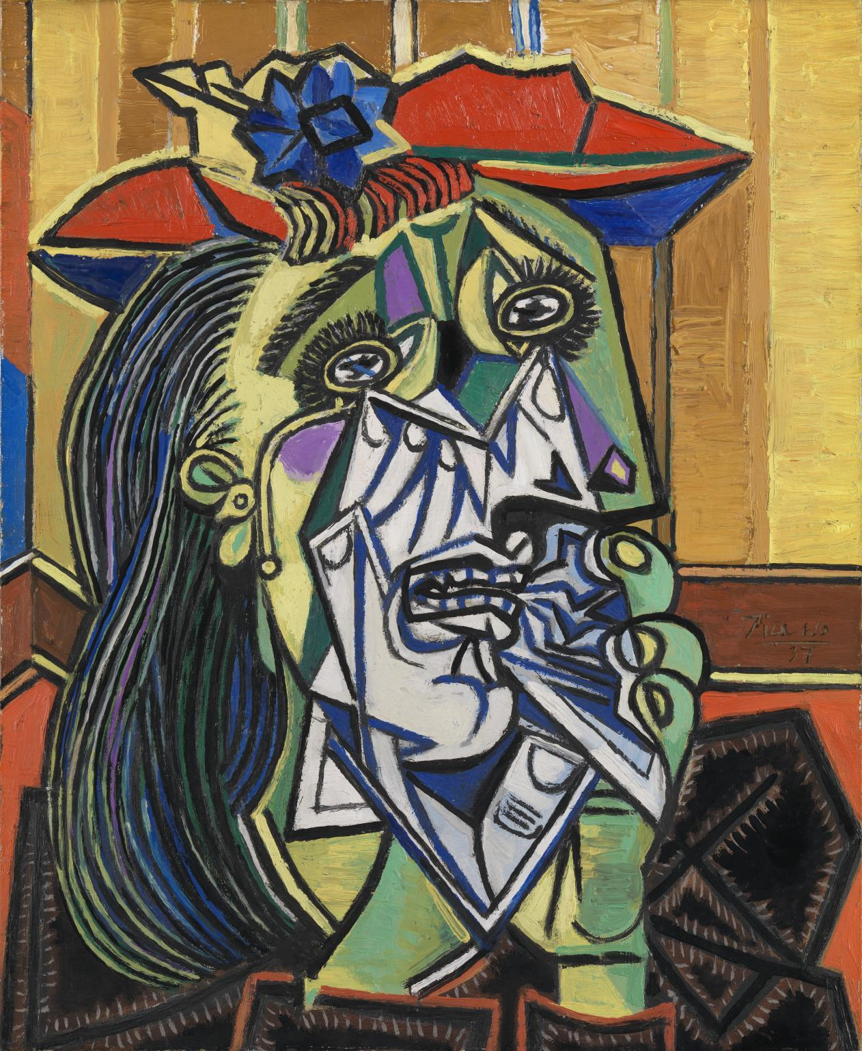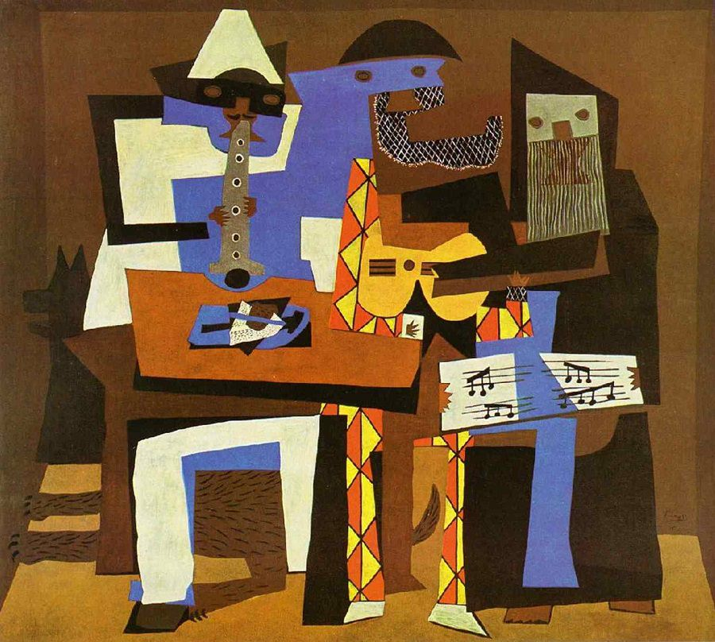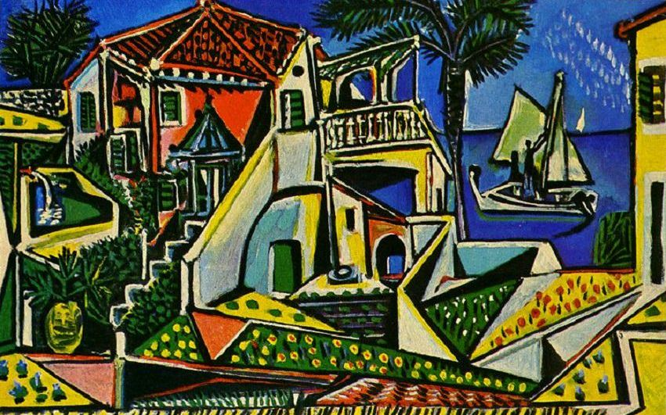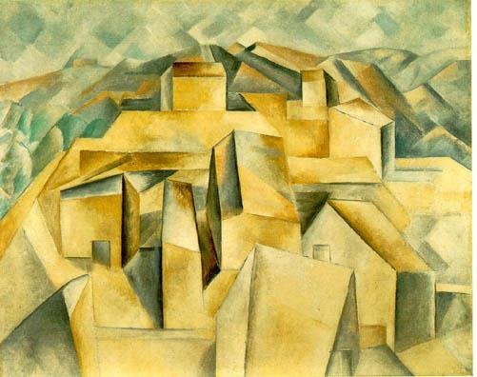

Georgia O’Keeffe—American Modernism
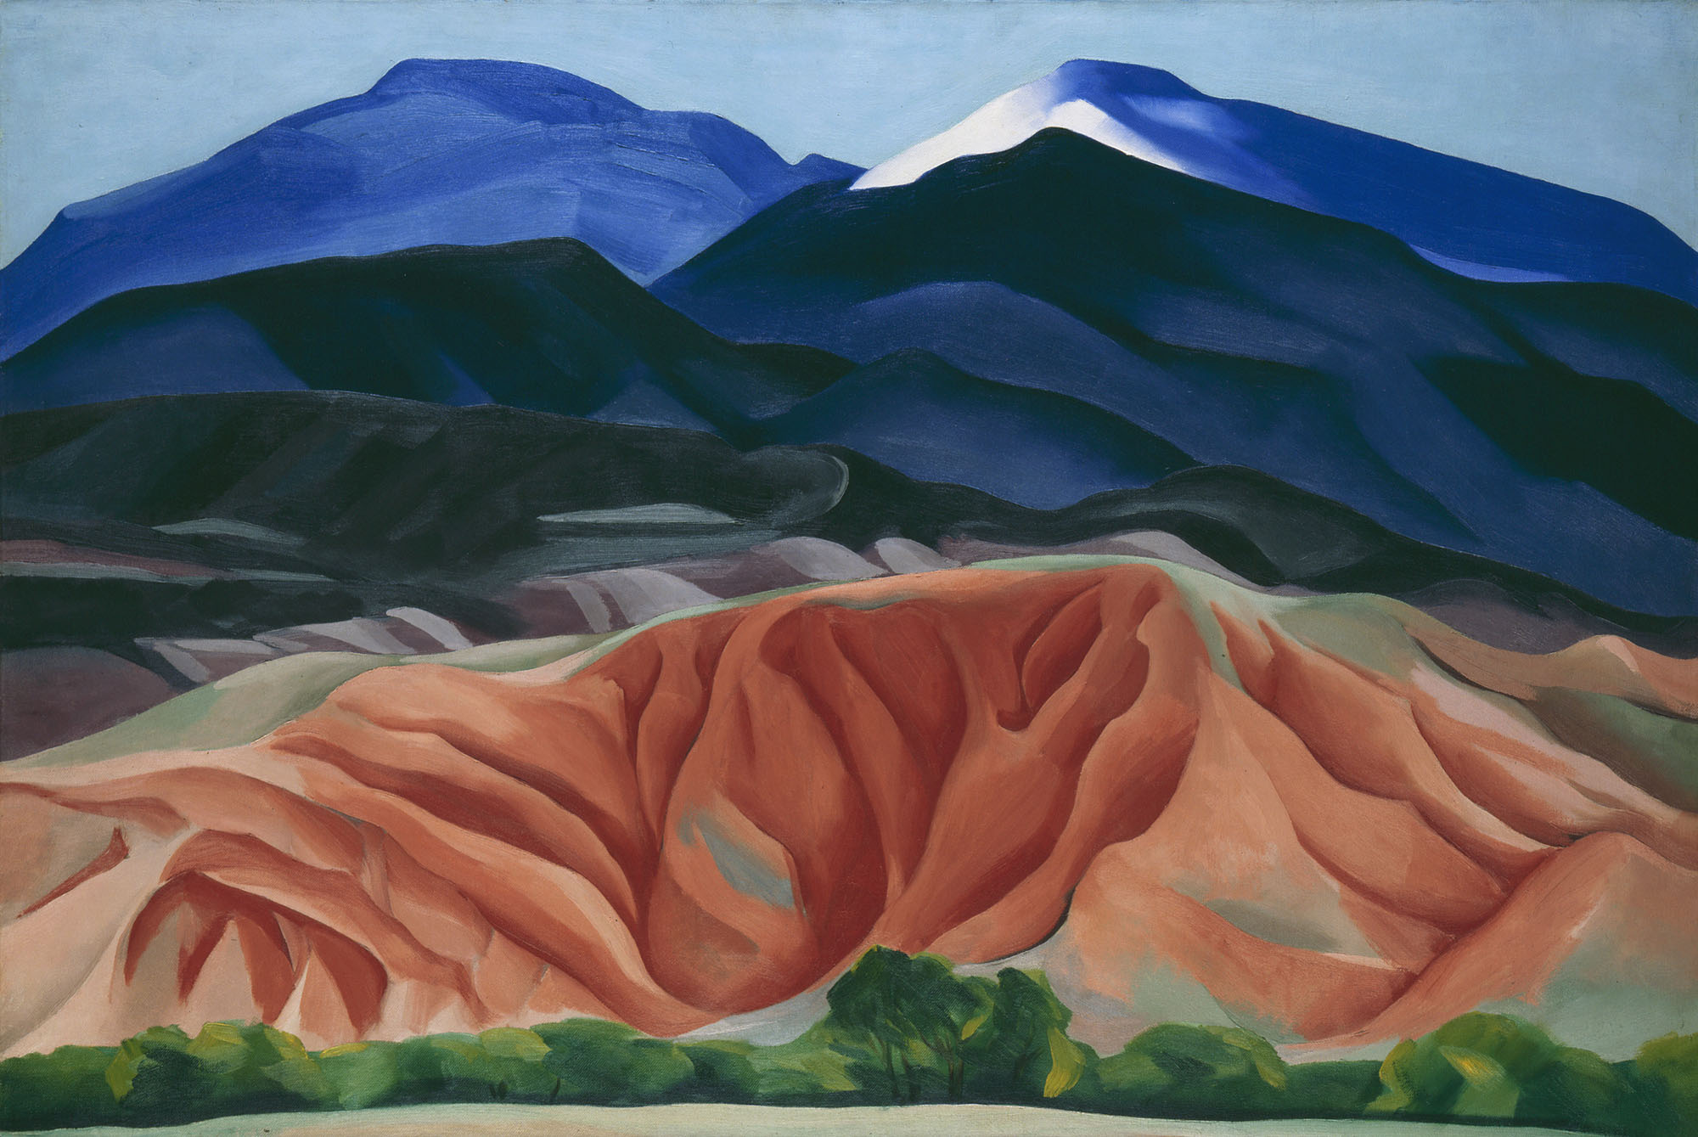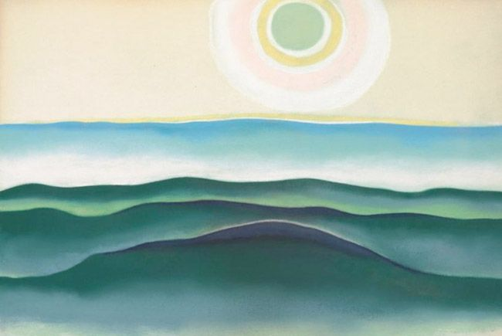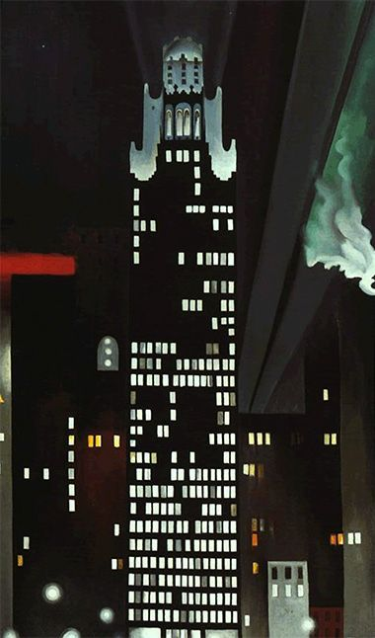

Salvador Dali--Surrealism
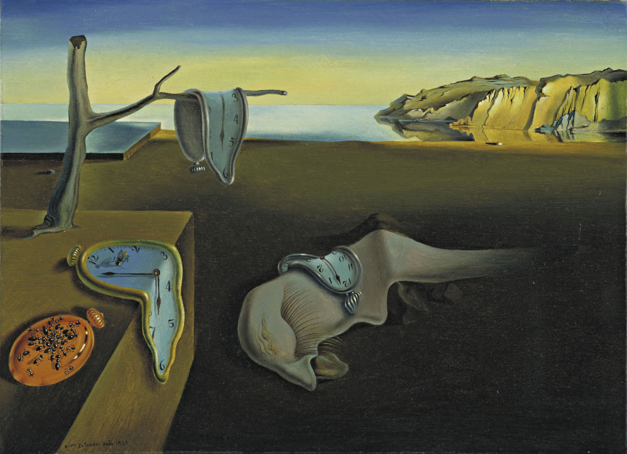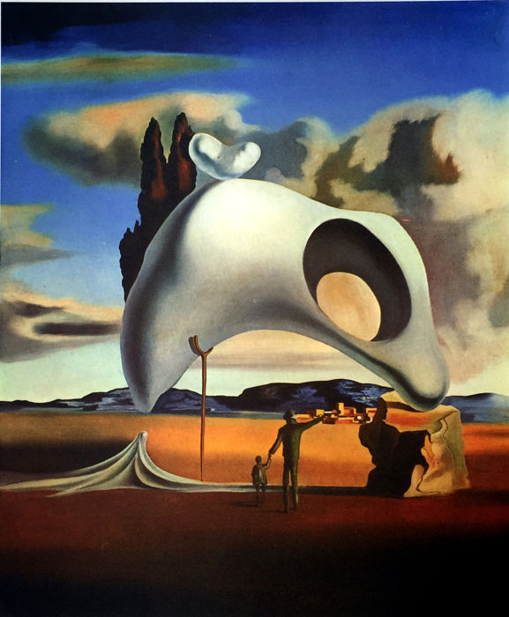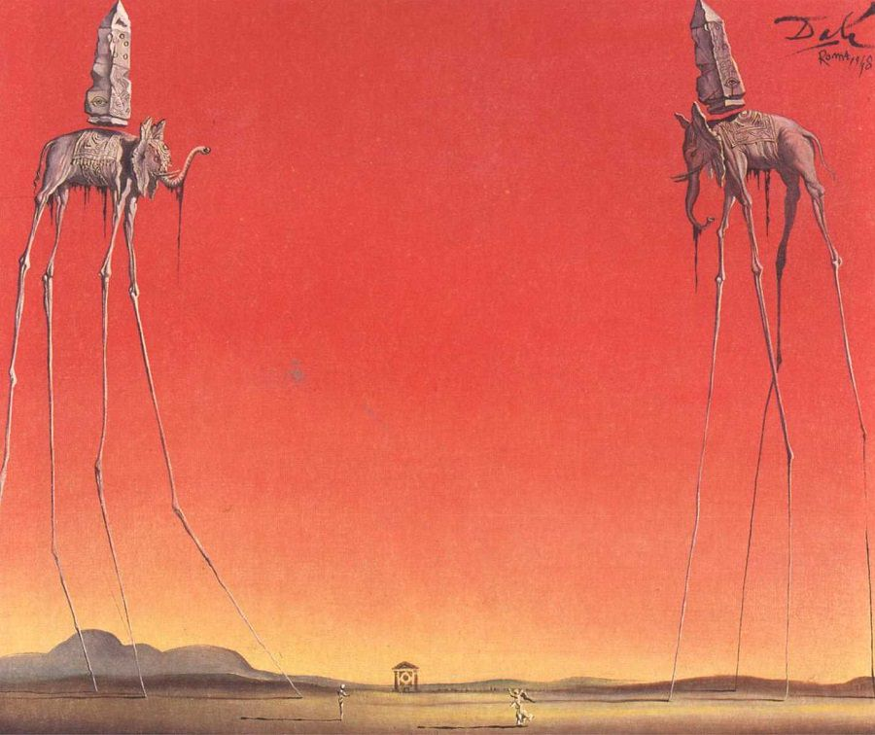

Keith Haring—pop art
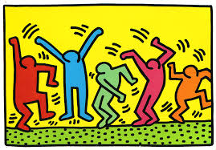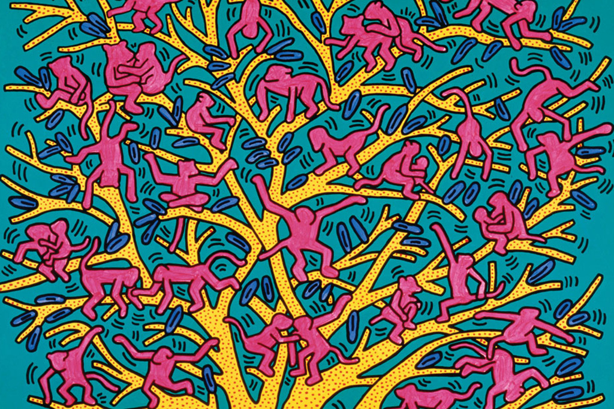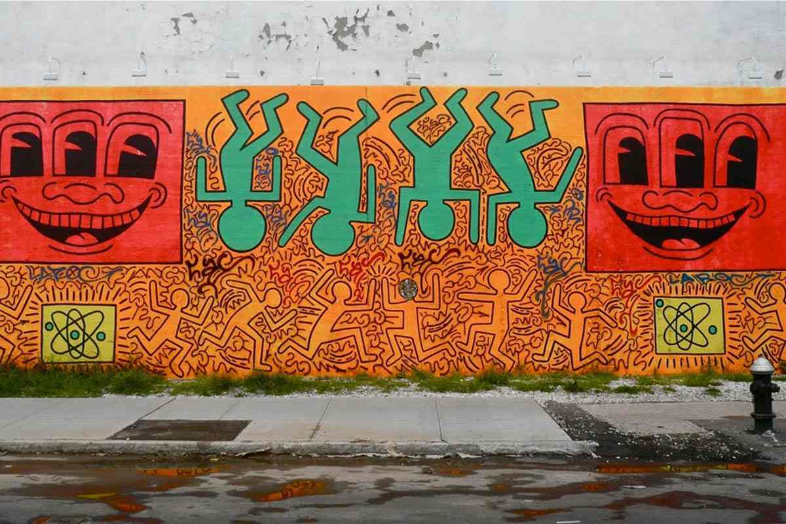

Bob Ross—cult classic
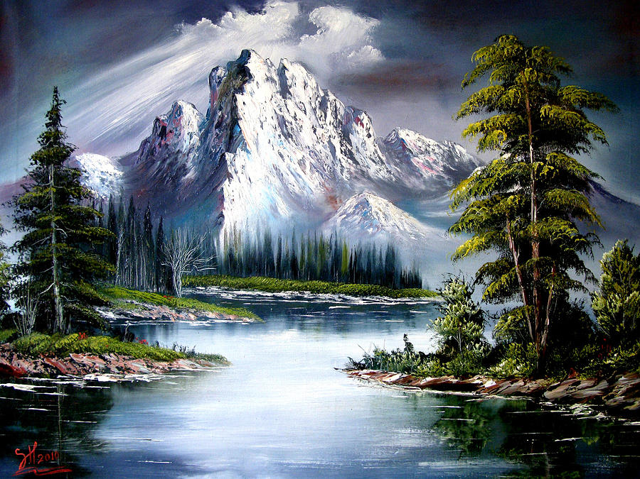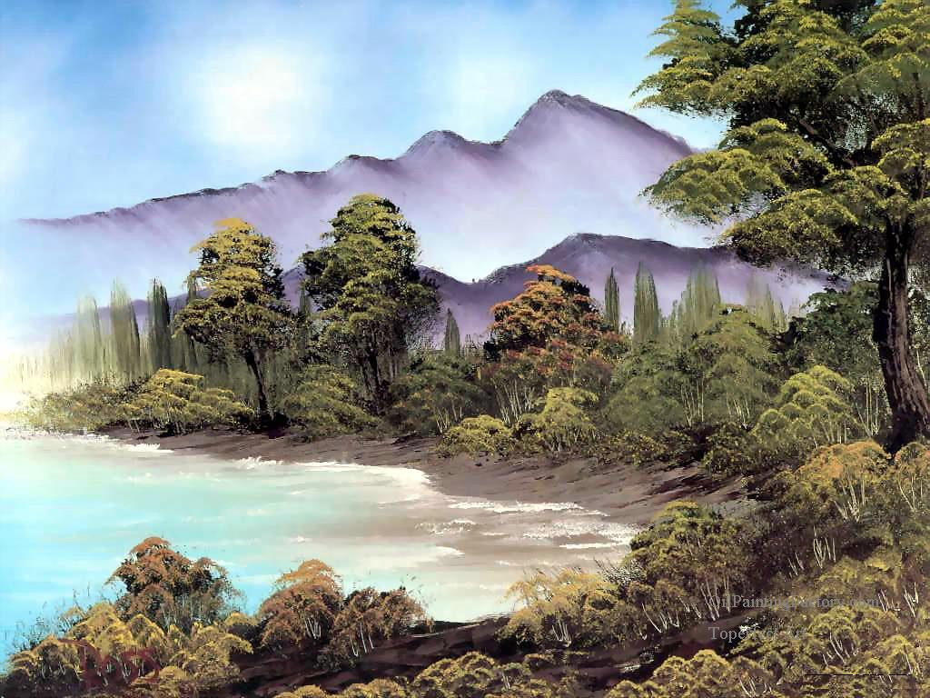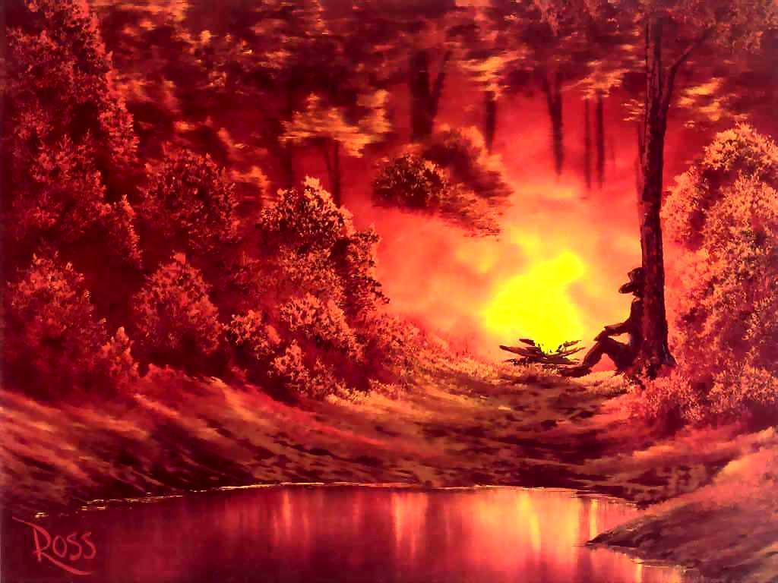

Preparation:
What do you need to prepare for this experience? List steps of preparation in a bulleted format.
- Printing artist’s images in advance and displaying them on tables.
- Cutting the images into smaller texture squares for students to reference
- Organizing oil pastels and pencils
- Create and print inquiry sheets about professional artists.

Safety:

Be specific about the safety procedures that need to be addressed with students. List all safety issue in a bulleted format.
- No safety issues with the project
- Safe space during observations during critique
- Keep oil pastels on the tray. Pick up oil pastels that are on the ground.
- Not smearing oil pastels with fingers—use paper towels
- Do not color oil pastels on your skin
- Don’t press super heavily with the oil pastels or else they will break or they will run through them very quickly.

Action to motivate/Inquiry Questions:
Describe how you will begin the lesson to stimulate student’s interest. How will you pique their curiosity and make them interested and excited about the lesson? What inquiry questions will you pose? Be specific about what you will say and do to motivate students and get them thinking and ready to participate. Be aware of the varying range of learning styles/intelligences of your students. Some ideas might include: telling a story, posing a series of questions, role-playing, etc.
- Students were excited about sitting at specific artist’s table groups. Since this is something they are already familiar with, they will be excited to get to know their artists more. Prompting their interest can be about asking them if they want to get to know their table artist better and learn how to make art just like they did.
- Icebreaker activity: have the students organize the artists from oldest to most contemporary based on art movements
- Students will complete the inquiry question activity based on each table artist’s body of work

Ideation/Inquiry:
Ideation is the creative process of generating, developing, and communicating new ideas, where an idea is understood as a basic element of thought that can be visual, concrete or abstract. List and describe inquiry questions and processes you will engage students in to help them develop ideas and plans for their artwork.
- Inquiry questions worksheet with artist
- Teacher will zoom in on specific textures and designs of each artist’s work. Students will have to re-create these textures on a 4”x6” paper.
- When they are done with their texture sample, students will use that same texture/design to create a landscape (discuss different types of landscapes and what landscapes feature in art).
- Students can get a small piece of sketchbook paper if they want to practice making their drawings.
- It might be important to emphasize that they don’t have to recreate the entire artist’s work when they do their original illustration.

Instruction:
Give a detailed account (in bulleted form) of what you will teach. Be sure to include approximate time for each activity and instructional methodology: skills, lecture, inquiry, etc. Include motivation and ideation/inquiry where appropriate; including what student will understand as a result of the art experience

Day 1 | Instruction - The teacher will... (Be specific about what concepts, information, understandings, etc. will be taught.) Identify instructional methodology. KNOW (Content) and DO (Skill)  Artist’s Presentation  Learning Target: I can work with my classmates to answer questions about the artist at my table.  Initial Prep Time:  - Print out all images of artist’s work so that each table has a hard copy.  - Type up inquiry sheet and make enough copies for students.  Class Discussions:  - Explain to students that they will be creating a landscape based on the texture and style of the artist at their table.  - Hand students the inquiry sheets and explain that they will work as a team to answer all the inquiry questions based on looking at their table artist’s work.  Work Time:  Presentations:  - Each student group will present the answers to three or four of their inquiry questions (depending on how many people were in their team). They will have three minutes to do so. Allow three groups to present before giving them a brain break.  Brain Break:  - Have students do some sort of mindful movement activity. In the case of our students, we had them clasp their hands and wiggle opposite fingers to re-center their energy and concentrate their focus.  - This was a differentiated strategy for our students due to their hyperactive nature. There might be other students in different environments that could sit through all the presentations.  Presentations (cont.):  - Finish up the last four presentations  - If there is time, have students organize the famous artist from oldest to most recent. The order of the artists is in the resources section.  Clean-up and line up | Learning - Students will... i.e.: explore ideation by making connections,  comparing, contrasting; synthesize possibilities for each painting technique; etc. (Be specific about what will be the intended result of the instruction as it relates to learning.) UNDERSTAND  - S-4 exploring thoughts underlying feelings and feelings underlying thoughts  - S-32 making plausible inferences, predictions, or interpretations  - S-2 developing insight into egocentricity or sociocentricity  - S-4 exploring thoughts underlying feelings and feelings underlying thoughts  - S-1 thinking independently  - S-3 exercising fairmindedness | Time  Total Class Time:  45 min.  5 min.  10 min.  9 min.  4 min.  12 min.  5 min.
Day 2  Day 3-4 | Artist’s Study  Learning Target: I can make a small drawing that copies the style of my table artist’s work.  Initial Prep Time:  - Cut all professional artist’s work into squares that zoom in on details of the paintings for the students to copy  - Or cut viewfinders out for each table to share  - Cut paper into 6”x9” sheets—students can fold those sheets in half to have a smaller area to work in if they want to focus on more tedious details  Class Discussion:  - Remind students that they will be doing the textural study to create a landscape based on the style of the artist at their table group  - Show them teacher examples of the studies, letting them know that they can use the full 6”x9” sheet or they can fold it in half to work on two different details.  - Review proper use of oil pastel materials by getting students to raise their hands. They are very soft, so heavy pressure will burn through them very quick. Also, students should be careful of pastels that drop of the floor. They can get easily crushed when they are stepped on, which stain the floor and waste materials.  - When they are finished, they can start drawing out ideas of the landscapes that they are working on. Leave notes at each table for possible things that a landscape drawing could have. Work mainly with pencil. They can sketch out small ideas or they can go ahead and get started  Work Time  Clean-Up:  - Collect all oil pastel studies; make sure that their names are on the back  - Put away all oil pastels, making sure that there aren’t any on the floor  Work Time  Learning Target: I can make a landscape drawing based on the style of my table artist.  Initial Prep Time:  - Cut paper for students  - Arrange oil pastels on table  Class Discussion:  - Remind students about expectations with noise level. Provide a visual of when things are getting too noisy and what the consequences are (taking away a marble for the tea party)  Work Time:  - Day 3: drawing of the landscape with pencil and 50% colored with oil pastel  - Day 4: 100% colored with oil pastel  Clean-Up:  - Collect all oil pastel studies; make sure that their names are on the back  - Put away all oil pastels, making sure that there aren’t any on the floor | - S-2 developing insight into egocentricity or sociocentricity  - S-10 refining generalizations and avoiding oversimplifications  - S-1 thinking independently  - S-3 exercising fairmindedness  - S-3 exercising fairmindedness  - S-10 refining generalizations and avoiding oversimplifications  - S-4 exploring thoughts underlying feelings and feelings underlying thoughts  - S-1 thinking independently  - S-3 exercising fairmindedness | Total Class Time:  45 min.  5 min.  35 min.  5 min.  Total Class Time: 45 min.  5 min.  35 min.  5 min.
Day 5 | Reflective Discussion  Learning Target:  - I can write an artist’s statement about how I made my work in the style of my table artist.  - I can compare/contrast my classmate’s work with their table artist’s work.  Initial Prep Time:  - Write down artist statement questions on the board  - Have drafting board ready to tape up professional artwork  Artist’s Statement:  - On the back of their projects, students will write two sentences about their work.  - What is this drawing about? What is it trying to communicate?  - What inspired you to make this drawing based on the style of your table artist?  Critique Discussion:  - Students at each table group stand in front of the classroom displaying their projects alongside example of their table artist. The rest of the students compare and contrast the technical and expressive aspects of the students’ work compared to their professional artist.  - Each student group will present their work for about 4 minutes before they switch to the next group. Make it clear to the students that participation is part of their grade. They have to say something at least once to get participation points.  - Three groups will present, then give students a brain break.  Guiding Questions:  - What do all these paintings have in common with each other? What makes them different?  - How are they similar to the artist’s work? How are they different?  - How would you describe the texture or style of the students’ work?  Brain Break Activity:  Critique Discussion Cont.:  - Four groups will present.  If there is time, do a second brain break activity. If there is still time after that, have students talk about what they learned from the project. | - S-12 developing one’s perspective: creating or exploring beliefs, arguments, or theories  - S-9 developing confidence in reason  - S-27 comparing and contrasting ideals with actual practice  - S-29 noting significant similarities and differences  - S-2 developing insight into egocentricity or sociocentricity  - S-4 exploring thoughts underlying feelings and feelings underlying thoughts  - S-27 comparing and contrasting ideals with actual practice  - S-29 noting significant similarities and differences  - S-2 developing insight into egocentricity or sociocentricity  - S-4 exploring thoughts underlying feelings and feelings underlying thoughts | Total Class Time:  45 min.  5 min.  12 min.  5 min.  16 min.  7 min.

Student reflective/inquiry activity:
Sample questions and activities (i.e. games, gallery walk, artist statement, interview) intended to promote deeper thinking, reflection and refined understandings precisely related to the grade level expectations. How will students reflect on their learning? A participatory activity that includes students in finding meaning, inquiring about materials and techniques and reflecting about their experience as it relates to objectives, standards and grade level expectations of the lesson.)
Artist’s Statement:
- On the back of their projects, students will write two sentences about their work.
- What is this drawing about? What is it trying to communicate?
- What inspired you to make this drawing based on the style of your table artist?

Critique Discussion
- Students at each table group stand in front of the classroom displaying their projects alongside example of their table artist. The rest of the students compare and contrast the technical and expressive aspects of the students’ work compared to their professional artist.
- Each student group will present their work for about 4 minutes before they switch to the next group. Make it clear to the students that participation is part of their grade. They have to say something at least once to get participation points.

Guiding Questions:
- What do all these paintings have in common with each other? What makes them different?
- How are they similar to the artist’s work? How are they different?
- How would you describe the texture or style of the students’ work?

Post-Assessment (teacher-centered/objectives as questions):  Have students achieved the objectives and grade level expectations specified in your lesson plan? | Post-Assessment Instrument:  How well have students achieved the objectives and grade level expectations specified in your lesson plan? Include your rubric, checklist, rating scale, etc.
Can students infer what the artist’s work is about and how it was created using the inquiry sheet?  Can students sketch replications of each artist’s textural sample using oil pastels?  Can students create a landscape based on the style of their table artist?  Can students analyze the similarities and differences of their work with their professional artist’s work in a group discussion activity? | Incomplete (N): (0 pts. per section)  - Artist’s Presentation: did not participate in the activity  - Craftsmanship: project was unfinished or not turned in  - Process: refused to problem-solve or take creative risks; did not have the motivation to finish the project  - Critique: student did not write an artist’s statement or give feedback to classmates; feedback was intentionally hurtful  - Studio Habits: student spent the majority of class talking to friends or not working; did not clean up after him/herself even after being asked; was deliberately disruptive to classmates and teacher  Partially Proficient PP: (2 pts. per section)  - Artist’s Presentation: student did not answer all the questions  - Craftsmanship: project has no immediate resemblance to one of the famous artists; colored pencil work is rushed, sloppy, or unfinished.  - Process: hesitant about taking creative risks; did not demonstrate a strong willingness to persevere through technical and conceptual challenges  - Critique: student wrote his/her artist’s statement with incomplete sentences; student left out at least one pros and grows feedback for one or more students  - Studio Habits: student had moments of being focused but was mostly distracted; did not take responsibility to clean up after him/herself; had side conversations while classmates and teachers were talking  Proficient (P): (4 pts. per section)  - Artist’s presentation: Student answered all the questions on the sheet and worked cooperatively with his/her classmates  - Craftsmanship: the drawing has a recognizable connection to at least one or two artists  - Process: persevered and problem-solved through technical and conceptual challenges; was willing to take creative risks  - Critique: student wrote his/her artist’s statement with complete sentences; offered appropriate and kind feedback during the critique activity but could’ve been more specific  - Studio Habits: student was generally focused on project, took responsibility to clean up after him/herself, and treated his/her classmates and the teacher with respect  Accomplished (A): (6 pts. per section)  - Artist’s presentation: student answered the questions with an in-depth analysis of the famous artist’s intent; worked effectively with his/her classmates  - Craftsmanship: the drawing has a recognizable connection to at least one or two artists; the student paid close attention to technical drawing skills like blending values; student demonstrated a strong understanding of atmospheric perspective  - Process: independently persevered and problem-solved through technical and conceptual challenges; took creative risks and reflected on how they worked/didn’t work during the project; asked critical thinking questions that further developed the lesson as a whole  - Critique: student wrote his/her artist’s statement in complete sentences; offered appropriate, kind, and specific feedback during the critique activity  - Studio Habits: student used all of class time to focus on project; helped others clean classroom; treated his/her classmates and teachers with respect; took initiative to help settle the noise level down  Total Score: __________/30 pts.

Self-Reflection:
After the lesson is concluded write a brief reflection of what went well, what surprised you, and what you would do differently. Specifically address: (1) To what extent were lesson objectives achieved? (Utilize assessment data to justify your level of achievement.) (2) What changes, omissions, or additions to the lesson would you make if you were to teach again? (3)What do you envision for the next lesson? (Continued practice, reteach content, etc.)
What Went Well

Artist’s Presentation
- The purpose of this activity was to get the students to analyze the artists at their table and reflect on their stylistic choices. They also had to do this activity as a team. The students had immediate interest in the activity because they loved sitting at “artist” table groups and wanted to learn more about their specific artists. The students also worked together pretty effectively without many classroom management issues. Their answers during their presentation were very observant and reflective. For example, some of the students described Picasso and Dali’s work as scary, depressing, and weird. The Van Gogh students said that his swirly painting style made them feel disoriented, confused, and calm. Finally, the da Vinci students guessed that his work was between the Middle Ages and the Renaissance because his art looked really old and biblical.
- Students agreed that Keith Haring’s work made them happy and excited because of the colorful dancing people. They also thought that Dali’s paintings were very scary because they didn’t know what kinds of objects were in his work and where he came up with the ideas. Finally, students felt that Bob Ross’s paintings were serene to look at and made them feel happy. Karen broke up time in between presentations so students could do a brain break movement activity.
- During the activity, about three-quarters of the students in the first group proceeded to tear the edges of the paper in somewhat of a pattern. This created an interesting border around the paper. I told them that I didn’t have a problem with them tearing the paper as long as they didn’t rip their written answers off or rip the artist’s work (since I would have to use them for the next fourth grade class). There were a handful of students that decided to fold the paper into origami-shaped sunglasses, which completely fascinated me. I didn’t know if it was a hyperactivity thing, but I was surprised that the fidget was something creative. With that said, there was one student that got his paper confiscated by Karen. His homeroom teacher noted that he folded and crumpled his papers in multiple classes to the point where it was deterring him from getting the work done. His paper was going to be shown to his mom during their next class meeting. Strangely, students in the second group did not tear or fold their inquiry sheets like the other fourth grade group. However, they did more drawings and doodling on the back of their projects.
- The students in the Picasso groups took their inquiry sheets and Picasso’s work to the window so they could trace his designs.

Ideation
- Students were just as proud of their ideation sketches as they were with their final drawing, especially if they were different. The students frequently asked when they could take their projects home, supposedly to give them as gifts to other people.
- Students were very enthusiastic with the project. They asked really great critical thinking questions (like how to combine the styles of more than one artist or whether they could integrate their own artistic style), and they were extremely open to constructive feedback from me. I feel like they really pushed me to think about how I could tweak and deepen the objectives of the project, which I really appreciated a lot.

Project
- Ironically, a lot of students chose to work with Haring for their final project. I don’t know why the change happened, but they seemed to really resonate with his graphic appeal at that point in the project. But Haring had a lot more creative spins in the students’ work. For example, students put the Haring dancing men in mazes, bamboo trees, and on Mars.
- Picasso also became a little bit more popular for the final project. In my opinion, Picasso style work had the most unique creative flair and the most inventive architecture. Students also experimented a little bit with Dali’s style, though they stuck with classic Dali motifs (such as the melting clocks and the tall elephants) rather than coming up with their own ideas.
- The students did an impeccable job thinking about portraying a landscape as a mood or a narrative. They also achieved the expectation of making their work look like a specific artist—while also adding their own creative spin to it.
- Some students played with the scale of the paper to push their idea. For example, one student combined Haring and Ross to create a flowing river scene that extended into an organic-shaped canvas (we attached seven extra pieces of paper). Another student did a panoramic strip to create a long Haring motif that almost looked like mini-golf props. Not only did this allow them to use the whole class time to work on their projects, but it also got them excited to expand and deepen their work.

Critique
- Students were asked to write 2 pros (or compliments), 1 grow (or constructive feedback) and the names of the artists that the students think they used. Students gave their feedback to three different students, moving to three different table groups throughout the class. After reading their feedback, I noticed that their “grows” were very detailed and emotionally appropriate. Some stated that the drawings should have more detail, but they didn’t specify which parts of the drawings needed more detail.
- All of the students wrote their responses in complete sentences, with some of them writing in cursive.

Management
- The students really needed brain breaks that broke up lectures and work time. The specific activities we did involved lots of concentration and right/left brain activity.
- On my end, I felt that I did a really good job keeping the group energized and walking around the room to keep their attention on me (and to hold people accountable for squirrely behavior they thought they could get away with). My mentor teacher thought this was an effective strategy because the students wouldn’t know where I would go to in the classroom, keeping them attentive and focused.
- Though I was sympathetic to the students’ desires to explore the work of other artists that they were drawn to, I did not want a bunch of students crowding around one table. I decided to problem-solve this by printing out small examples of textures and styles from each of the seven artists, glue those down onto poster boards, and put them in the middle of the table. This would give them the variety to experiment with different mediums without getting up. We also want to display all the works in the back of the room so students could see the “whole picture” and have it work together.
- Talking was less of an issue with this project compared to later projects. The “artist’s in the circle” management tactic (mentioned on my student teaching website) worked really well to help them quiet down, get focused, and earn marbles towards a tea party. I wondered if this worked so effectively because this management strategy related directly to the theme of the project.
- Because some of the students finished quicker than others, we made sure that they used all their class time by giving feedback and approving their work before they could free draw for the rest of class.

Areas of Improvement

Artist’s Presentation
- I made students clap for each other after they did their artist’s presentations. Clapping caused them to get riled up to the point where it was hard to quiet them down between groups. My mentor teacher proposed that students do jazz hands as a way to show support without making noise. This really helped them to keep quiet and focused.
- I wouldn’t really change the questions or format of the artist’s inquiry worksheet. Maybe the graphic design of it could’ve been better, but the content helped the students to think critically.

Ideation
- Students hated working with oil pastels because they didn’t allow for the intricate, sharp details that they could have with colored pencils. These students were more likely to give up and want to start over with their project. However, some students liked working with the oil pastels because it gave them bright colors and a lot of surface area to cover. We decided to give students both options, but I feel like this group of students really gravitated towards exclusively working with colored pencils. I’ll consider that the next time I teach this lesson. I also gave students the option to work with scratch tools to scratch faint designs into oil pastels. Some students were drawn to that while others weren’t.
- The initial requirement was that students would make a landscape based on the artist assigned at their table group. However, some students really didn’t like the artist assigned at their table group and wanted to explore other options. This was especially true for students that sat at the Dali table (scary imagery), the Da Vinci table (too technical), and the Picasso (too many sharp, abstract angles). Van Gogh was by far the most popular artist because of his swirly designs (my mentor teacher suspected that it’s because Waldorf students focus so heavily on form drawing). Bob Ross came in at a close second, probably because of his cult status and his approachable realism landscapes. I predicted a lot of students would like Haring because of his simple and graphic style, but the students felt that his work was too simple.
- I felt that technical tightness needed to be encouraged when they started creating their final drawing. I also noticed that students tended to separate different artistic styles based on foreground, middle ground, and background. We discussed these special relationships, how to merge all the styles, and how to focus on technical refinement. When they come up with the ideas of a final landscape, we want them to think about telling a story or focusing on a mood. Copying each other wasn’t allowed.

Project
- Students that did not do a preliminary sketch before coloring focused a lot more on gesture rather than technique. This caused them to get stumped and a little frustrated about why their work wasn’t at a higher technical level. I needed to emphasize that from the beginning. When I did that with the other group, the work was more technically thought out.
- At the beginning of the project, the students were less proactive about making their work look exactly like the work of the artists they were referencing. We had to set the expectation that their viewers needed to quickly identify which artist they were referencing. If they didn’t, they would get marked down for it. This caused students to critically think through the drawing process more.
- The students we were working with were extremely meticulous and slightly perfectionistic. If things weren’t going according to plan, they wanted to start over or even pick a different artist altogether. I didn’t allow them to start over when they were close to the due date, which caused them to feel an extreme amount of distress. One student was extremely attached to his work looking photorealistic (even though his technical realism drawing skills were already pretty strong for fourth grade) and got very stuck when I told him to engage and persist through the project rather than starting over. Another student had a very ambitiously detailed idea and didn’t have time to finish it up. Even though students could take their projects home and continue to work on them, they learned that they needed to plan their projects a little more strategically to meet the deadline.
- Another perfectionistic issue with the students’ work was that they were not open to constructive feedback when they were finished with their project. Even when I modeled my suggestions for them on a separate sheet of paper, students were very picky and nervous about ruining their project. I didn’t fight them too much on it, but this perfectionistic energy is something I know I’ll have to deal with as I continue to teach this group.
- The Van Gogh/Bob Ross combination was the most popular. While this wasn’t bad, it caused a lot of projects to look really similar to each other (like a mountain scape with a starry night sky). I think I would’ve pushed them more to think about making a landscape that was unique to their style as artists. One student did this by adding a dragon in her landscape. Other students added Georgia O’Keeffe motifs into the work, which added an interesting zest to the image. The students also struggled with adding dimension into their mountains, which we problem-solved together.

Critique
- We only did the critique with one of the fourth-grade groups. This was mainly because one group got ahead of the other due to federal holidays and snow days.
- “Pro” comments were a little more generalized. Students didn’t have a problem stating which parts of the drawings they liked, but they didn’t write why they liked the parts of the drawings that they did. My mentor teacher and I felt that sentence stems would’ve helped them get more specific.
- The noise level management was pretty difficult. Some factors that we think impacted the noise level was having a snow day the day before, having class on a Friday, and having to move their bodies a lot to do the critique project. Promising them that they could free draw motivated them to be quiet a few times, but talking caused the activity to go longer. With less time in class, students seemed to care less about the free drawing reward. Towards the end of class, I had to ring the bell twice to get their attention for clean-up. They continued to talk over me both times, causing me to almost yell over them. Once they were able to get quiet, I expressed my disappointment about them not being able to follow instructions or silencing cues. I also wanted to ask them what they thought about the lesson, giving them the chance to give me feedback on what I could’ve improved on. But I told them that the excessive talking made me lose trust with seeing them as credible teachers for me.
- While I had this conversation, two girls were having side conversations. I pulled them aside and asked them why they were talking while I was. They were nervous about being caught and tried to evade taking responsibility. Since one of the students shared her drawings to the class before the critique, I explained to her that I gave her respectful listening when she was presenting and felt hurt when she didn’t do the same for me. Both girls felt bad about that. I told them that if I caught them having side conversations while I was talking, I would separate them. They understood the expectation.

Management
- I noticed how quickly students lost attention or became a little too chatty. It was practically four minutes. I was a little surprised and nervous by this, but jumping right into the activity calmed everything down. They really needed brain break activities to break up the instruction time.
- I had to really work on being absorbed in the one-on-one interaction and step back to assess the whole group. When things got out of control, I was advised not to stereotype the entire group for being rowdy and unruly when they talked. Since the students were so used to teachers that were mellow and soft-spoken, it didn’t resonate for them when I became more assertive to grab their attention and set my expectations (particularly for clean-up). I needed to work on diversifying my nonverbal communication and quieting down so that students could hold themselves accountable for quieting themselves down.

Appendix: Include all handouts, prompts, written materials, rubrics, etc. that will be given to students.

8/9/15 Fahey

