How to Draw Two-Point Linear Perspective

Step 1: Tape your drawing paper down onto a larger piece of paper.

Step 2: Using your ruler, draw a straight line halfway across both papers. This is called the horizon line.

Step 3: Make two dots at the ends of the horizon line. These are your vanishing points.

Step 4: Using your ruler, draw a vertical line.
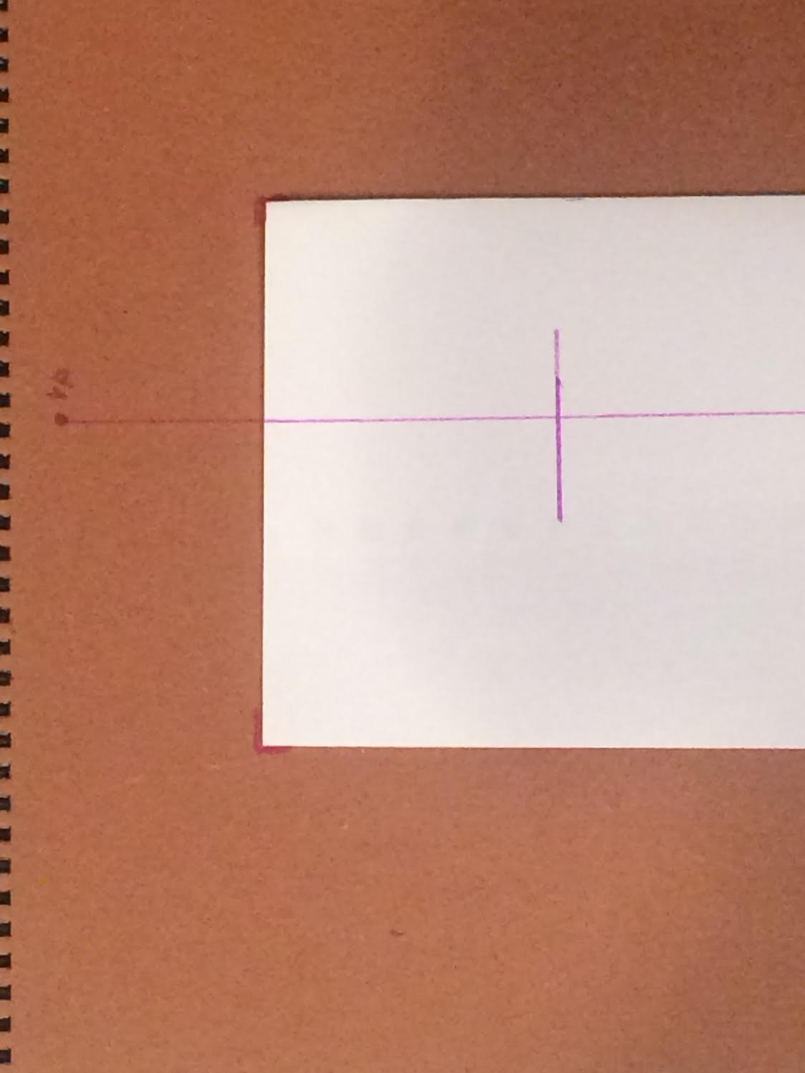

Step 5: Using your ruler, line up the top of the line with the closest vanishing point. Draw a new line. Do the same for the bottom.
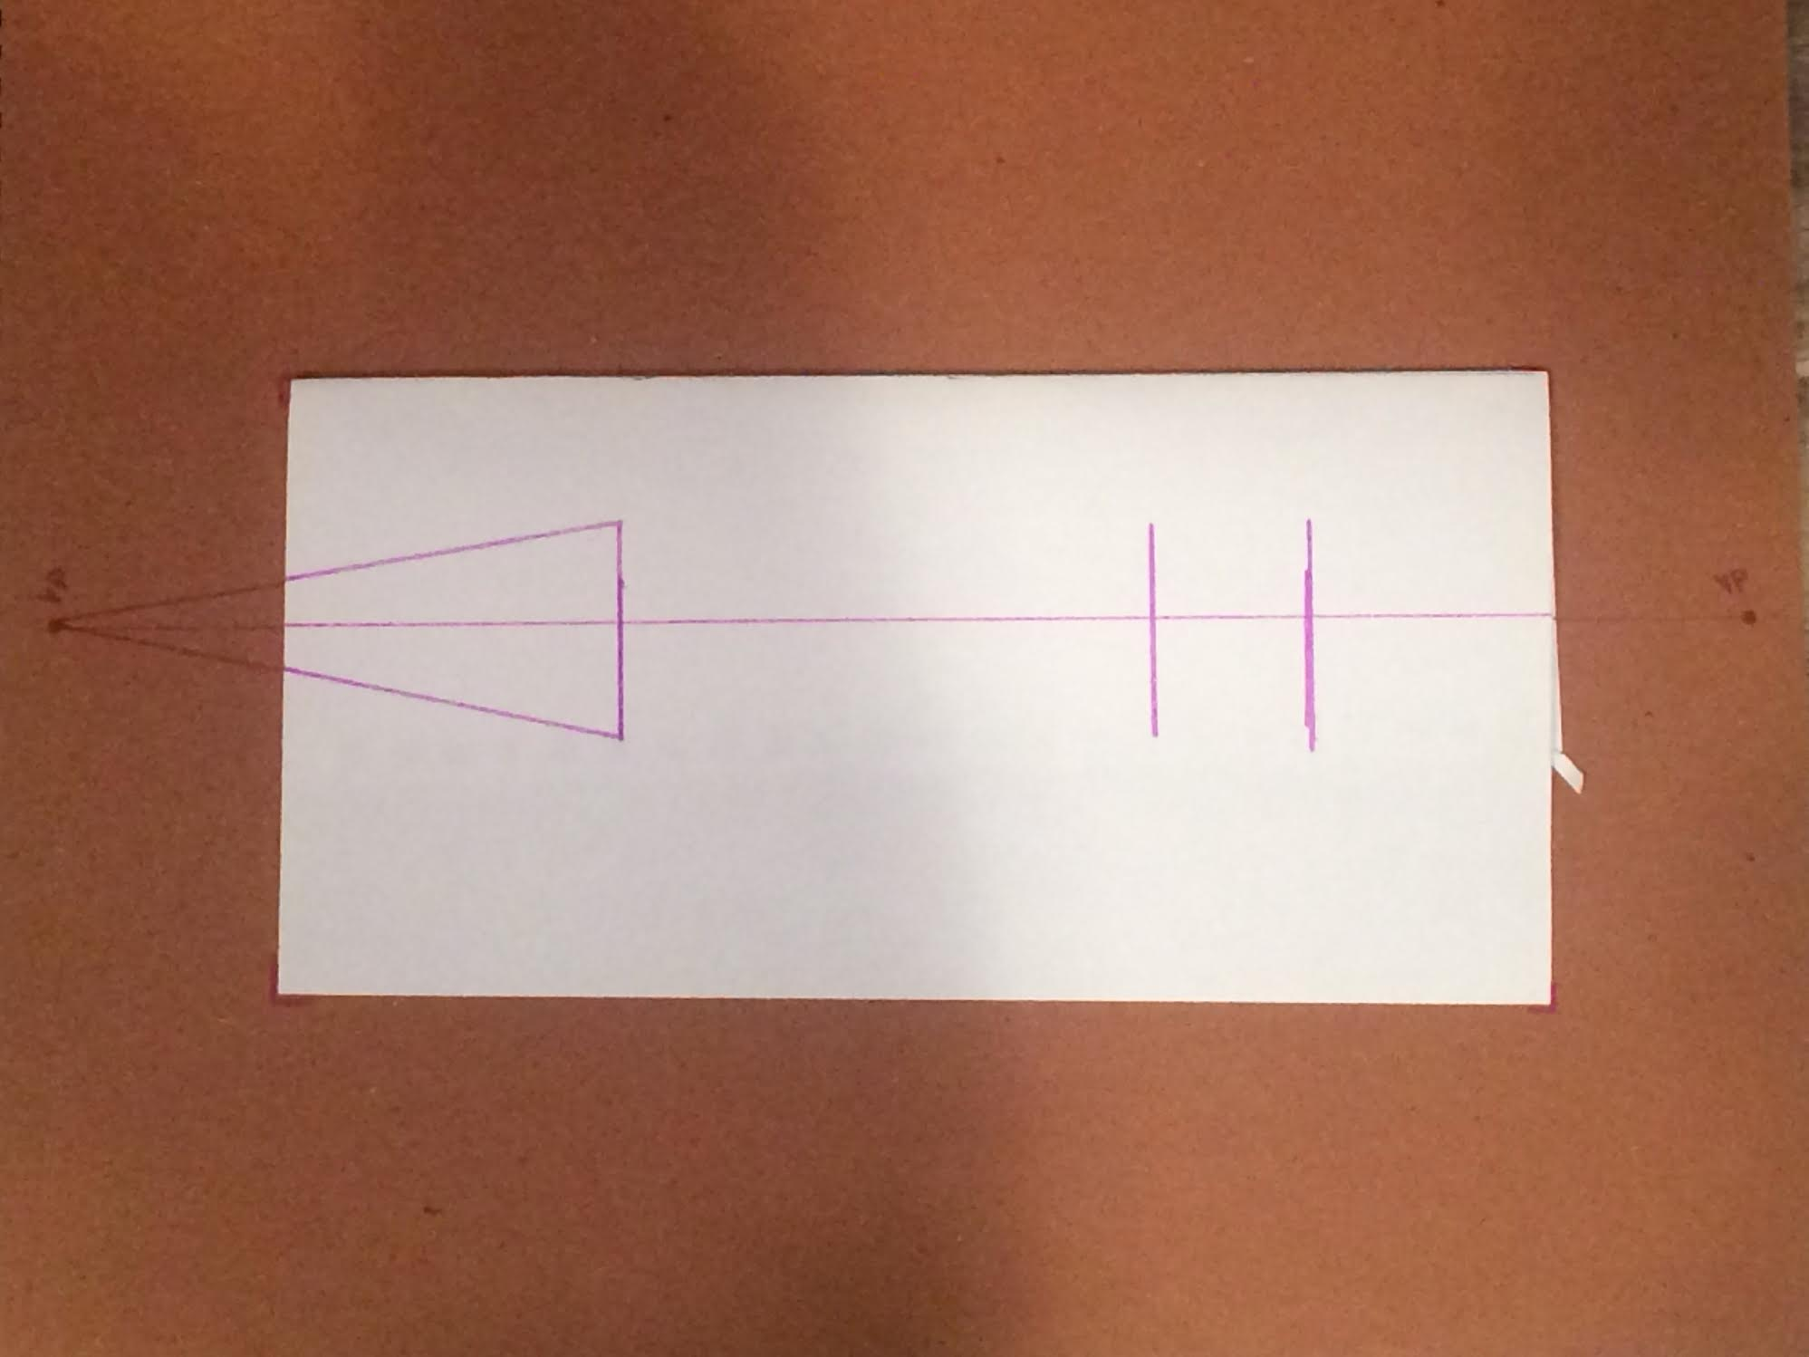

Step 6: Repeat step five for the farther vanishing point.
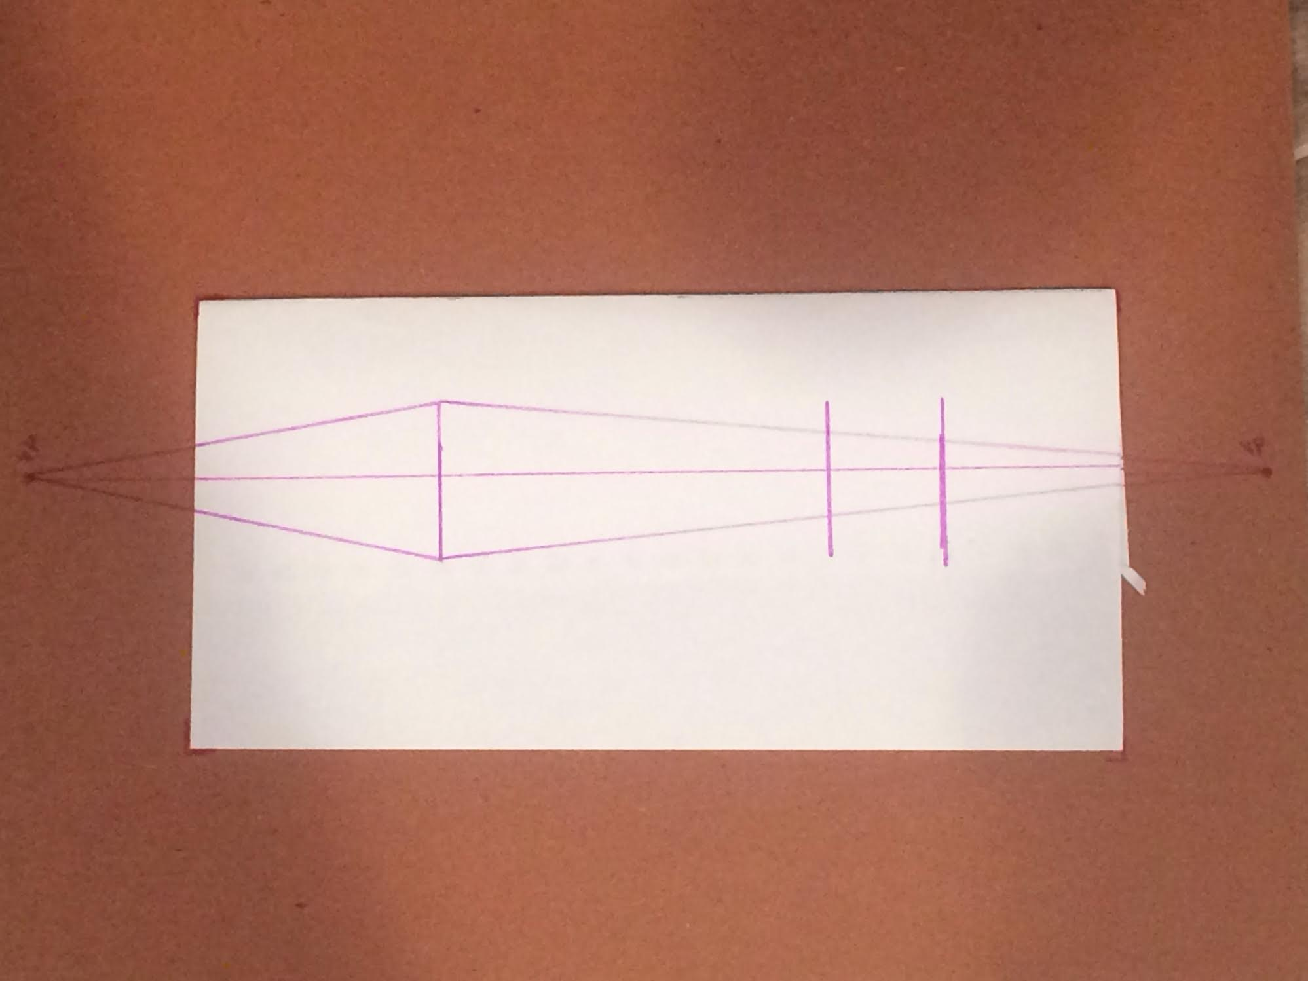

Step 7: Draw two more vertical lines. Outline your square or rectangle.
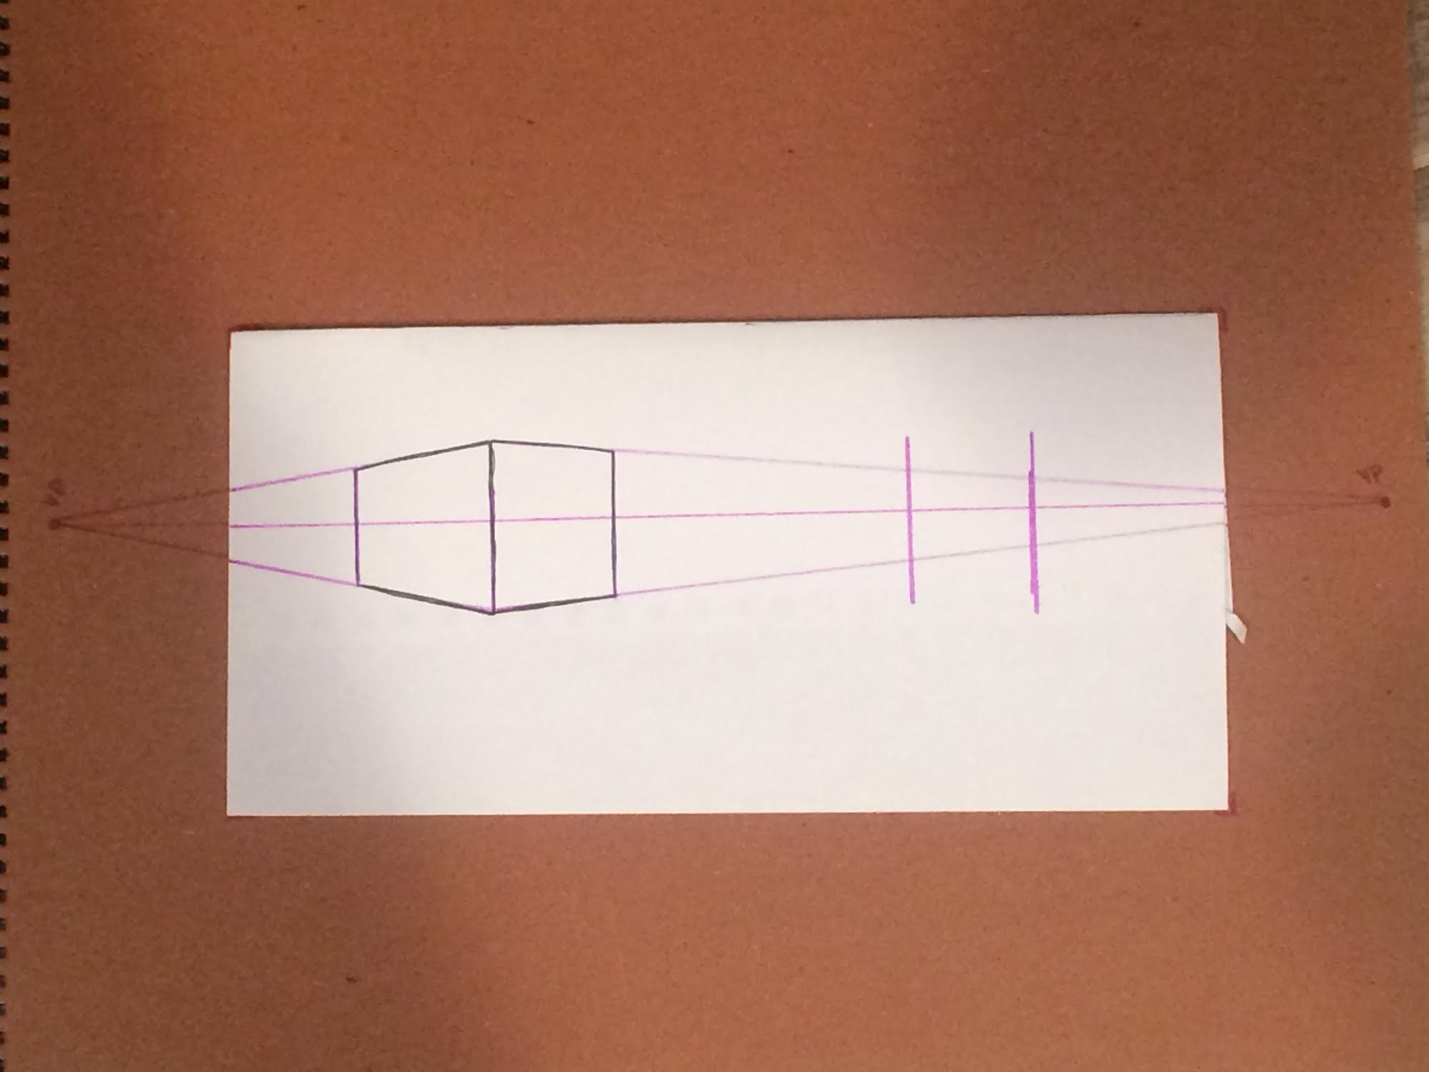

Step 8: Shapes above the horizon line=seeing the bottom
Shapes below the horizontal line=seeing the top
