Unit Plan Title: Individual to Community Artwork Length:__Sept 8 - Dec 7_________________

Course Name | Polaris Grades 2/3 | Grade Level | 2/3

Standards | Grade Level Expectations (List all GLEs for grade level)
1. Observe and Learn to Comprehend | - The characteristics and expressive features in art and design allow us to discuss and determine the artist’s intent and purpose.  - Artists make choices that express intent and purpose in their art.
2. Envision and Critique to Reflect | - Artists, viewers, and patrons use the language of art to respond to the meaning of their own art and the art of others.  - Artists, viewers, and patrons make connections among the characteristics, expressive features, and purposes of art and design.
3. Invent and Discover to Create | - Use symbols to identify and demonstrate characteristics and expressive features of art and design using basic media.  - Demonstrate basic studio skills with confidence to create meaningful art.
4. Relate and Connect to Transfer | - Historical and cultural ideas of the human experience are evident in works of art.  - Works of art connect individual ideas to make meanings related to the community.

Colorado 21st Century Skills  Critical Thinking and Reasoning: Think Deep, Think Different  Information Literacy: Untangling the Web  Collaboration: Working Together, Learning Together  Self-Direction: Owning Your Learning  Invention: Creating Solutions | Creative Process in Visual Art  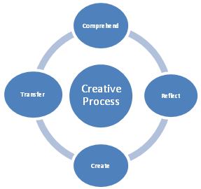 | Studio Thinking  Develop Craft: Learning to use materials, tools and techniques  Engage and Persist: Learning to embrace problems and not give up  Envision: Imagine the possible next steps; see what is not there  Express: Convey an idea, feeling, personal meaning  Observe: Seeing things that otherwise might not be seen  Reflect: think, talk and evaluate your work and the work of others  Stretch and Explore: Reach beyond one’s perceived capacities  Understand Art World: Learn about contemporary and past art(ist)

Lesson Titles and Description | Lesson Length | Sequence
Sketchbook Lesson | 1 Classe - Sept 8 | 0
Lesson 1 - Personal Stamps : In this lesson, the students will begin to use their sketchbook as a place to develop ideas with pencil, marker, and watercolor. After they develop their idea for the design of a stamp, they will create a rubber stamp with that design. This will allow students to explore the creation of an idea and its refinement using reflection. Using that stamp, they will mark their sketchbook and be given the chance to mark their classmates sketchbooks. This communal action will begin bridging us into more community based art.  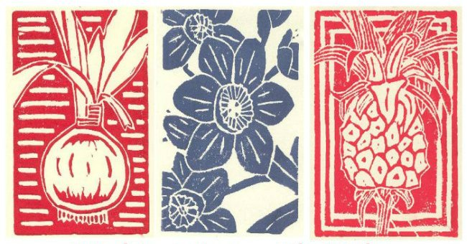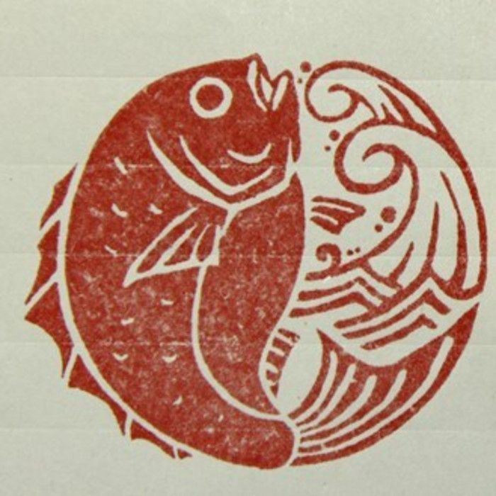  Literacy: Students can write a list of objects, hobbies, and activities that interest them in their sketchbook as part of the brainstorming process.  Numeracy: Students will use their stamps repeatedly and in a patterned sequence.  Vocabulary: printmaking, gouge, carve, brayer | 3 Classes - Sept 15 + 22 +29 | 1
Lesson 2 - Quilted self portrait: In this lesson, students will create stylized and thematic self portraits and attach them into a cohesive piece. This will allow students to explore their personal interests, observe their classmates interests, and see how they fit together as a group. Using pen, watercolor, their personal stamp, and scissors, they will create images of things they like, attach them together by theme, and work together to finish a single artwork. This will allow them to develop craft with basic tools, reflect on the intent and purpose in the design in others work, and envision how community effort can create a greater artwork than individual effort.  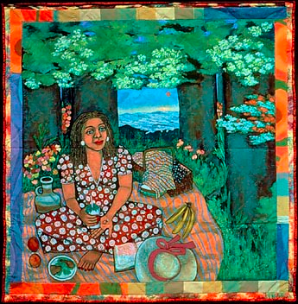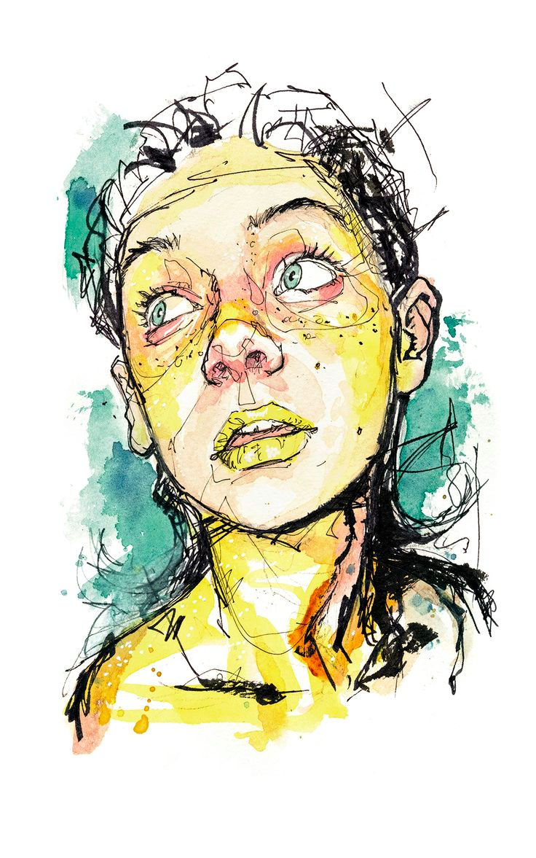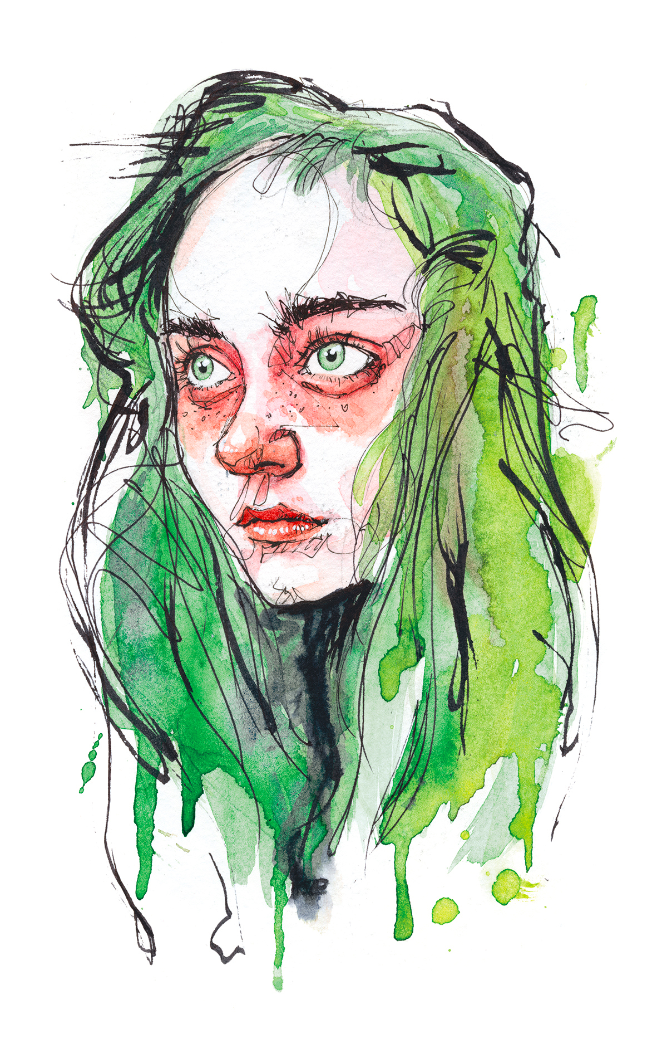  Artists: Faith Ringgold, Dominic Beyeler  Literacy: Students will be able to discuss how the collaged images in their portrait tell the story of their personal identity.  Numeracy: Students will organize each of their portraits into a grid, becoming aware of pattern and sequence in their composition. They will also learn how to measure and cut different sized squares and strips of wrapping paper to create the border of the quilt.  Vocabulary: Quilt, portrait, watercolor wash, collage | 3 Classes - Oct 6 + 13 + 27 | 2
Lesson 3 - Pipe cleaner Animal Zoo: In this project, the students will use pipecleaners to make animals for a “zoo”. These stylized animals will be an attempt to take a two dimensional design from their sketchbooks and create a three dimensional sculpture. This will cause them to think about the way that lines work in space, how three dimensional artworks require a different planning processes than two dimensional artworks, and how abstract representation can be identified.  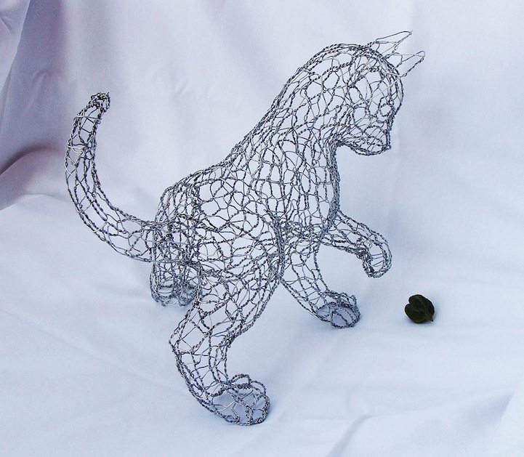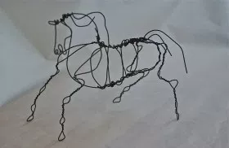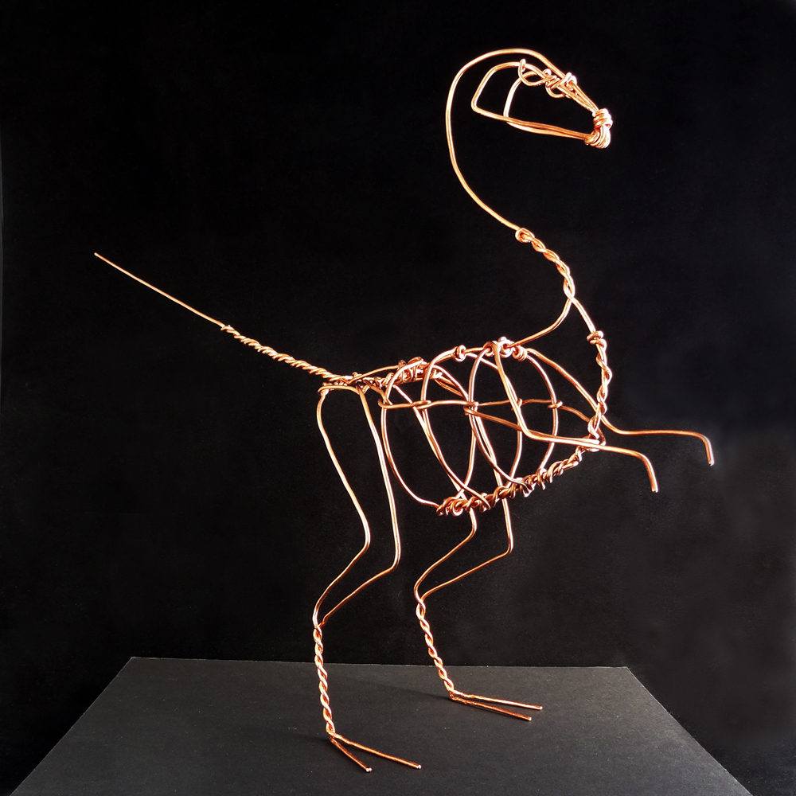  Artists: Calder, Asawa  Literacy: Students will be able to discuss their sculptures ideation, form, and interaction with their classmates sculptures.  Numeracy: working with proportions, scaling | 1 Class - Dec 1 | 3

Unit: Focusing Lens/Lenses: Timeless, Transferrable and Universal (I.E. Beliefs/Values, Identity, Relationships. Tension/Conflict, Freedom, Design, Aesthetic, Patterns, Origins, Transformation, Change, Influence, Collaboration, Intention, Play/Exploration, Synergy/Flow, Choices, Balance, Inspiration, System, Structure/Function, Reform) | Community  Identity | Unit: Prepared Graduate  Competencies | Comprehend - Analyze, interpret, and make meaning of art and design critically using oral and written discourse.  Reflect - Recognize, articulate, and implement critical thinking in the visual arts by synthesizing, evaluating, and analyzing visual information.  Create - Create works of art that articulate more sophisticated ideas, feelings, emotions, and points of view about art and design through an expanded use of media and technologies  Transfer - Identify, compare and justify that the visual arts are a way to acknowledge, exhibit and learn about the diversity of peoples, cultures and ideas.

Unit: Standards and Grade Level Expectations  (Unit must have all standards; NOT all GLEs.) | (Visual Arts Standard Name and appropriate GLEs for each standard)  Comprehend - Artists make choices that express intent and purpose in their art. ( I can talk about my choices and ideas that went into my art.)  Reflect - Artists, viewers, and patrons use the language of art to respond to the meaning of their own art and the art of others. ( I can tell others about the connections and details in my art and other people’s art. )  Create - Use symbols to identify and demonstrate characteristics and expressive features of art and design using basic media. (I can create art with meaning by using studio skills. )  Transfer - Works of art connect individual ideas to make meanings related to the community. (I can tell you about art in my community.)

Unit: Inquiry Questions  (Engaging-Debatable: In art, what does it mean when something is beautiful? How can something be so ugly it is beautiful?) | (3-5 “big” questions; pertinent to all lessons)  - How is an artist's identity conveyed in their art?  - Why would an artist collaborate with others to make art?  - How does the individual interpret art made by one person in comparison to art made by multiple people?

Unit Standards | Comprehend/Reflect/Create/Transfer

Unit: Concepts: Timeless, Transferrable and Universal (I.E. Composition, Patterns, Technique, Rhythm, Paradox, Influence, Style, Force, Culture, Space/Time/Energy, Line, Law/Rules, Value, Expressions, Emotions, Tradition, Symbol, Movement, Shape, Improvisation, Observation) | Intention  Collaboration  Identity  Symbol  Style

Enduring Understandings: My students will UNDERSTAND...  (Timeless, Transferrable and Universal. Shows a relationship between two or more concepts.) | Conceptual Guiding Questions | Factual Guiding Questions
Artists use symbols and stylistic choices to express their identity. | Why do artists use symbols to express identity? | What kinds of basic shapes are used in symbols?
Artists discuss and share their ideas with other people to make large-scale projects. | Why would artists work together to make big art projects? | What unit of measurement is used to record the size of large art pieces?
Artists practice and combine different materials in their sketchbook to take creative risks for their final project. | How do artists combine different art materials to express their identity? | What are examples of art materials?

Critical Content: My students will KNOW...  (NOT Timeless, Transferrable and Universal. Factual information in the unit [topics] that students must know.) |  | Key Skills: What my students will be able to DO...  (Timeless, Transferrable and Universal. What students will do AND be able to transfer to new learning experiences as a result of learning the unit.)
Students will know:  Lesson 1:  - How to use their sketchbooks to plan their stamp design and experiment with materials.  - How to carve into a stamp.  - How to ink a stamp using a brayer.  - How to press the stamp onto the paper to get a crisp print.  - How to arrange a pattern on paper by repeatedly printing with a stamp.  - How to use lists as a form of brainstorming for their final project.  Lesson 2:  - How to use their sketchbooks to plan their stamp design and experiment with materials.  - How to combine watercolor washes with pen and ink drawings to make a portrait.  - what the features of the face are.  - How artists like Faith Ringgold use quilted borders as an expressive element of the project.  - How to incorporate collaged and stamped images into their portrait.  - How mixed media images tell the story of their personal identity  Lesson 3:  - How to use their sketchbooks to plan their stamp design and experiment with materials.  - How to use sketch-noting to plan out the composition of the illustrated page.  - How an illustration tells a story without using words  - How to read their story aloud to another audience  - How to organize each page in a book for narrative structure and fluidity |  | Students will be able to:  - Create an effective plan before jumping into a final project.  - Present their work to a group of their peers.  - Compare and contrast different types of artistic styles.  - Collaborate with each other  - Order and sequence parts of a larger project so it reads fluidly
Vocabulary | Lesson 1: printmaking, gouge, carve, brayer  Lesson 2: Quilt, portrait, watercolor wash, collage  Lesson 3: book-binding, illustration. sketch-noting
Literacy Integration | Lesson 1: Students can write a list of objects, hobbies, and activities that interest them in their sketchbook as part of the brainstorming process.  Lesson 2: Students will be able to discuss how the collaged images in their portrait tell the story of their personal identity (visual literacy).  Lesson 3: Students will organize their images into a narrative structure. They will also read their story aloud to another audience.
Numeracy Integration | Lesson 1: Students will use their stamps repeatedly and in a patterned sequence.  Lesson 2: Students will organize each of their portraits into a grid, becoming aware of pattern and sequence in their composition. They will also learn how to measure and cut different sized squares and strips of wrapping paper to create the border of the quilt.  Lesson 3: Students will label their page numbers and understand what order each of the pages should be sequenced based on the illustrations on their pages.

