Checkpoint 1: Building the Jar

Step 1: Place a ruler across the clay and cut off the uneven edges (top and bottom) with a needle tool.

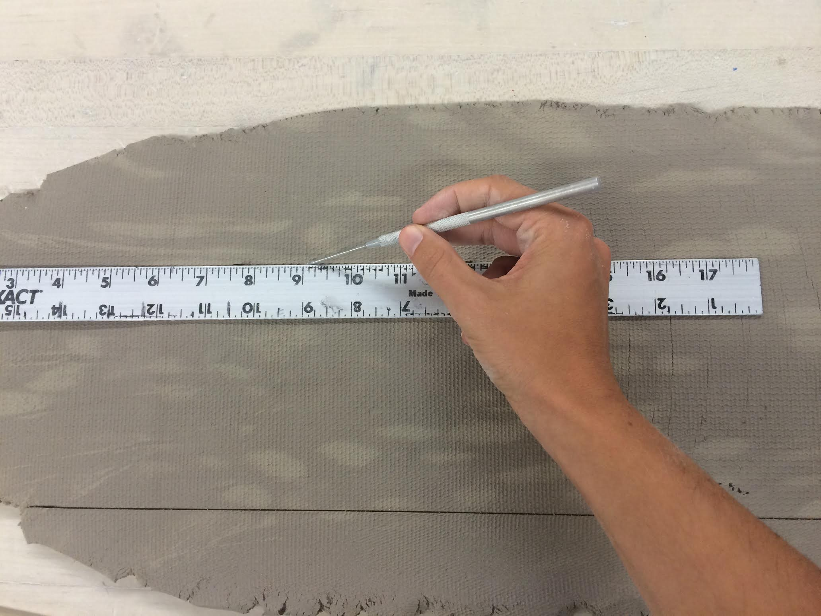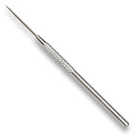

Step 2: Line up the ruler at the edge of the clay and cut off the uneven edges. Place all excess clay pieces in a tightly wrapped trash bag.
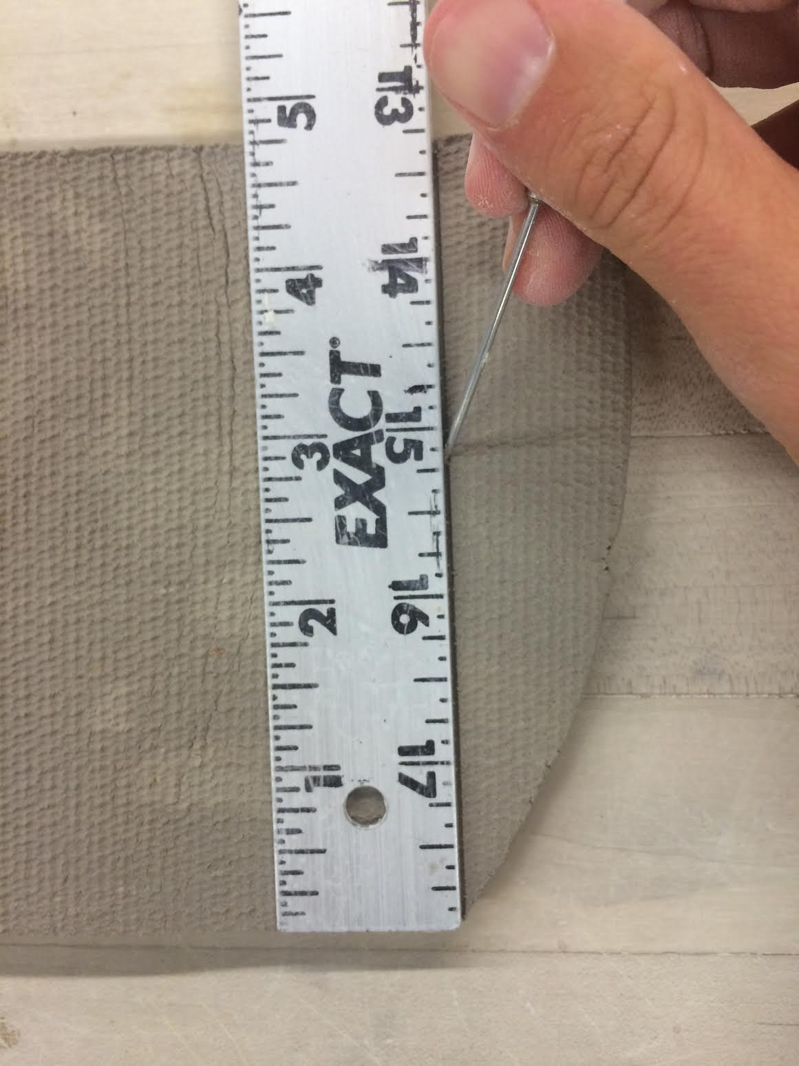

Step 3: Wrap two sheets of computer paper loosely around a glaze jar so the paper can be easily slipped off.

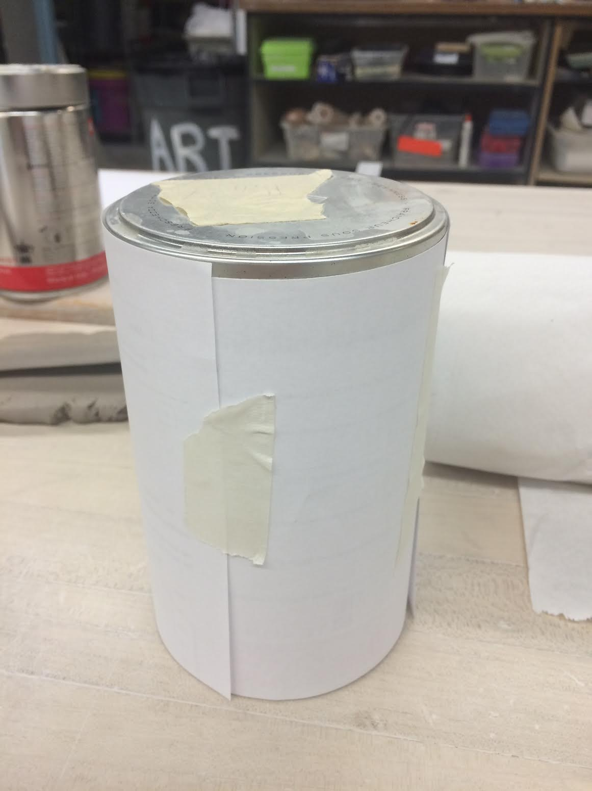

Step 4: Wrap the clay slab loosely around the clay. Mark where the edges meet on the clay wall with a needle tool. Lay the clay flat and cut the excess clay using the metal knife tool.

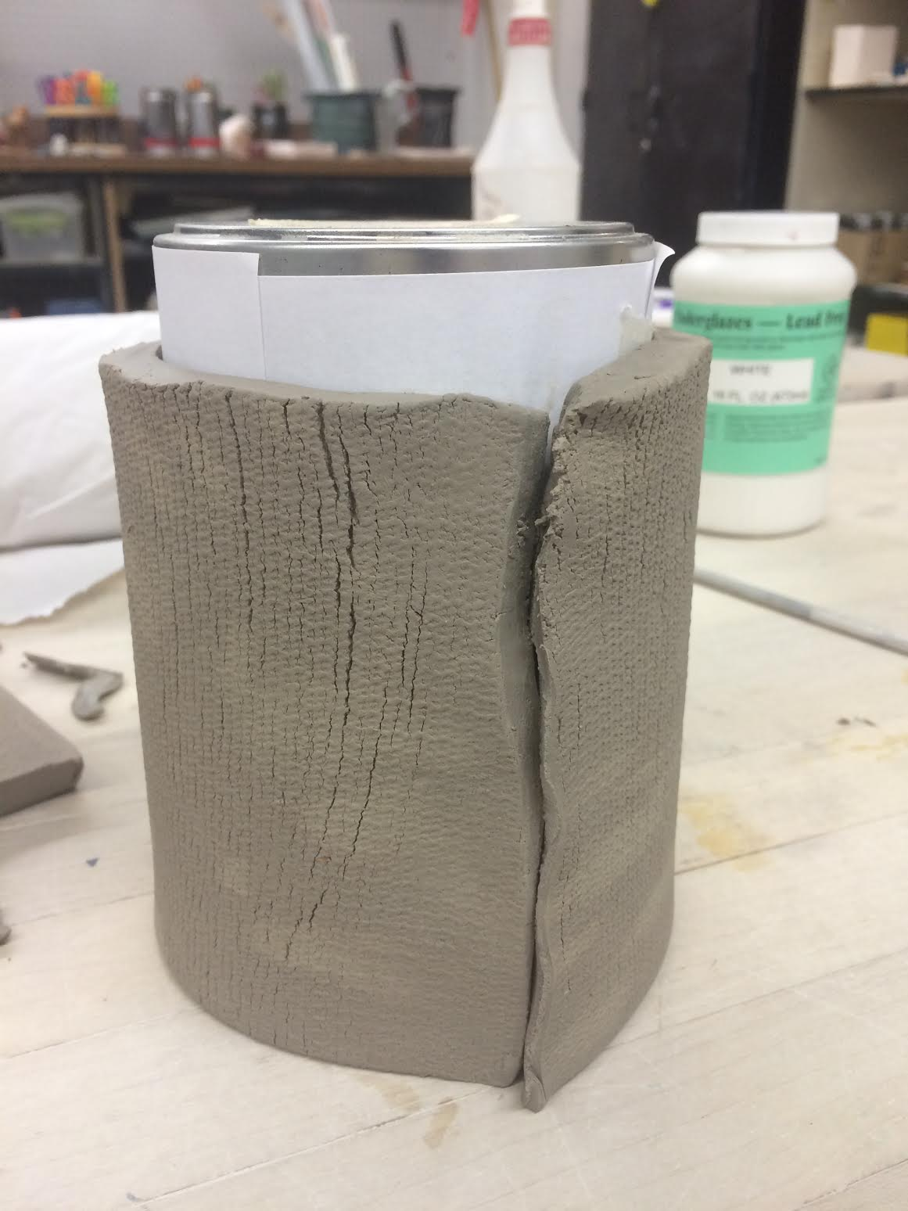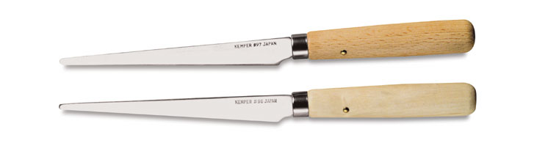

Step 5: Slip and score the edges of the clay.
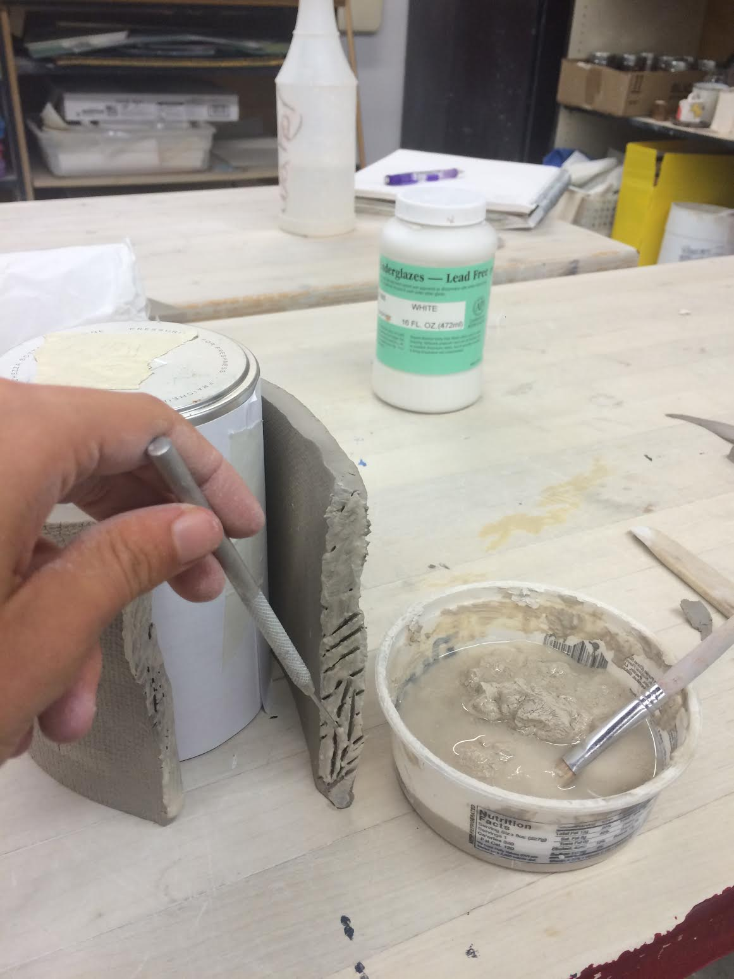

Step 6: Press the edges together against the jar and lightly smooth over with a metal or rubber rib.

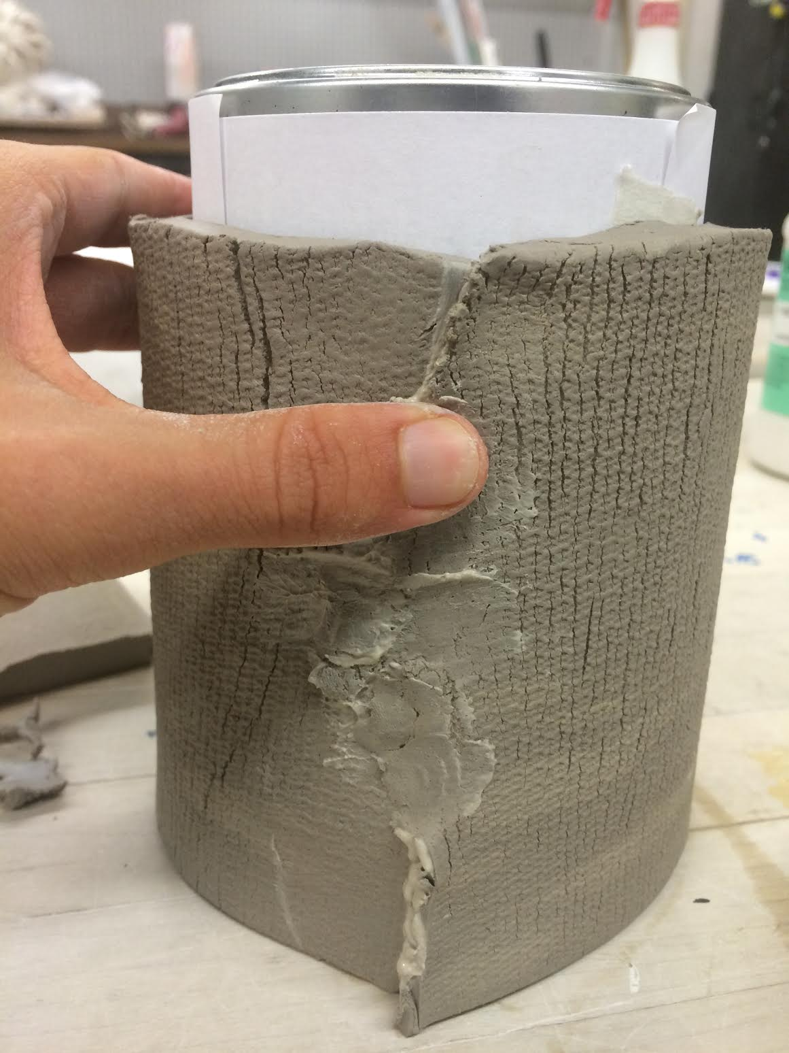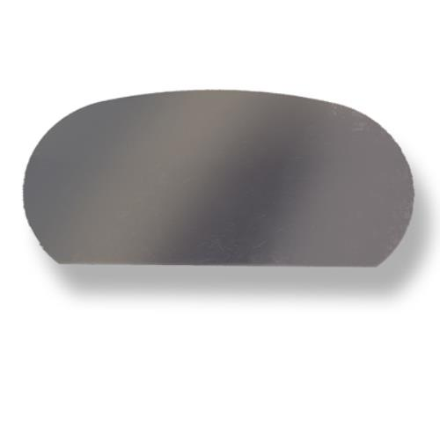

Step 7: Check to see if the clay is still holding its form against the jar. The walls should be straight, with no bends or curves.

Step 8: Knead the clay into a ball and bring it over to the rolling press. Roll the clay flat.
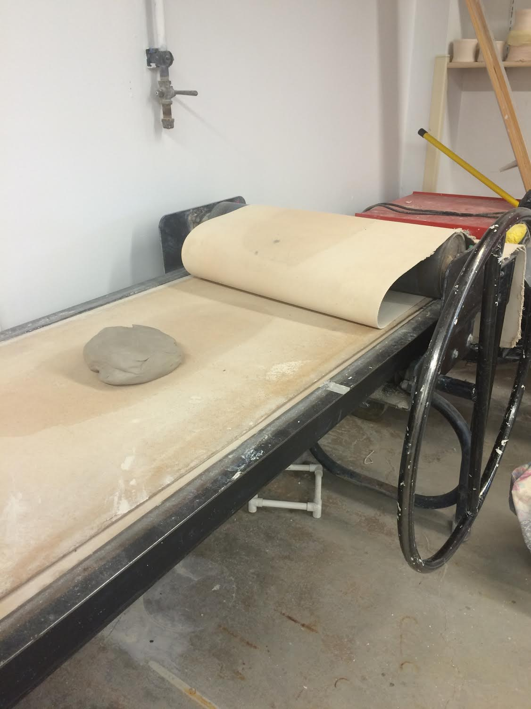

Step 10: Place the jar on top of the clay slab and trace a circle around the base using the needle tool. Cut the base out using a metal knife or a needle tool.
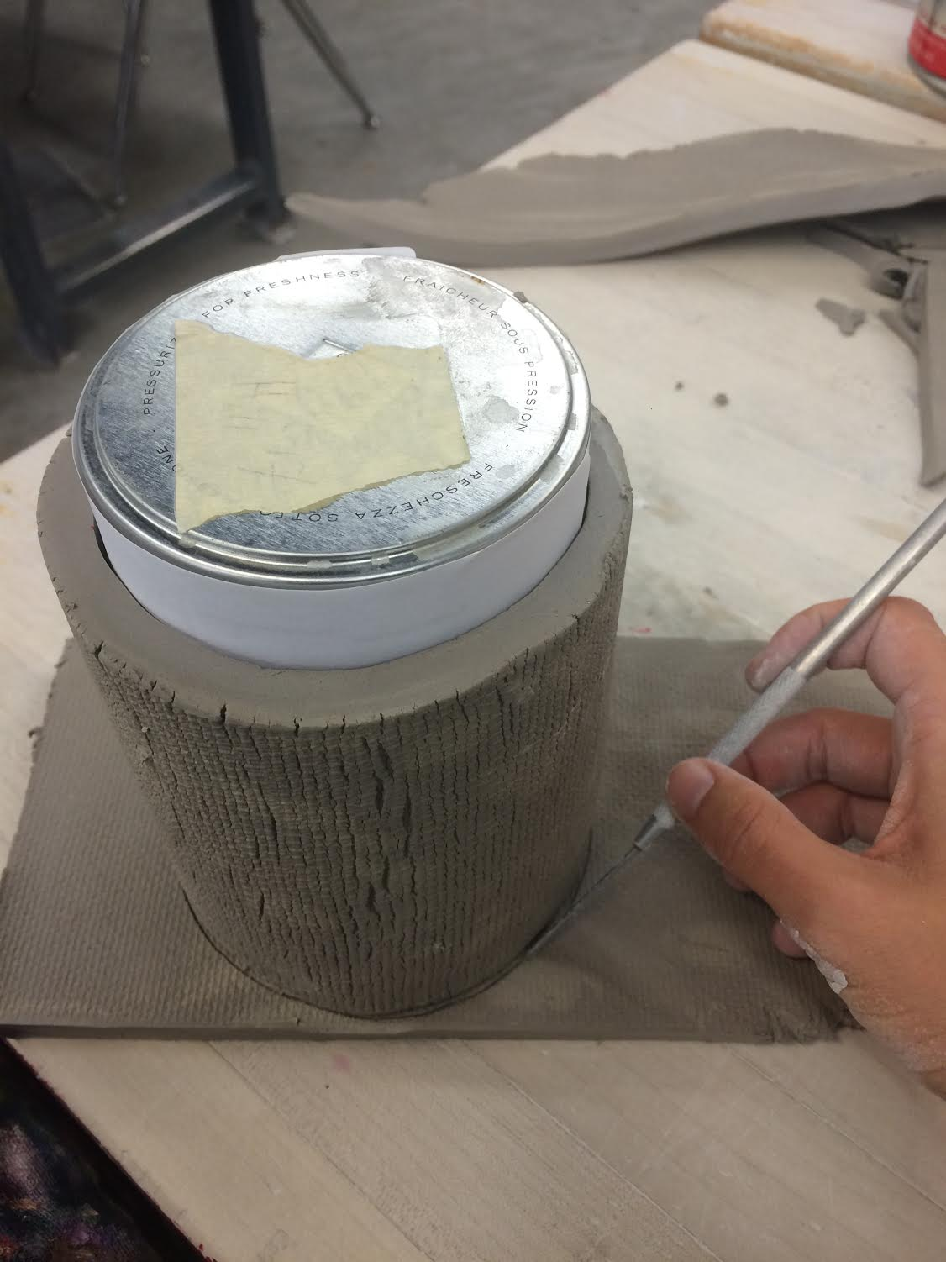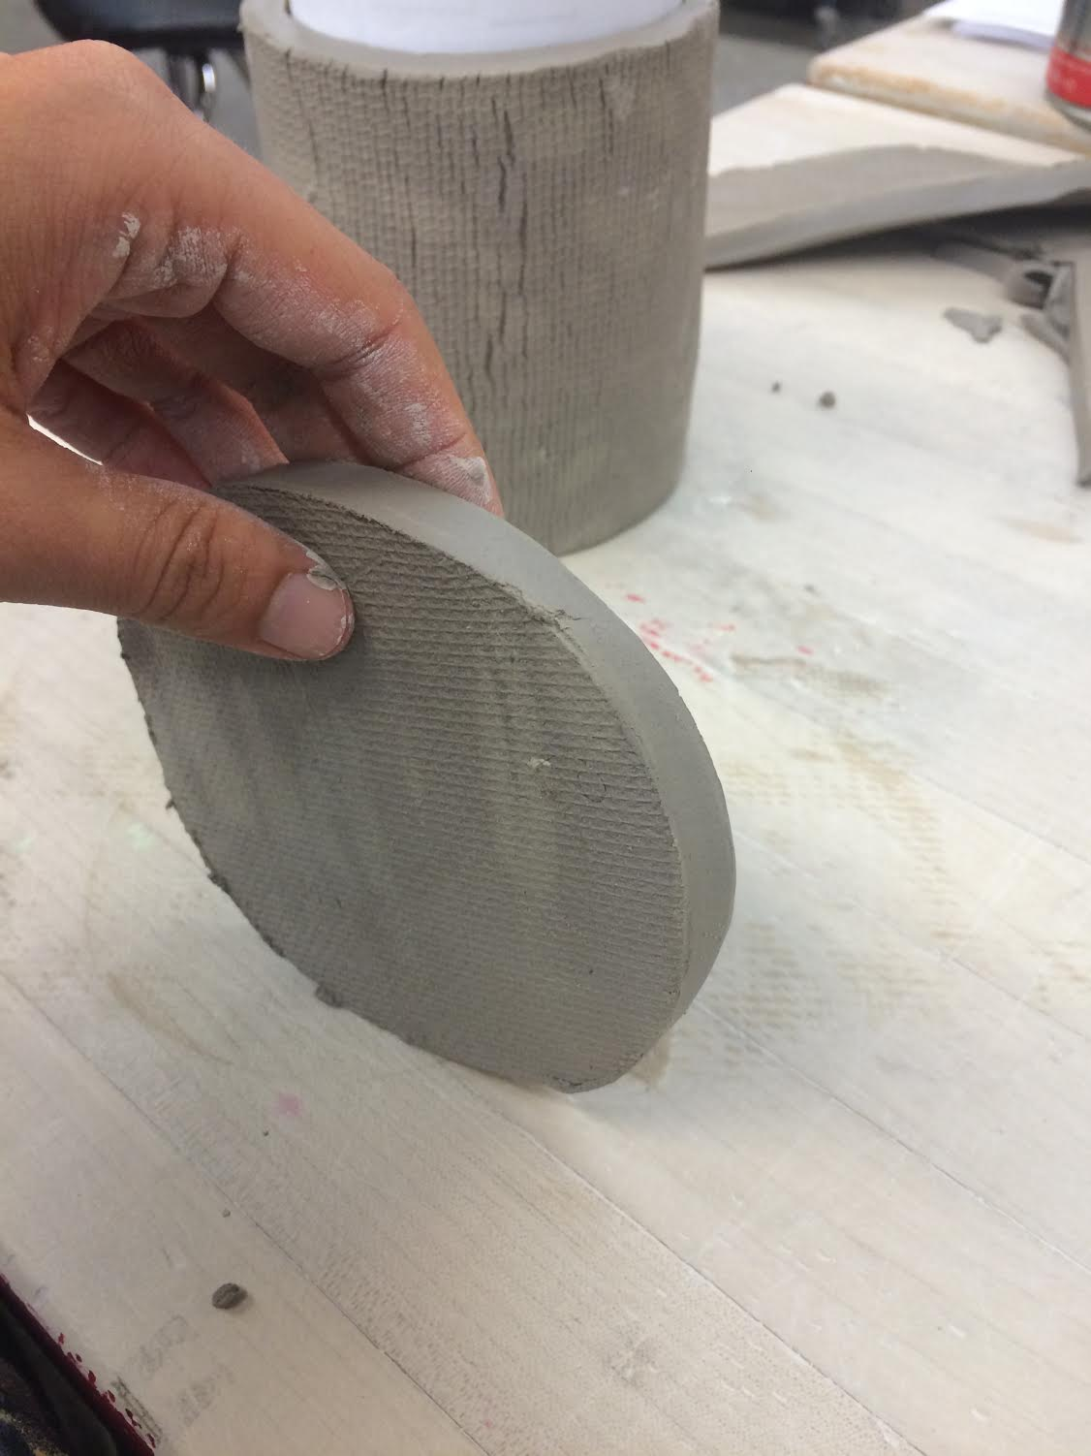

Step 11: Slip and score the bottom edge of the jar walls and the top of the base lid.

Step 12: Put the base lid onto the bottom of the jar. Smooth the edges with a metal rib up and across the seam. Roll the jar on its side across the table to smooth out uneven edges. Make sure that there isn’t any clay crumbs on the table.
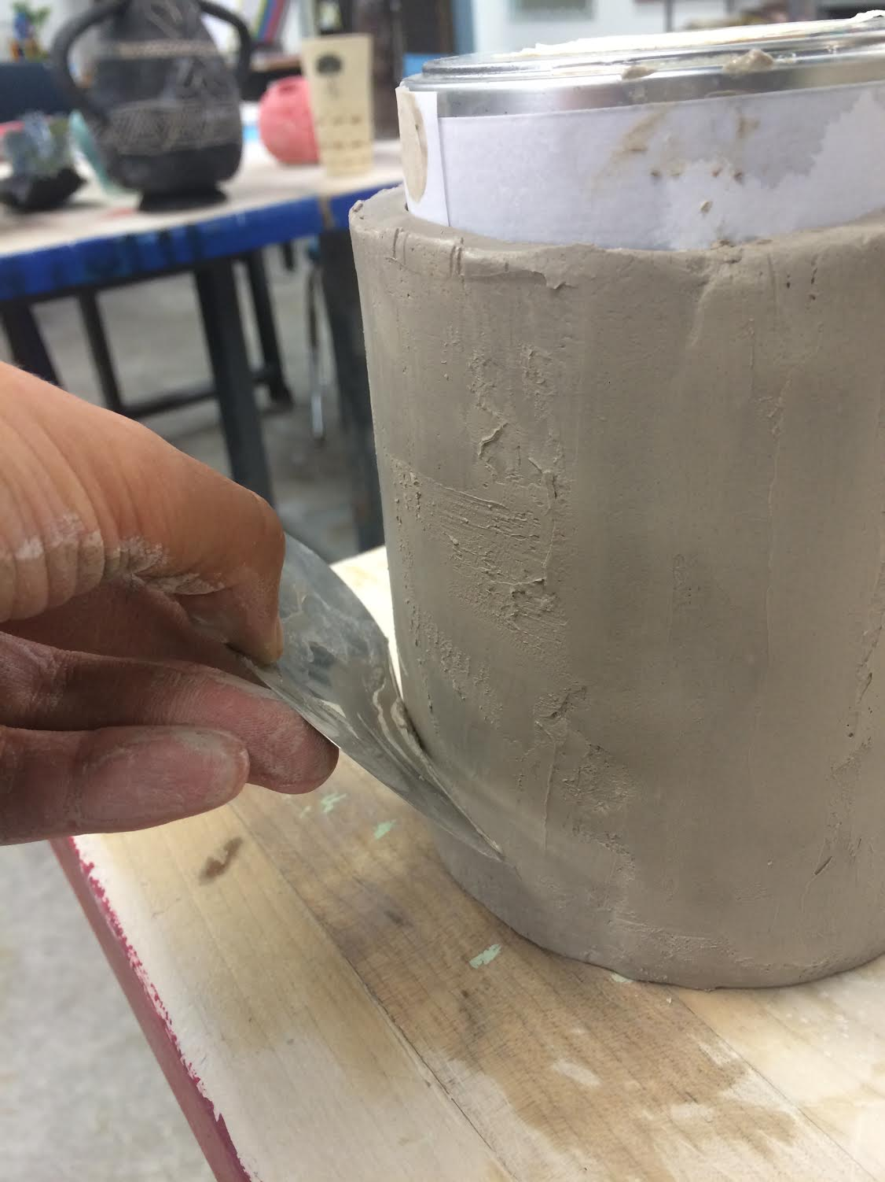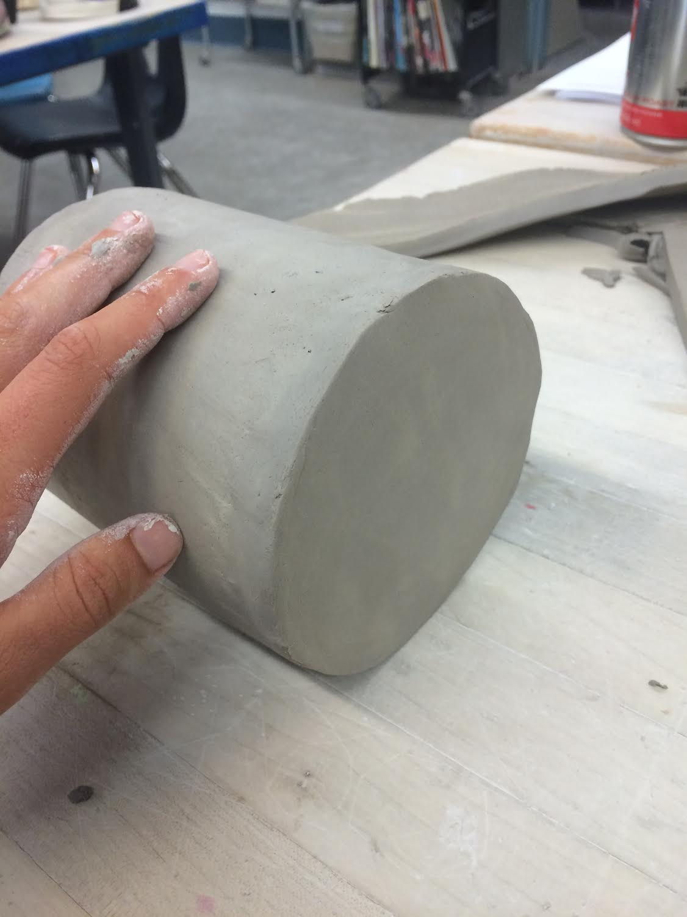

Step 13: Write your name in hieroglyphs on the name plate template. Trace the template on the clay wall. Write your hieroglyph name on the clay wall.

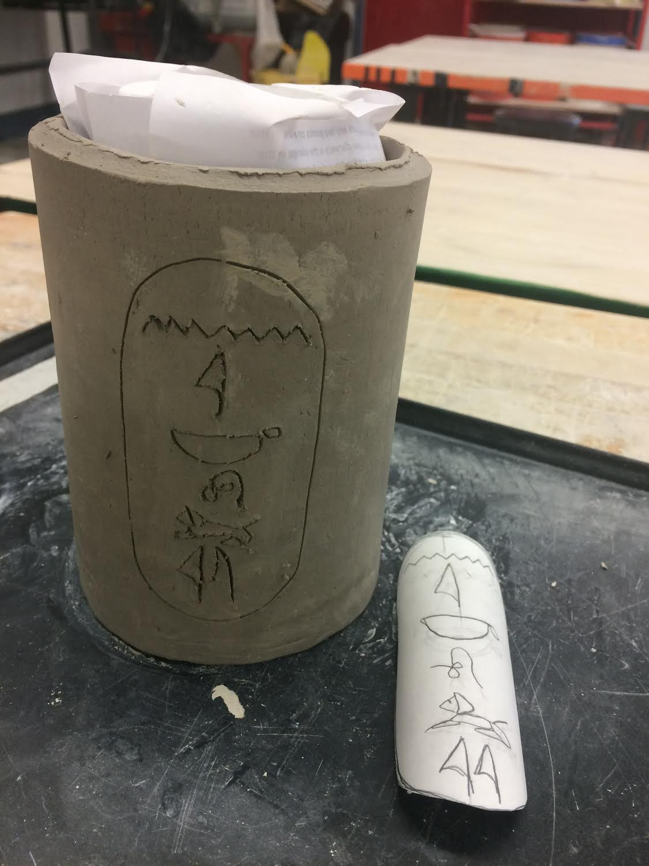

Step 14: If the jar has reached a leather hard state, remove the jar mold from inside. The form should be able to stand on its own without the walls bending.

Checkpoint 2: Building the animal head and mini-sculpture

Step 1: Throw clay rectangles onto the table multiple times to soften and “wake up” the clay. There should not be any tools or calavera projects on the table while doing this step.

Step 2: Draw the basic shape of your animal head. Mold the clay ball into the basic shape of your animal head or your mini-sculpture. Hold the shape above your jar to check size.

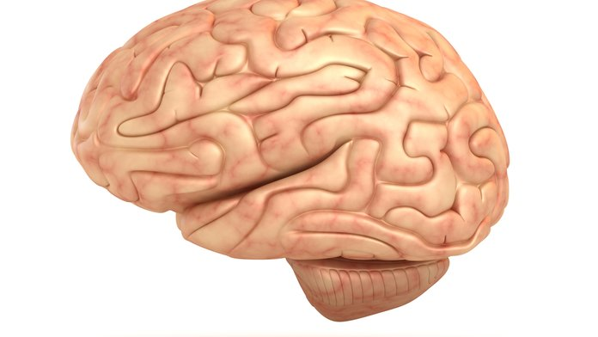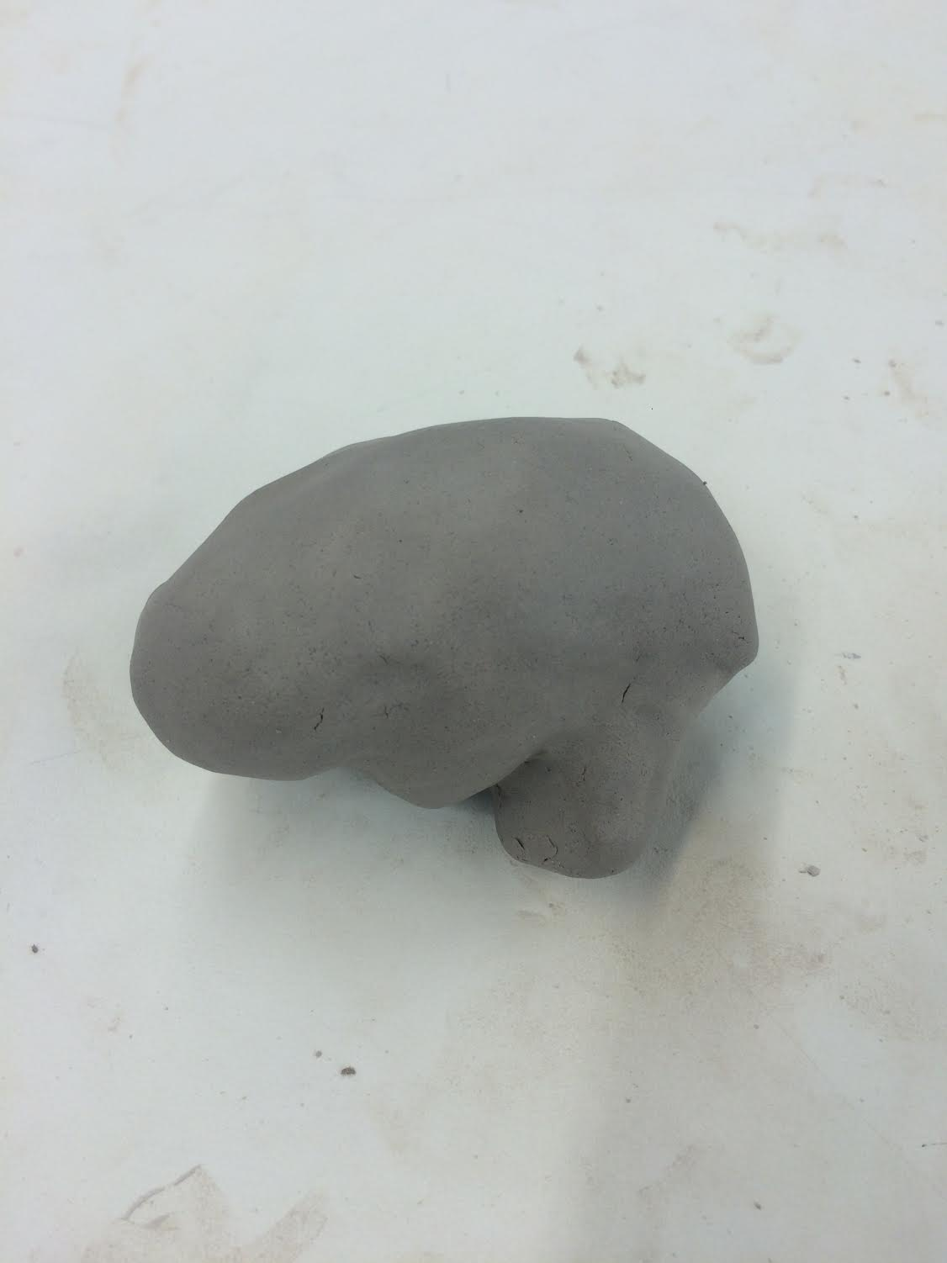

Step 3: Cut the form in half using the metal knife tool.

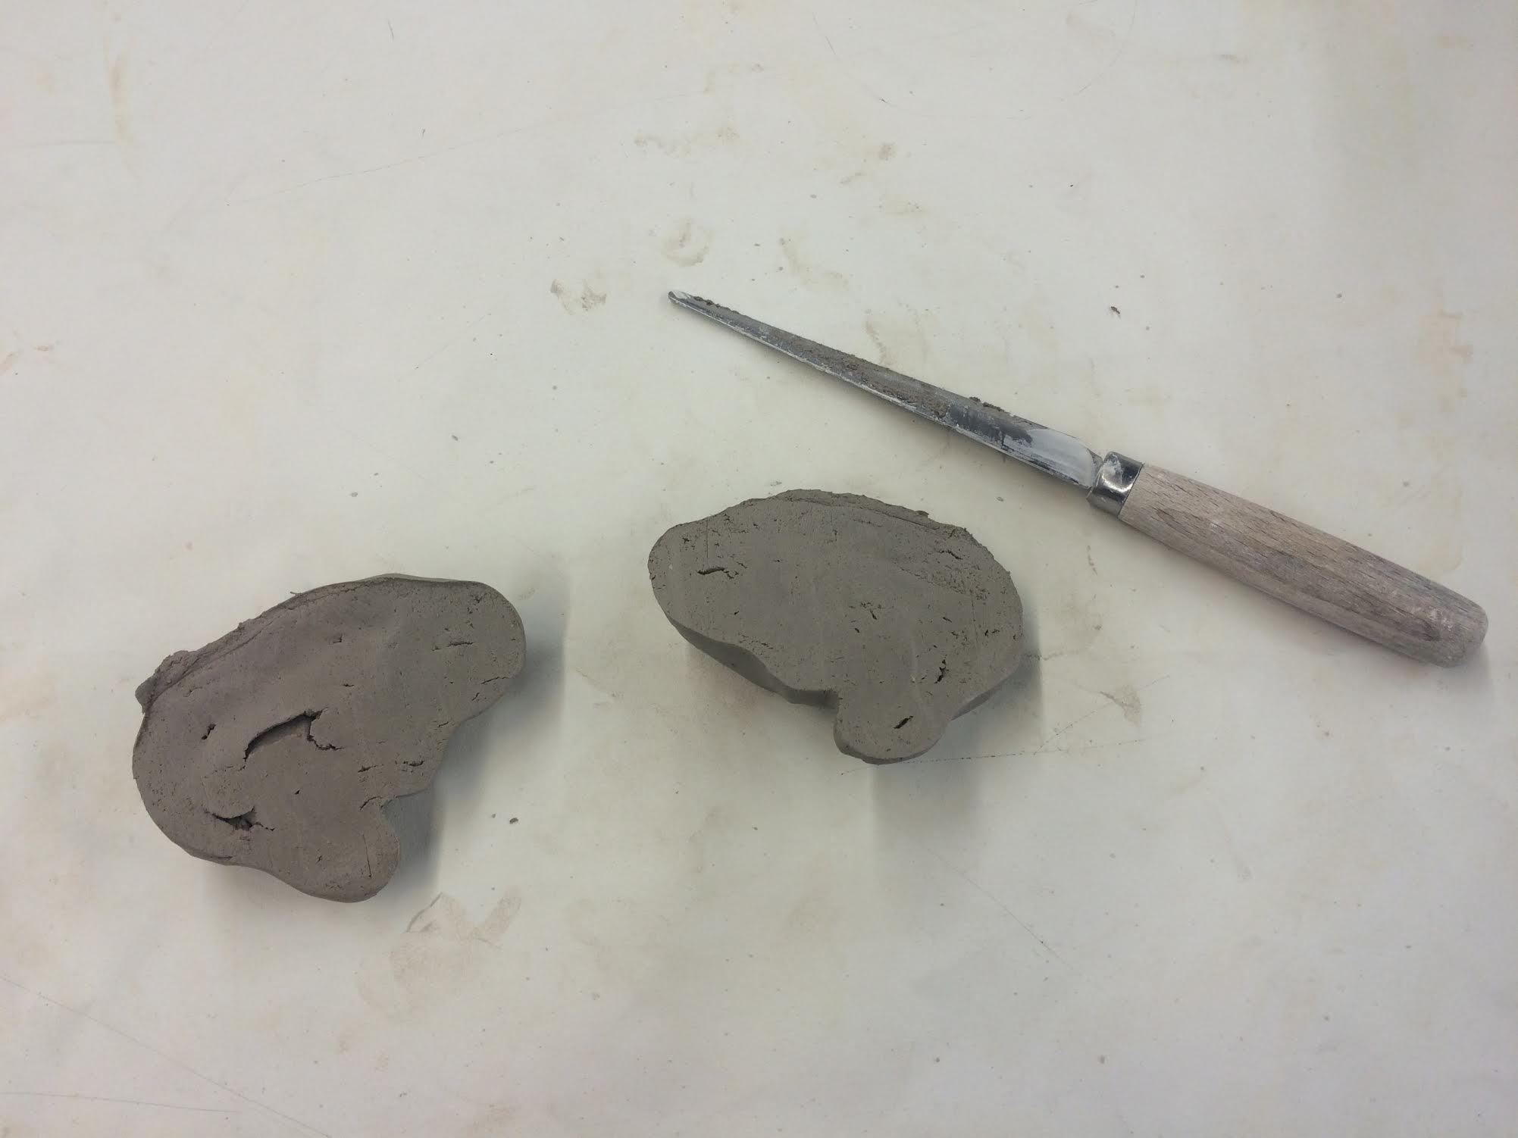

Step 5: Carefully scoop out the inside clay of both forms using the loop tool. The walls of your figure should be ¼” thick. Take breaks to check the thickness of the walls by pinching with your fingers.
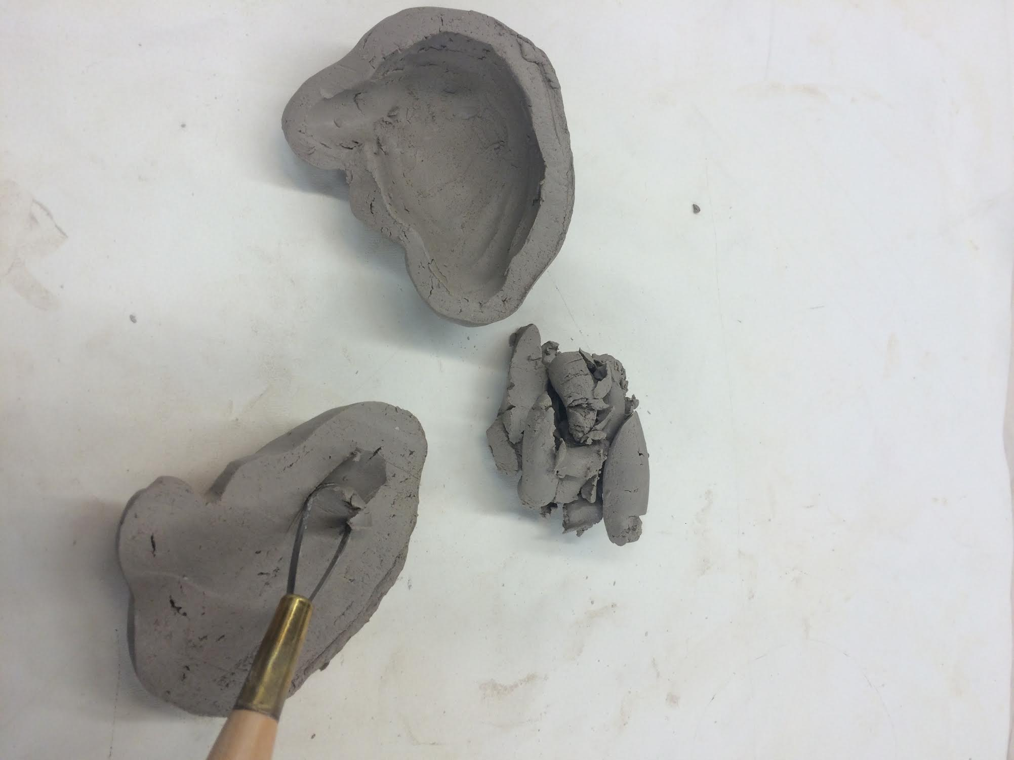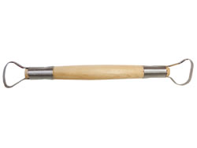

Step 6: Hold up both sides and line up the edges. Slip and score the sides and smooth the seam with a metal rib.
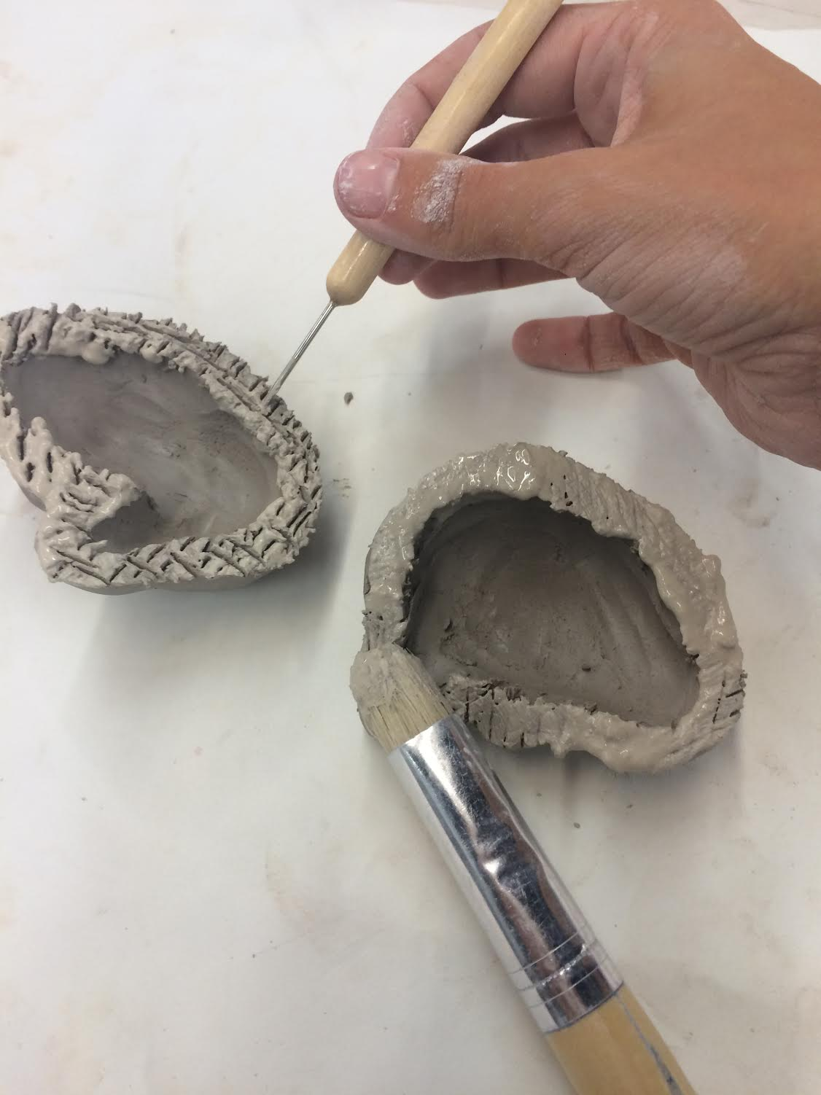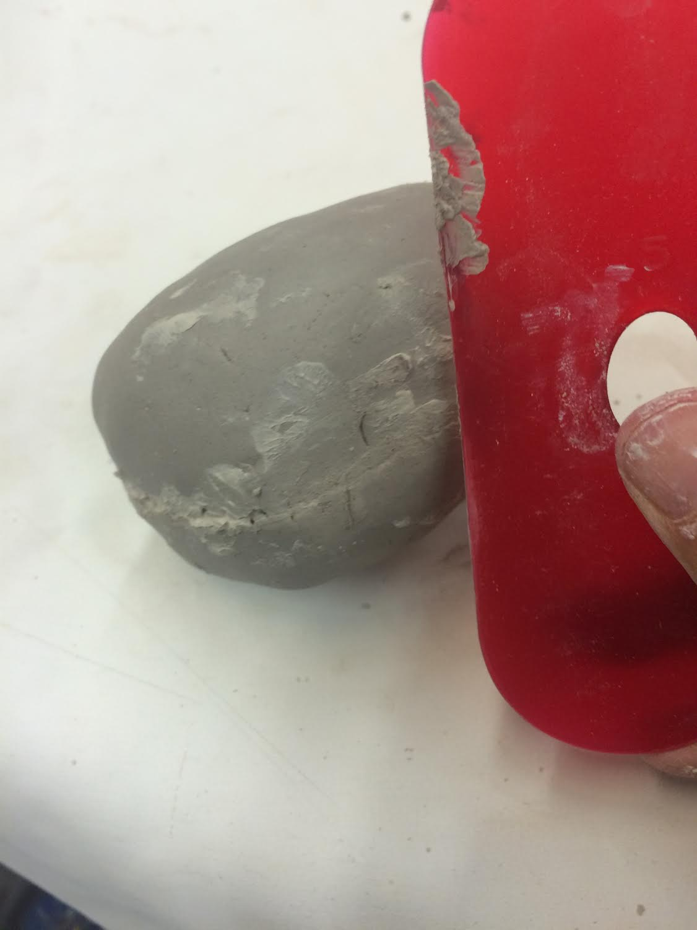

Step 7: Sculpt details of animal head or mini-sculpture. Make sure to use reference photos. Save all excess clay in a bag to be used later (for the lid).
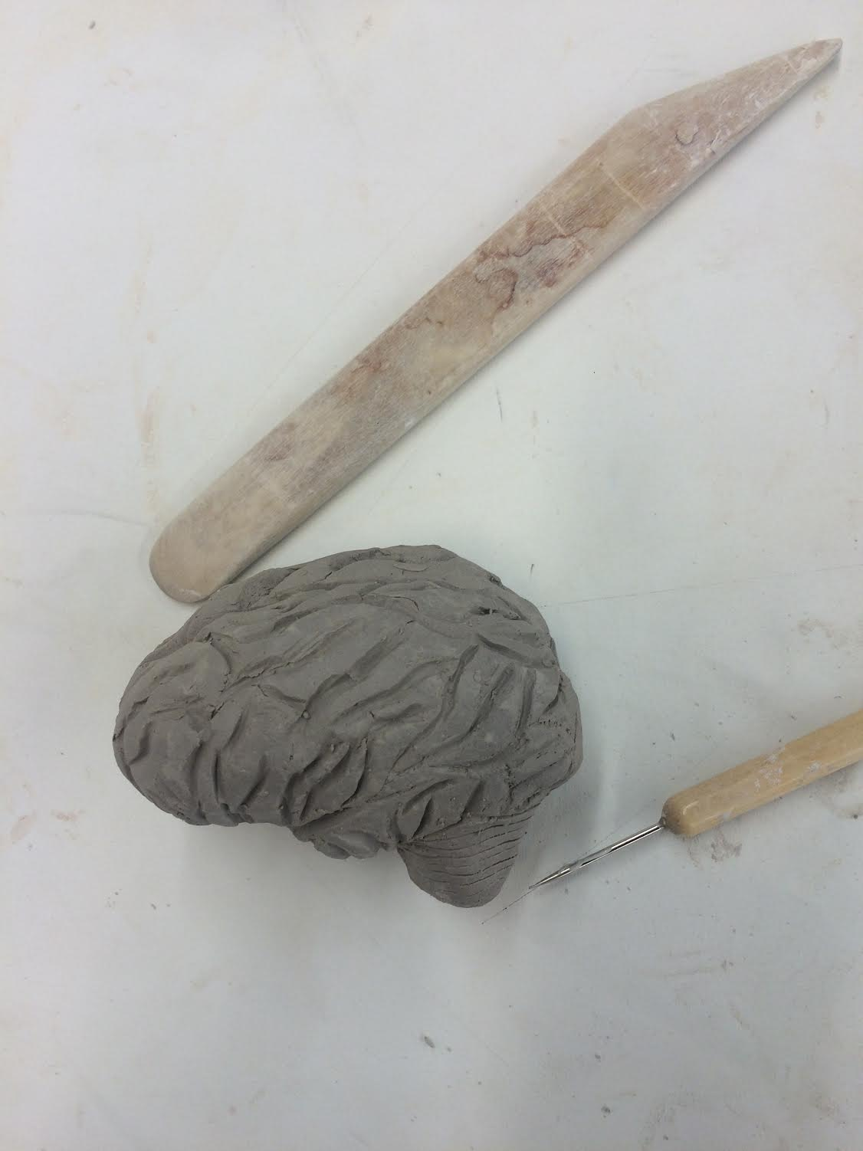

Checkpoint 3: The Lid

Step 1: Knead excess clay from animal head/mini-sculpture using the ram horn technique and flatten using the rolling press.

Step 2: Place the canopic jar on the clay pancake and trace a circle around the edge using the needle tool. Cut out using the metal knife tool.
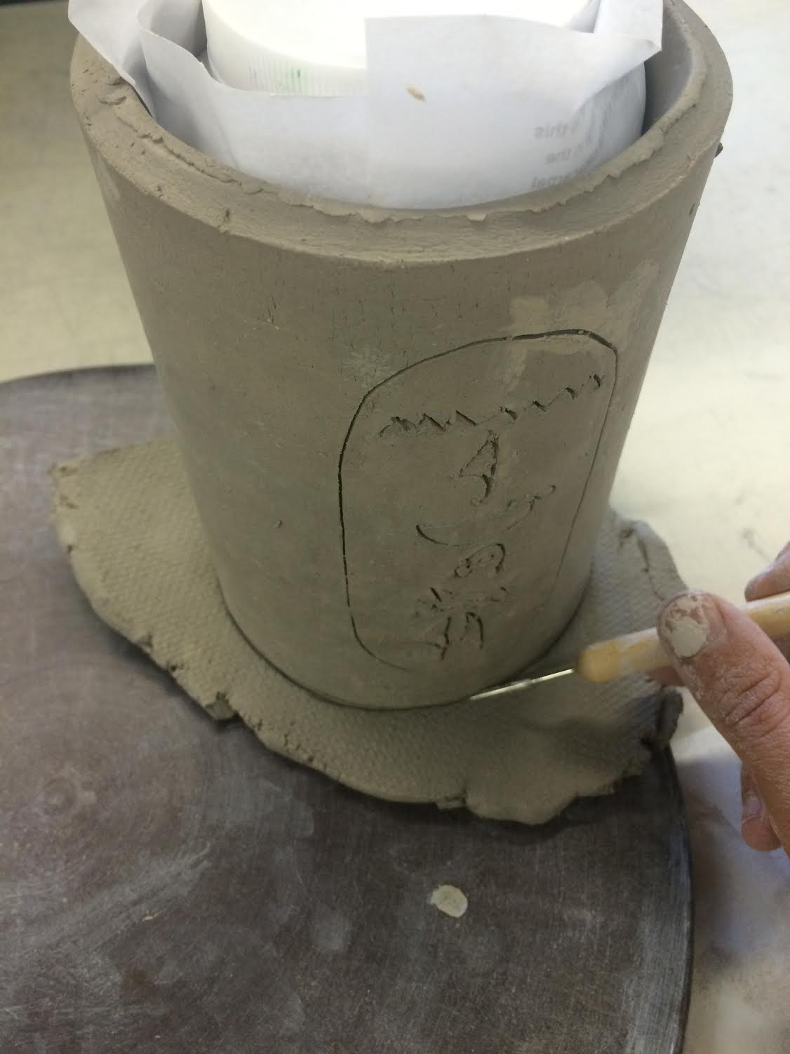
Step 3: Put slip on top edge of jar. Place lid on top of the jar and turn it. This should mark where the rim is.
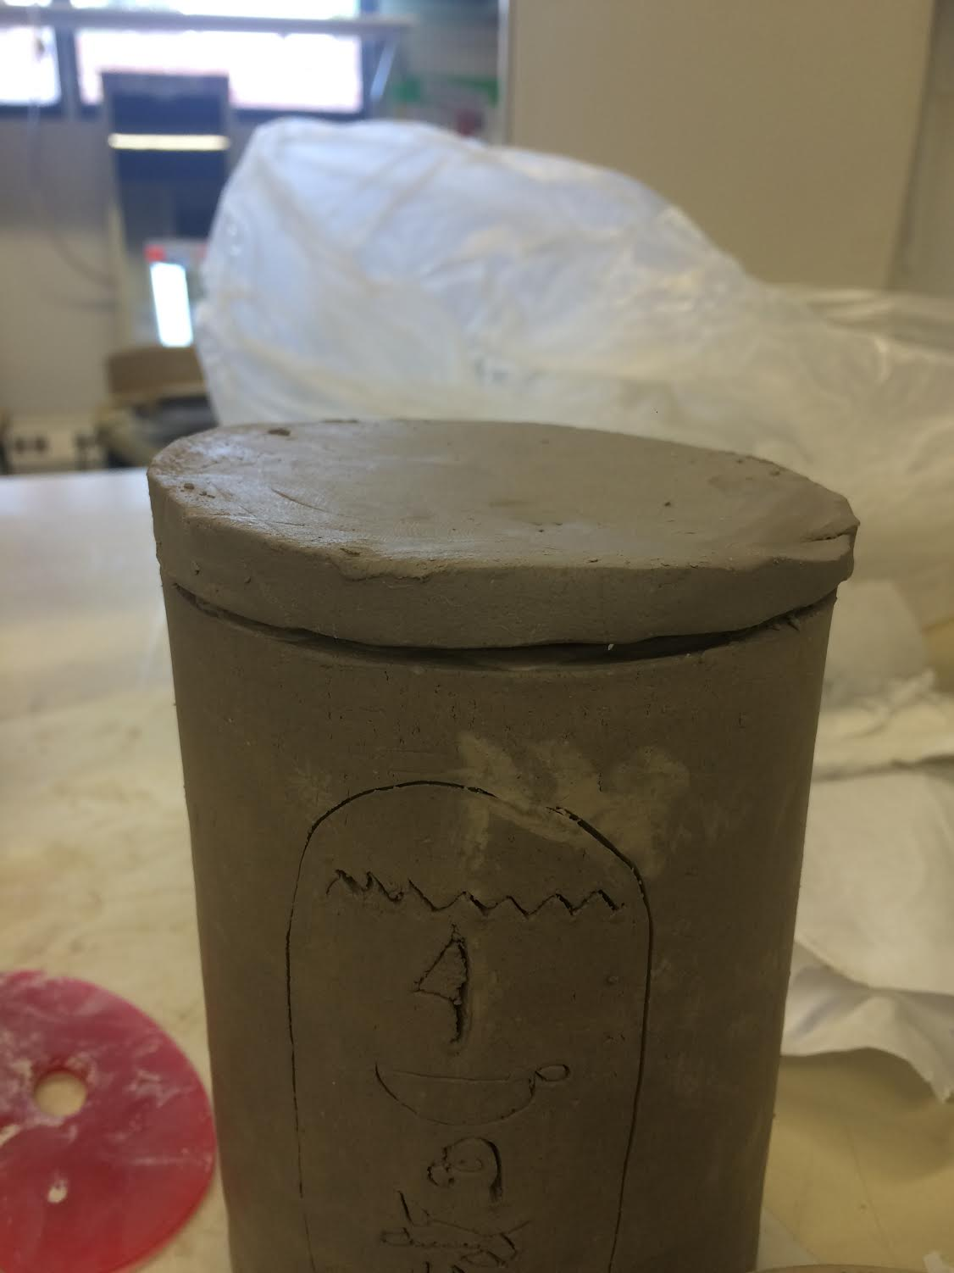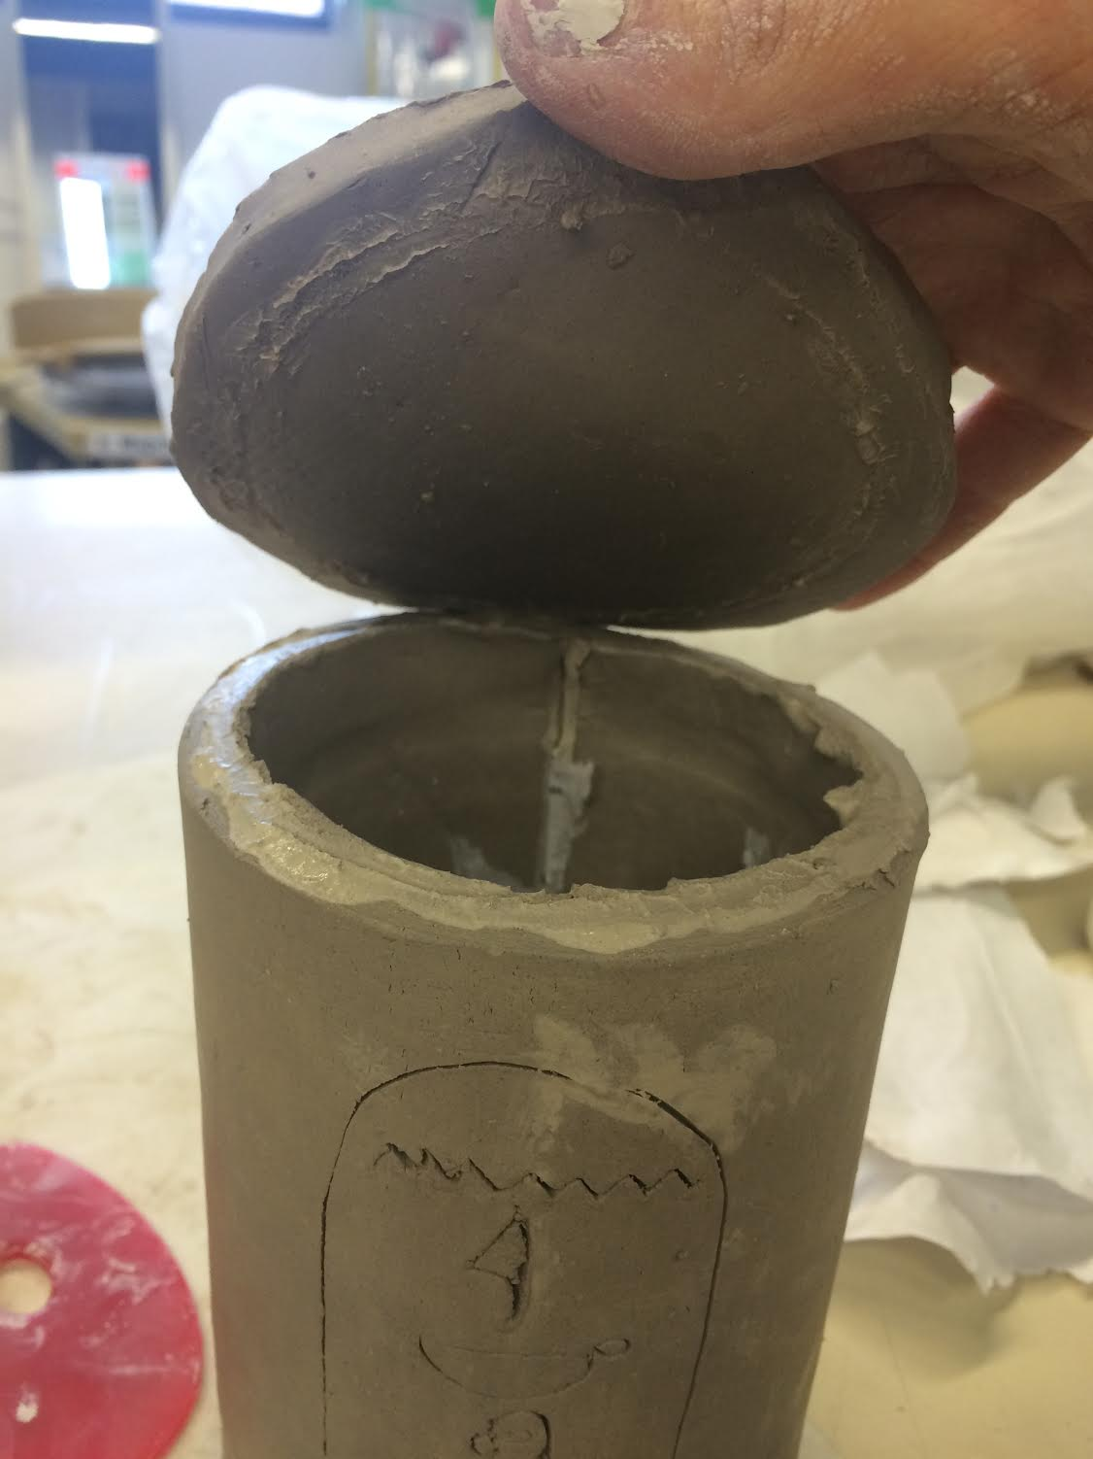

Step 4: Create a small coil and wrap it on the inside of the lid, next to the slip mark. Slip and score it onto the lid. Place the lid back onto the jar to see if the inside lip was placed correctly. The lid should not move.
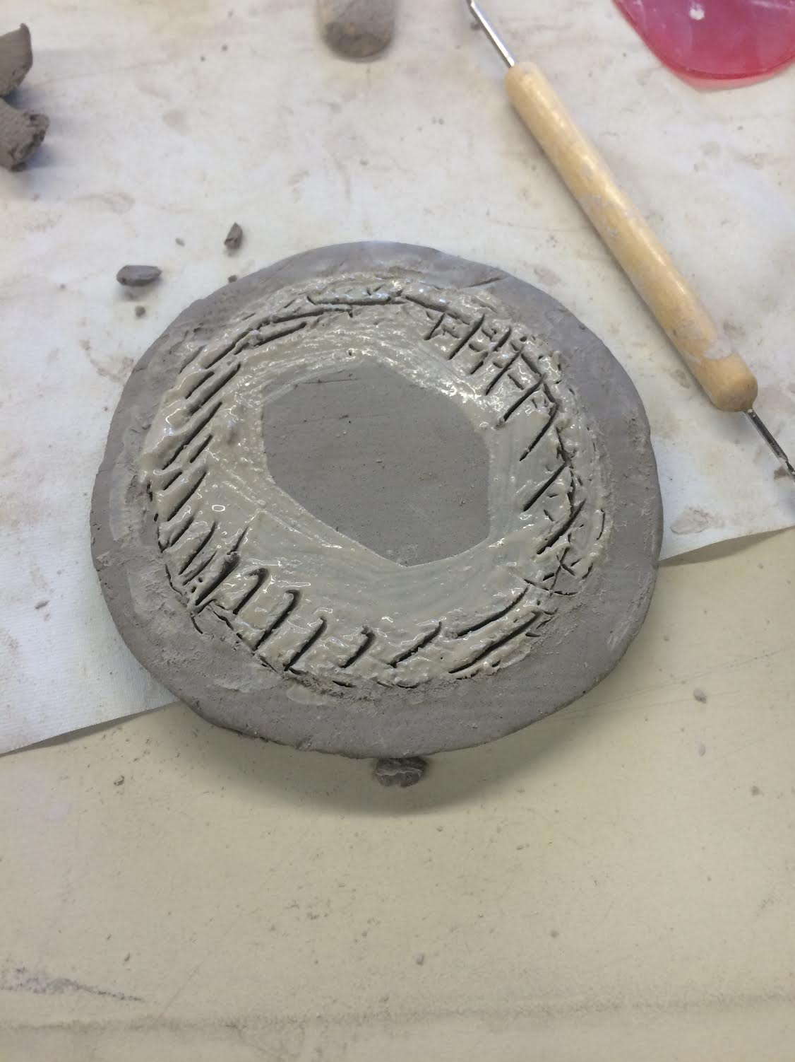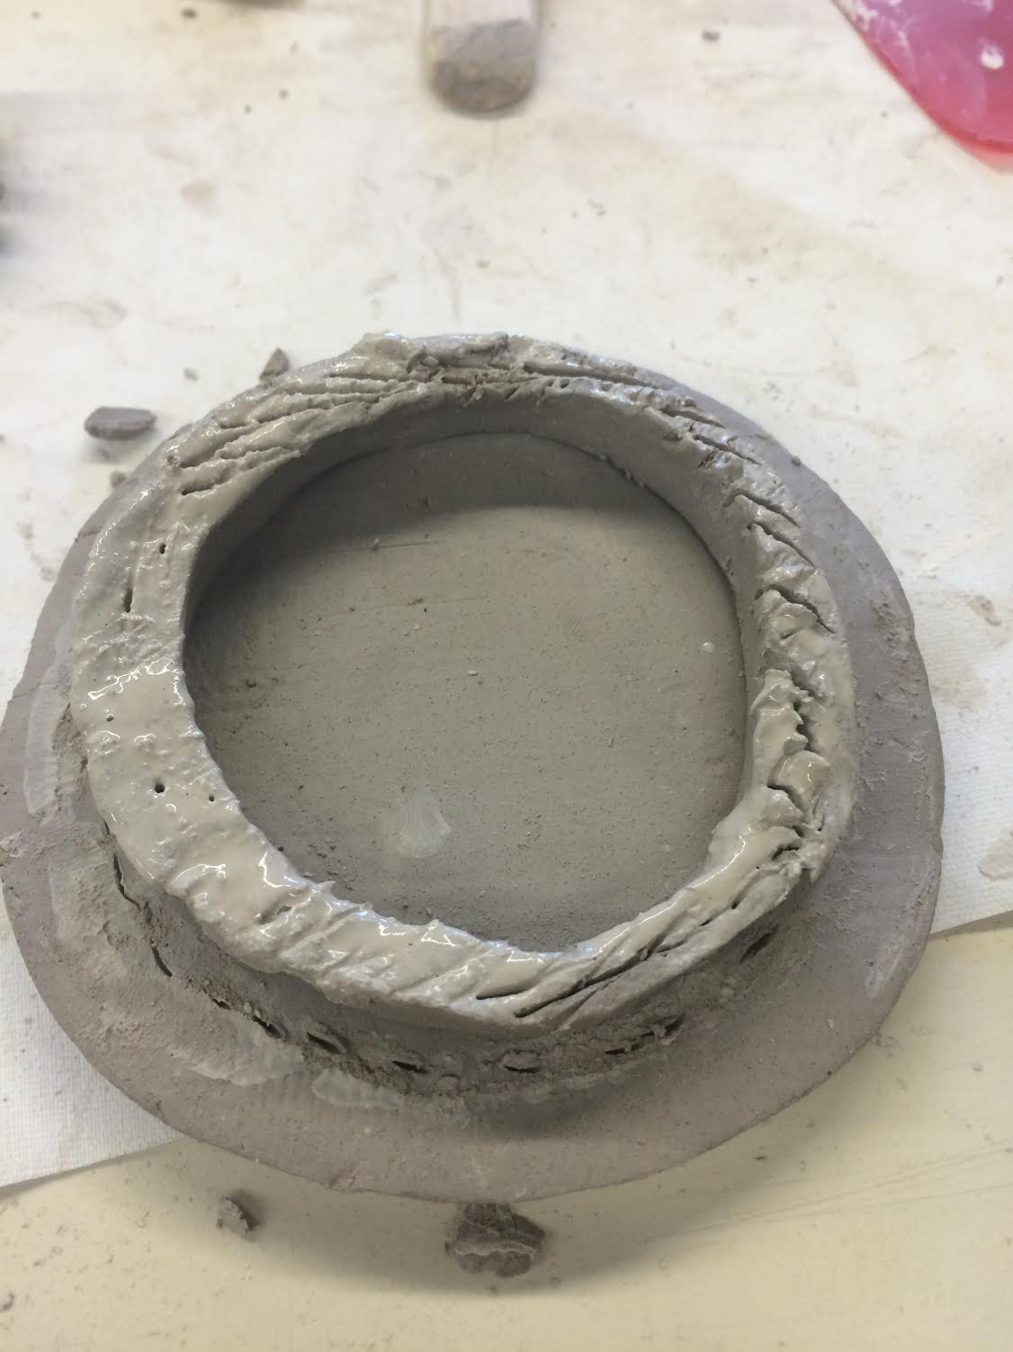
Step 5: Lay a piece of newspaper onto the top of the lid (flipped upside down) and trace a circle. Fold the newspaper into quarters and cut a circle that would be big enough to fit the rim. Once the newspaper fits snug on the rim, place the lid on top of the canopic jar.
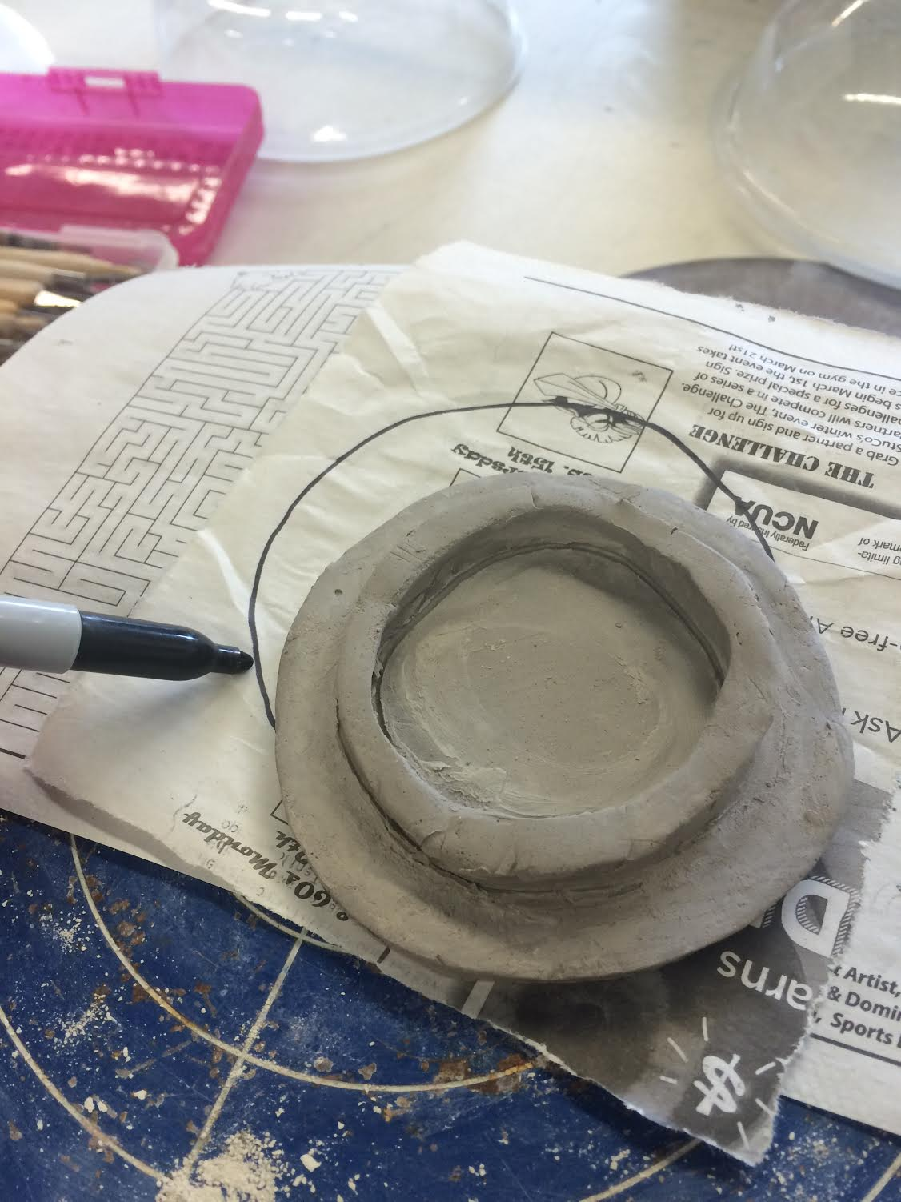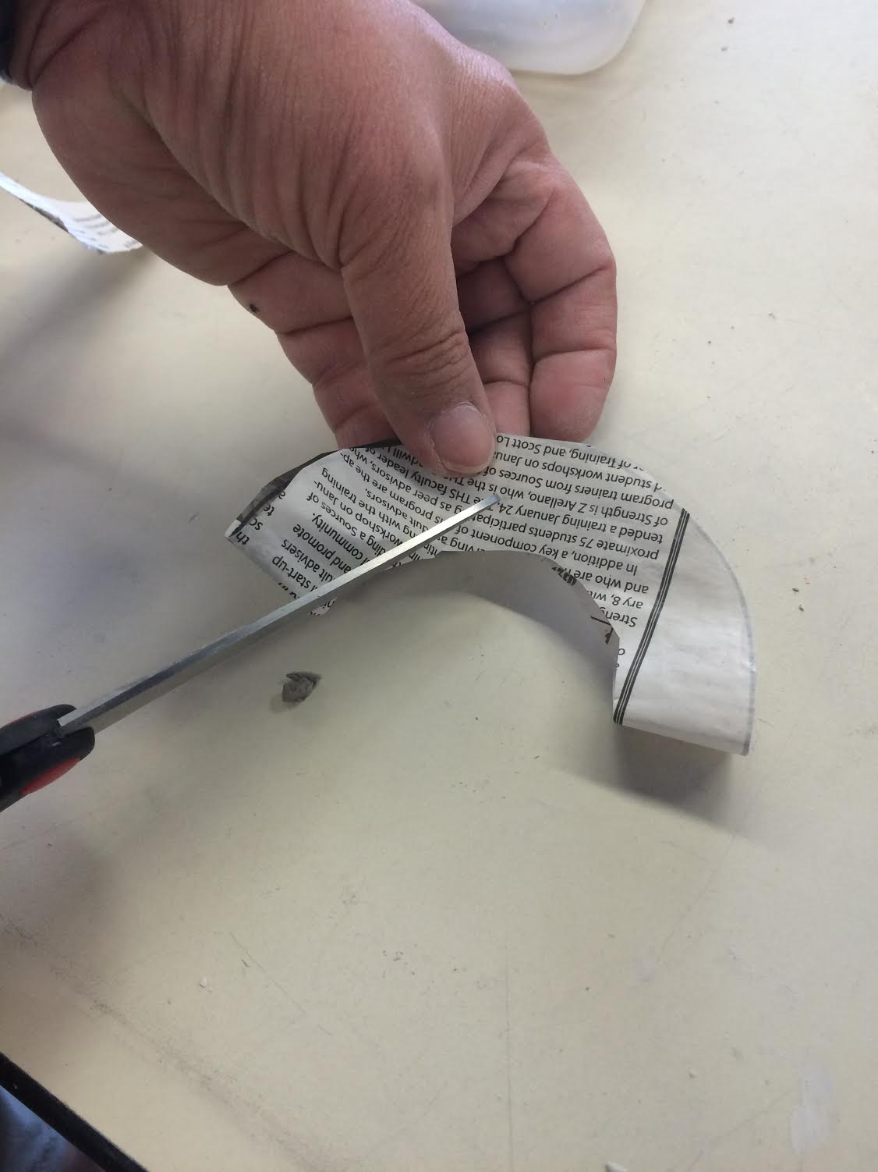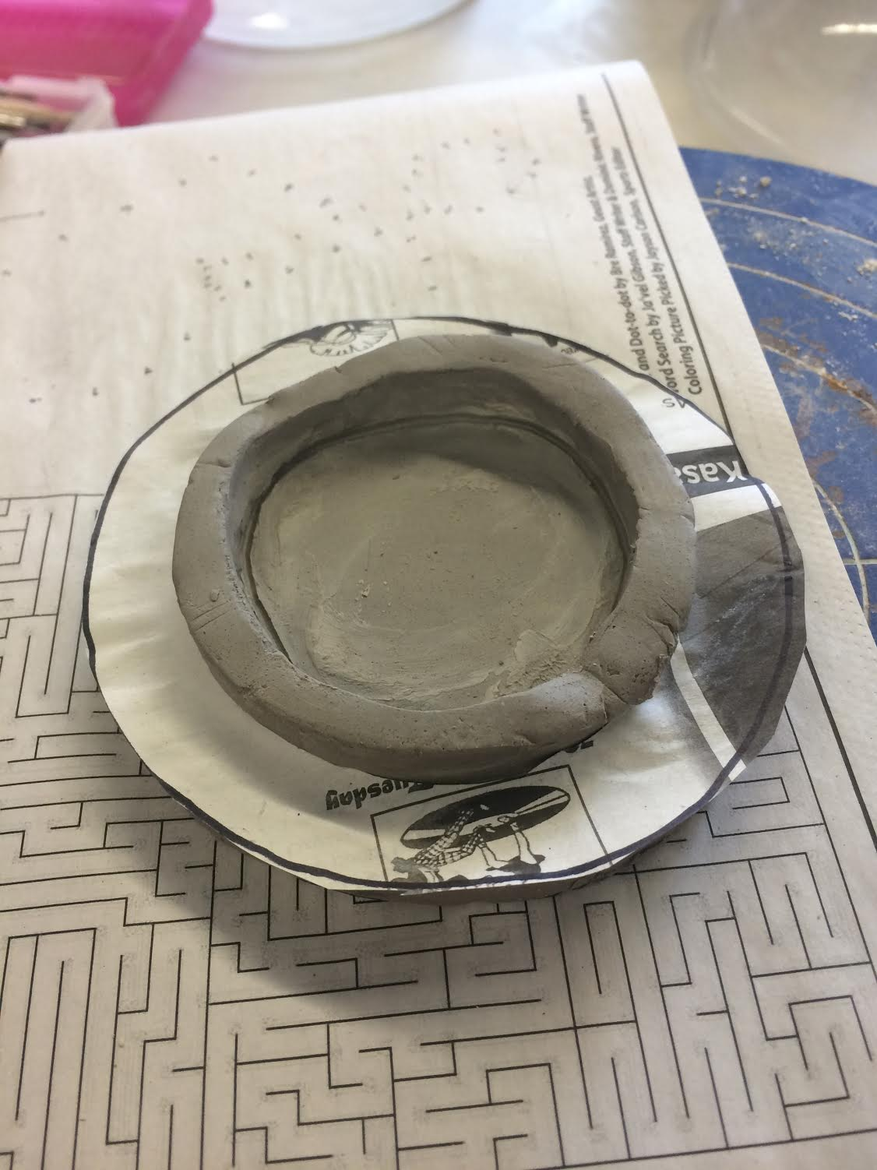

Step 6: Slip and score the base of the animal head form onto the lid. Poke two holes on the inside center of the lid to make sure air can get through.
