Lesson Plan Title: Making a Personal Stamp Length: 3 classes (Sept. 15, 22, and 29)

Note: Before you plan and write art experiences; pre-assess your students based on the proposed concepts, enduring understandings, and objectives of the unit/lesson(s). You may also gather this information from (previous) teachers, by reviewing already completed art work, consulting curriculum materials, etc., to get a better understanding of what content students already know and what they will need to know to be successful.

Pre-Assessment:
This will need to be done prior to teaching your lesson. Outline the method you will use to determine the skill/knowledge level of your students based on the concepts/enduring understandings/objectives of the lesson. (Hint: turn these into questions.) Be specific in describing what you would recognize as proficient skill/knowledge.
- What is a thumbnail sketch?
- How do you think you would carve into a stamp?
- How could you arrange more than one stamped image on your piece of paper?
- What is texture? Rhythm/repetition? Positive/negative space?
- How does an artist’s style represent his/her identity?

Performance:
What will students accomplish as a result of this lesson? This can be presented to students in the form of a story. In this narrative the students take on a role and create a learning product about a specific topic for a certain audience. (RAFT – Role / Audience / Format / Topic)P

- Role: Artist
- Audience: classmates and teachers
- Format: printmaking stamp
- Topic: Personal symbol

You the artist will create a stamp with an image that represents your personal identity to show your classmates and teachers.

Concepts:
List the big ideas students will be introduced to in the lesson. These ideas are universal, timeless and transferrable. Examples of concepts used in art might include: Composition, Patterns, Technique, Rhythm, Paradox, Influence, Style, Force, Culture, Space/Time/Energy, Line, Law/Rules, Value, Expressions, Emotions, Tradition, Symbol, Movement, Shape, Improvisation, and Observation Look for concepts in the standards, content specific curriculum, etc.
Composition
Symbol
Repetition/Reproduction
Style

Enduring Understanding (s):
Enduring Understandings show a relationship between two or more concepts; connected with an active verb. The best enduring understandings not only link two or more concepts; but demonstrate why this relationship is important. Like concepts, they are timeless, transferrable and universal.
Artists use symbols and stylistic choices to express their identity.
- What kinds of symbols do artists use to express identity?
- What kinds of basic shapes are used in symbols?

Artists practice and combine different materials in their sketchbook to take creative risks for their final project.
- How can artists combine different art materials?
- What are examples of art materials?

Standards: (All lessons should address all standards.)
1. Observe and Learn to Comprehend
2. Envision and Critique to Reflect
3. Invent and Discover to Create
4. Relate and Connect to Transfer

Objectives/Outcomes/Learning Targets:
Objectives describe a learning experience with a condition → behavior (measurable) → criterion. Aligned to: Bloom’s – Standards – GLEs - Art learning and, when appropriate, Numeracy, Literacy and Technology. Should be written as: Objective. (Bloom’s: _____ - Standard: _____ - GLE: _____ -Art learning: _____ -Numeracy, Literacy, and/or Technology)
- After seeing examples of professional Printmakers work, students will be able to draw three thumbnail sketches in a space the same size as their stamps showing a logo that best represents them in their sketchbooks
  - Bloom’s Taxonomy: Create
  - Standard: Reflect
  - GLE: 2. Artists, viewers, and patrons make connections among the characteristics, expressive features, and purposes of art and design.
  - Art Learning: artists and culture, ideation
  - Literacy: Students can write a list of objects, hobbies, and activities that interest them in their sketchbook as part of the brainstorming process.
- Given a demonstration of relief carving techniques and printing reproduction, students will be able to use these processes to experiment with mark making, inking techniques and layering using rubber stamps on paper
  - Bloom’s Taxonomy: Analyze
  - Standard: Create
  - GLE: 2. Demonstrate basic studio skills with confidence to create meaningful art.
  - Art Learning: tools and techniques
  - Vocabulary (literacy): printmaking, gouge, carve, brayer
- Given the demonstration on materials and techniques, students will be able to identify texture, rhythm/repetition, inking techniques and positive and negative space in their stamps and final designs
  - Bloom’s Taxonomy: Understand
  - Standard: Comprehend
  - GLE: 1. The characteristics and expressive features in art and design allow us to discuss and determine the artist’s intent and purpose. 2. Artists make choices that express intent and purpose in their art.
  - Art Learning: expressive features and inherent characteristics
  - Numeracy: Students will use their stamps repeatedly and in a patterned sequence.
  - Vocabulary (literacy): texture, rhythm, repetition
- Using prior knowledge students with be able to reflect on how their designs, techniques and final print are an expression of their artistic identity
  - Bloom’s Taxonomy: Evaluate
  - Standard: Transfer
  - GLE: 2. Works of art connect individual ideas to make meanings related to the community.
  - Art Learning: critical reflection
  - Literacy: Students write and talk about their artistic process.

Differentiation:
Explain specifically how you have addressed the needs of exceptional students at both end of the skill and cognitive scale. Describe the strategies you will use for students who are already proficient and need growth beyond what you have planned for the rest of the class, as well as modifications for students with physical and/or cognitive challenges. Students must still meet the objectives.

Differentiation:  (Multiple means for students to access content and multiple modes for student to express understanding.) | Access (Resources and/or Process) | Expression (Products and/or Performance)
 | For students with fine motor skills challenges, the process could focus on getting the student familiar with making marks and knowing how deep to carve into the plate. Learning is more sensory-based with the materials before constructing the idea. | For students with fine motor skill challenges, the teacher can work with the student in the ideation phase to create a more simplified or abstract stamp. As part of the reflective activity, the student could talk with the teacher about what the expressive qualities of an abstract stamp are. For example, how would the student describe the lines and shapes of the piece? Are they choppy or fluid, smooth or rough? How does that affect the way the viewer interprets the stamp?
Extensions for depth and complexity: | Access (Resources and/or Process) | Expression (Products and/or Performance)
 | Students could use watercolor after the image is printed as a way to explore color. They could also print multiple images on the same page (with different levels of opacity--less ink for a more hazy image) and explore pattern and rhythm in their composition. | They could print on different types of surfaces, such as cotton fabric or cardboard. When reflecting on their project, students can discuss how printing on different surfaces affects the way the viewer interprets the work. Also, students could focus on making a detailed border, with patterns and textures reminiscent of the subject they’re referencing.

Literacy:
List terms (vocabulary) specific to the topic that students will be introduced to in the lesson and describe how literacy is integrated into the lesson.
Rubber Stamps
relief
ink
brayer
composition
style
repetition

Answering and asking questions about the material and process, planning out stamp designs which may include letters and words (and considering that whatever they write or draw on their stamp will be flipped), Talking, discussing with peers and instructors about ideas and processes, ;listening to instructions and completing them successfully.

Sketchbook Time - 5 minute self reflective “sketch journaling” segments will start each lesson where they make a drawing based on a short verbal prompt.

Materials:
Must be grade level appropriate. List everything you will need for this lesson, including art supplies and tools. (These are the materials students will use.) List all materials in a bulleted format.
- Pre cut Rubber stamps,
- Tarp
- Cutting/carving tools for relief on rubber stamps
- Sketchbooks
- Examples of prints and subject matter
- Markers
- Colored pencils
- brayer
- ink
- tracing paper
- paper cut to the size of the rubber stamp
- 1 large rubber stamp for students to practice on

Resources:

List all visual aids and reference material (books, slides, posters, etc. Be specific; include title, artist, etc. Make reference to where the material can be found. (These are the resources used by the teacher to support/develop the lesson.) List all resources in a bulleted format.
- Examples of other artists relief prints and blocks from the internet and from instructors. Bruce 60” by Neil Shigley, Student Teachers personal prints and prints of classmates and friends.
- large test block for students to practice on

Preparation:
What do you need to prepare for this experience? List steps of preparation in a bulleted format.
- Before class begins sketchbooks will be set up at each table
- have markers, colored pencils and crayons on each table
- have tarp ready/available
- Example table set up with printing paper, ink, brayer, rubber stamp, tracing paper, marker/pencil, tools and test block
- Have printing paper ready (cut the same size as the block)
- prepare tracing paper so after demonstrations and instructions it can be passed out to students

Safety:

Be specific about the safety procedures that need to be addressed with students. List all safety issue in a bulleted format.
Carving tools- always carve away from you and others sitting near you, when you are not using a tool put it away or to the side. When putting tools away make sure you put them in the container correctly so they will not poke anyone trying to get one.

Action to motivate/Inquiry Questions:
Describe how you will begin the lesson to stimulate student’s interest. How will you pique their curiosity and make them interested and excited about the lesson? What inquiry questions will you pose? Be specific about what you will say and do to motivate students and get them thinking and ready to participate. Be aware of the varying range of learning styles/intelligences of your students. Some ideas might include: telling a story, posing a series of questions, role-playing, etc.
Action to motivate:
Students will be interested to work on this lesson because they’ve never tried printmaking before. Carving into a stamp and reproducing the image is a new art-making experience for them.

Inquiry Questions
- Have you ever used a rubber stamp? What and how did you create with it?
- Have you thought about how stamps were made?
- Why do you think stamps were invented? What were they used for other than art?

Ideation/Inquiry:
Ideation is the creative process of generating, developing, and communicating new ideas, where an idea is understood as a basic element of thought that can be visual, concrete or abstract. List and describe inquiry questions and processes you will engage students in to help them develop ideas and plans for their artwork.
- Students will be asked if they have ever used a stamp, making them think of past stamp designs they may have seen.
- Students will be verbally/visually given examples of things to draw (pet/fav food/fav place/shooting star)
- Student will be reminded of the things they drew on their name page and prompted to develop those further.
- Students will be directly verbally prompted with “..., leaves, pets, even your name.”

Instruction:
Give a detailed account (in bulleted form) of what you will teach. Be sure to include approximate time for each activity and instructional methodology: skills, lecture, inquiry, etc. Include motivation and ideation/inquiry where appropriate; including what student will understand as a result of the art experience

Day 1 | Instruction - The teacher will... (Be specific about what concepts, information, understandings, etc. will be taught.) Identify instructional methodology. KNOW (Content) and DO (Skill)  - 1.Pre-Class Work  - Art teacher will prepare an easily accessible pile of sketchbooks. Students will collect them during Sketchbook Time, so an obstruction such as a small tarp should be placed over the sketchbooks.  - Art teacher will prepare an easily accessible location that can be quickly transitioned to the demonstration table during Sketchbook Time. This will keep students focused during the Start of Class.  - Start of Class (8:15)  - The normal start-of-day procedure for the class will be observed. Students will enter, store consumables and supplies, take attendance, and meet for the Gladiator Circle.  - The Gladiator Circle will proceed under the classroom teachers control initially, but will transition to the art teachers at the end.  - Presentation (8:30)  - Students attention will be gained by classroom preferred method. Nicole and Emily will have students face the front of the classroom for discussion and introduction  - Preparatory Set  - Q: Does anyone know what a stamp is?  - Q: Has anyone ever used a stamp?  - Q: Has anyone ever made one?  - Discussion and Demonstration  - We are going to be making and using stamps. It is going to be a three part process. First, we’ll design them, then we’ll learn how to make them, and finally, we’ll get to use them on different kinds of paper and on our sketchbooks.  - Here is a stamp I have made. I sketched what I wanted it to look like, then I drew on the rubber and cut it out. (Using brayer, load the stamp with ink). The parts I didn’t cut away get ink on them and when you press it down onto paper…(Press the stamp on example paper) ...you will get the image!  - Today, we are going to be designing your stamp. What is on the stamp is completely up to you, so consider what you want the stamp to be. What symbol represents you,, like your pet or your favorite food? Do you want to make a stamp of a place you like, like the beach you were at on vacation or a mountain you climbed? Or do you just want it to be something fun - like a lightning bolt or a shooting star?  - Have visual aid of sample ideas.  - Briefly talk about positive and negative space, layering stamps, texture, rhythm, pattern, inking techniques using examples as reference  - Explain that the image will be flipped because of how it is transferred. Tell them not to use letters, since they would be backwards - unless they want that!  - Now, the one thing you HAVE to do is make it fit on the stamp. Draw a design, then trace one of these stamp size cards and try drawing it again in the square.  - After demonstration and assignment, students are released to work.  - Work Time (8:40)  - Students will work on their designs freely, using the stamp size as a guide for image size.  - Art teacher will patrol to offer help, advice, and assist in ideation.  - Refocus (9:00)  - Students attention will be gathered in the standard way for the classroom.  - Art teacher will discuss the following:  - Ask students several reflection questions:  - What did you design?  - Why did you want to design that?  - Work Time (9:05)  - After seeing examples of professional Printmakers work, students will be able to draw three simplified sketches in a space the same size as their stamps showing a logo that best represents them in their sketchbooks  - Students will work on their designs.  - Art teacher will patrol to offer help, advice, and assist in ideation.  - Cleanup (9:20)  - Students attention will be gathered in the standard way for the classroom.  - Announce that it is time for cleanup. Explain that they will have time to finish their stamps in the next class. Also explain that next time they will start cutting the stamps.  - Explain the order for the cleanup.  - Close your sketchbook with your tracing paper in it.  - Put all of your table’s pencils and markers away.  - If you have any trash, throw it away.  - Bring all the sketchbooks and carefully pile them up.  - After cleanup, transition classroom control back to teacher during the recess lineup. | Learning - Students will... i.e.: explore ideation by making connections,  comparing, contrasting; synthesize possibilities for each painting technique; etc. (Be specific about what will be the intended result of the instruction as it relates to learning.) UNDERSTAND  - exercising fairmindedness  - thinking independently  - refining generalizations and avoiding oversimplification  - exploring thoughts underlying feelings and feelings underlying thoughts  - thinking independently  - refining generalizations and avoiding oversimplification  - thinking independently  - exercising fairmindedness | Time  15 minutes  (8:15-8:30)  10 minutes  (8:30-8:40)  20 minutes  (8:40-9:00)  5 minutes  (9-9:05)  15 minutes  (9:05-9:20)  10 minutes  (9:20-9:30)
Day 2 | - Pre-Class Work  - Set-up and prepare needed materials for the day and studio space  - Start of Class (8:15)  - The normal start-of-day procedure for the class will be observed. Students will enter, store consumables and supplies, take attendance, and meet for the Gladiator Circle.  - The Gladiator Circle will proceed under the classroom teachers control initially, but will transition to the art teachers at the end.  - Sketchbook Time (8:30)  - Sketchbook time is Optional for the instructor.  - Students will claim their sketchbooks from the sketchbook supply.  - Students working on unfinished work will be assisted by art teacher.  - Presentation (8:35)  - Main Presentation  - I would like everyone to come over to the demonstration table. I do not want to see anyones hands - please put your hands into your pockets until I say to take them out.  - Today, we are going to start cutting our stamps. We will be using cutters, bench hooks, and sharpies. Only four of you will be cutting at any time so we can make sure nobody hurts their fingers with the cutter.  - Only proceed when everyone's hands are behind their back or away. Stop instantly if anyone takes their hands out.  - When it is your turn, you will start by drawing your design on the rubber with a Sharpie marker. You are going to draw the parts that you don’t want to make a mark when you stamp.  - Mark a simple shape on the demonstration rubber.  - You will then put your block on the bench hook like this. I do not want to see you holding your stamp or turning freely.  - Put the block on the bench hook.  - You will then take your cutter by the red handle and use it to cut. You will only cut away from yourself. While one hand is cutting, the other holds the bench hook in place.  - Start to cut out the shape, only cutting away from you. One hand holds the bench hook, one the cutter.  - If you need to turn or move the rubber, put down your cutter and use your empty hand to turn it. Do not cut while holding the rubber.  - Put the cutter down and turn the rubber.  - You don’t need to cut very deep to make your stamp. It should be about as 1/8th of an inch deep, or a little bit deeper than your fingernail. Remind them that where they cut will not make a mark.  - Ask for Questions  - After questions, select four students who have finished their designs to start cutting.  - The art instructor will stay by the cutting students at all times.  - The classroom teacher will assist by patrolling the rest of the class.  - If needed, the classroom teacher can temporarily replace the art instructor, but not for forever.  - When a student is done cutting, have them report to the classroom teacher. The student will begin the sponge activities and the classroom teacher will select a new student who has finished their design to come to the cutting station.  - Sponge Activities  - Now, while you are NOT cutting your stamp, you still need to be doing something. There are 3 things you could be doing.  - First, make sure you’ve finished your stamp drawing and drawn it into a box.  - Second, make sure you have finished your name page.  - Third, come over here to the stamping table. You can try out these stamps we have made with markers.  - Do the following demonstration with the demonstration rubber.  - All you have to do to stamp with them is take a Crayola marker, rub it really quickly over the surface, and then stamp it down on a piece of paper.  - You need to be both fast and gentle. These stamps can break if you are too rough and if you take too long, the ink might dry.  - Try stamping on top of a stamp and also try putting more than one color of marker on a stamp.  - End of Class Refocus (9:15)  - Ask those that have finished their cut what they thought about the process.  - What was cutting rubber like?  - What worked?  - What would you do differently?  - Ask those that tried marker stamping about the process.  - What was it like?  - How could you use this in the future?  - Cleanup (9:20)  - Students attention will be gathered in the standard way for the classroom.  - Announce that it is time for cleanup. Explain that they will have time to finish their stamps in the next class. Also explain that next time they will start cutting the stamps.  - Explain the order for the cleanup.  - Close your sketchbook with your tracing paper in it.  - Put all of your table’s pencils and markers away.  - If you have any trash, throw it away.  - Bring all the sketchbooks and carefully pile them up.  - After cleanup, transition classroom control back to teacher during the recess lineup. | - exercising fairmindedness  - exploring implications and consequences  - exploring thoughts underlying feelings and feelings underlying thoughts  - exercising fairmindedness  - thinking independently | 15 minutes  (8:15-8:30)  5 minutes  (8:30-8:35)  20 minutes  (8:35-9:15)  5 minutes  (9:15-9:20)  10 minutes  (9:20-9:30)
Day 3 | - Reviewing what students learned and safety protocols (have students talk about what they’ve already learned). Addressing the entire process of carving. (5 minutes) (Brittany circle up=5 minutes)  - Carving away from you  - Not carving towards your partner  - Using each other for support—paying attention to instructions so they know what to work on  - Two carving stations—only four students at the station at a time  - What do you do in the meantime?  - Bring How to Be an Explorer of the World!!!!!!!!!!!  - Color blocking—this is what you do (don’t spend a ton of time describing)  - Students that are finished can do the stamping with markers  - Talk to Patrick about a sponge activity related to stamping if materials are limited  - Layering different colors  - Coloring only a section of it to see how it works  - Different colors on one block  - Printing more than one stamp (either in brick pattern, in a swirl or layering prints)  - Exchanging prints with other people in their sketchbooks and having other students print their prints with their prints.  - Bringing little stamps to play  - Emily will provide an example of the sponge activities  - Ask how many students are ready to carve?  - What do you do while you’re waiting to carve? Mention that in the written instructions. Sponge activities and coloring out carved areas  - 7-10 minutes (set a timer)—make sure you problem-solve  - They should finish by the end of class so we can ink  - Carving—safety instructions (talk about it and write it down)  - No one gets carving tools unless they know what the safety protocols are—answer those questions  - How deep to carve into the block—not much  - Carving instructions  - We will begin by reviewing what we know about stamps how they look, positive and negative space. And go over safety rules. Students will help come up with these.(Questions will be asked throughout this process to check for understanding and to help problem solving.)  - Students will transfer drawings on blocks (will simplify as needed)  - Students will then take markers and color all of the places they are going to carve out.  - After transfer and coloring students will practice using the tools on a test block to get a feel for the material.  - Finally, students will get started on their stamps.  - Nicole and I will monitor to make sure they are following the safety rules and check for understanding, ask questions and answer questions.  - Clean-up (5-7 minutes)  - Make sure everyone cleans up shavings from block  - When students are done, they need to clean up right away before someone else takes their spot  Possible Scenarios:  - Around 1-2 students not done with carving  - Give students a little bit of time (3 minutes max) to carve, but after they see the inking demonstration  - Leonard and Luca hyperactivity (talk to Britany)  - Gifted and talented—sponge activity—how to be an explorer of the world (reward)  - Students need longer than 8-10 minutes to carve, and they get upset or anxious that they’re being rushed  - Make it clear in the instructions that we need to have time to get to the other projects and start inking the next day (everyone needs to be on the same page with it). Gives students turns to carve. And we’ll have 3 minutes after our inking demo to carve, so don’t get stressed.  - Not enough supplies to do two workshops  - Extend printmaking assignment and eliminate one of the assignments  - While Emily’s workshopping carving, I could talk to students about ideation for the next project (pre-assessment)  Note:  - Bring colored paper for sponge activity  - Talk to Patrick about materials availability for two carving stations | - thinking independently  - exercising fairmindedness  - exercising fairmindedness  - thinking independently | 5 minutes  (8:15-8:20)  1 hour  (8:20-9:20)  10 minutes  (9:20-9:30)

Student reflective/inquiry activity:
Sample questions and activities (i.e. games, gallery walk, artist statement, interview) intended to promote deeper thinking, reflection and refined understandings precisely related to the grade level expectations. How will students reflect on their learning? A participatory activity that includes students in finding meaning, inquiring about materials and techniques and reflecting about their experience as it relates to objectives, standards and grade level expectations of the lesson.)
- During the Refocus segment, students will be prompted to think about your design.
  - What did you design?
  - Why did you do that?
- During Refocus segment at the end of Lesson 2, the students are asked:
  - What was cutting the rubber like? What worked and why do you think that?
  - What was using the stamps like?
    - How could you use that in the future?

Post-Assessment (teacher-centered/objectives as questions):  Have students achieved the objectives and grade level expectations specified in your lesson plan? | Post-Assessment Instrument:  How well have students achieved the objectives and grade level expectations specified in your lesson plan? Include your rubric, checklist, rating scale, etc.
- Can students draw three thumbnail sketches of their stamp logo in their sketchbooks?  - Can students experiment with carving techniques on their stamps and printing reproduction on their final prints?  - Can students identify texture, rhythm/repetition, types of inking techniques, and positive/negative space in their final designs?  - Can students reflect on how their designs, techniques, and final prints are an expression of their artistic identity? | 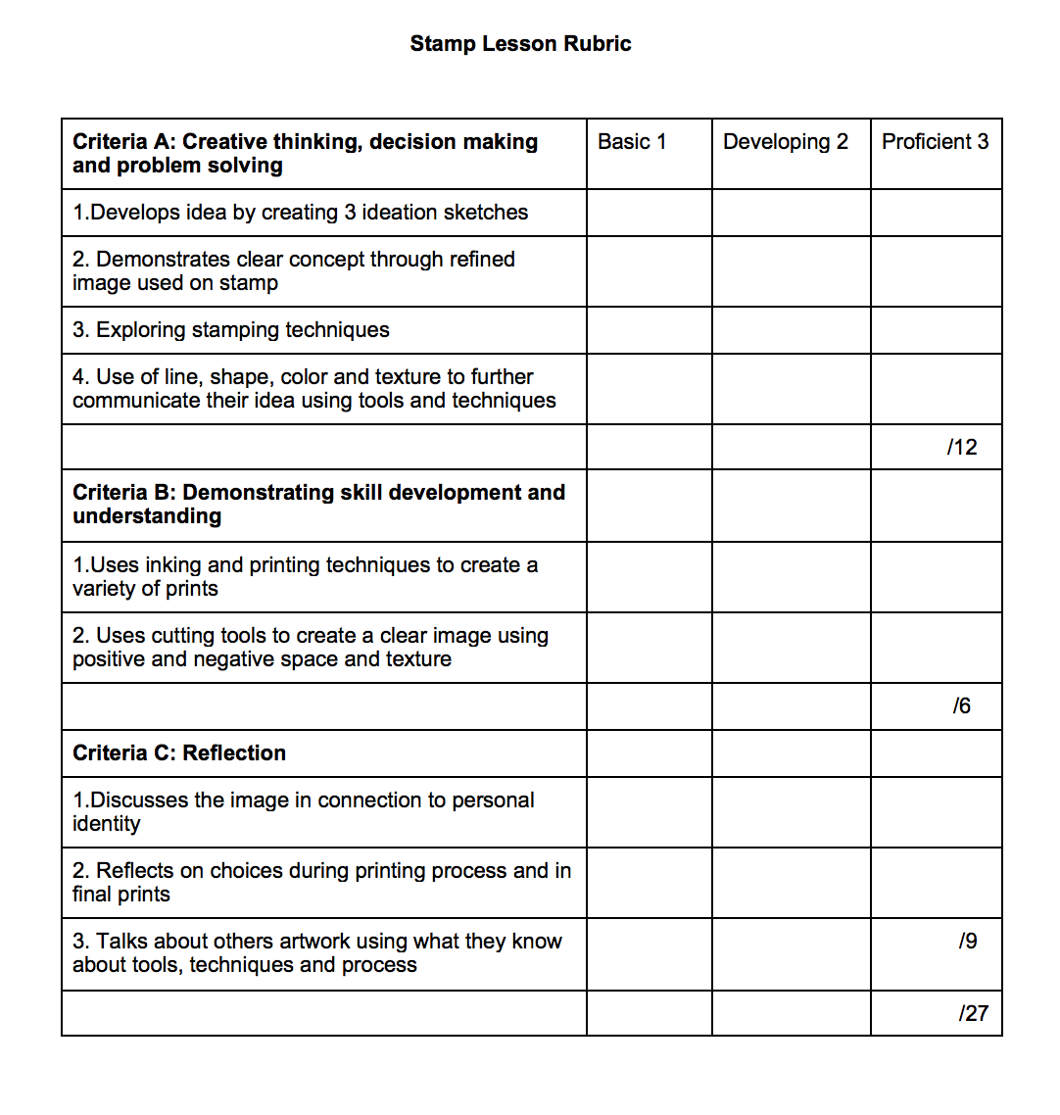

Self-Reflection:
After the lesson is concluded write a brief reflection of what went well, what surprised you, and what you would do differently. Specifically address: (1) To what extent were lesson objectives achieved? (Utilize assessment data to justify your level of achievement.) (2) What changes, omissions, or additions to the lesson would you make if you were to teach again? (3)What do you envision for the next lesson? (Continued practice, reteach content, etc.)

Appendix: Include all handouts, prompts, written materials, rubrics, etc. that will be given to students.

8/9/15 Fahey

