Lesson Plan Title: Surreal Self-Portraits (Drawing/Painting 1 and 2) Length: 3 weeks

Note: Before you plan and write art experiences; pre-assess your students based on the proposed concepts, enduring understandings, and objectives of the unit/lesson(s). You may also gather this information from (previous) teachers, by reviewing already completed art work, consulting curriculum materials, etc., to get a better understanding of what content students already know and what they will need to know to be successful.

Pre-Assessment:
This will need to be done prior to teaching your lesson. Outline the method you will use to determine the skill/knowledge level of your students based on the concepts/enduring understandings/objectives of the lesson. (Hint: turn these into questions.) Be specific in describing what you would recognize as proficient skill/knowledge.
- What characteristics classify surrealism art? What does all surrealism art have in common?
- How much of the body is in portrait art?
- How are soft-shaded values created?

Performance:
What will students accomplish as a result of this lesson? This can be presented to students in the form of a story. In this narrative the students take on a role and create a learning product about a specific topic for a certain audience. (RAFT – Role / Audience / Format / Topic)
N/A

Concepts:
List the big ideas students will be introduced to in the lesson. These ideas are universal, timeless and transferrable. Examples of concepts used in art might include: Composition, Patterns, Technique, Rhythm, Paradox, Influence, Style, Force, Culture, Space/Time/Energy, Line, Law/Rules, Value, Expressions, Emotions, Tradition, Symbol, Movement, Shape, Improvisation, and Observation Look for concepts in the standards, content specific curriculum, etc.
Emotion, Symbol, Style, Value

Enduring Understanding (s):
Enduring Understandings show a relationship between two or more concepts; connected with an active verb. The best enduring understandings not only link two or more concepts; but demonstrate why this relationship is important. Like concepts, they are timeless, transferrable and universal.
Artists use symbols to convey emotions and represent the artistic style of their work.

Standards: (All lessons should address all standards.)
1. Observe and Learn to Comprehend
2. Envision and Critique to Reflect
3. Invent and Discover to Create
4. Relate and Connect to Transfer

Objectives/Outcomes/Learning Targets:
Objectives describe a learning experience with a condition → behavior (measurable) → criterion. Aligned to: Bloom’s – Standards – GLEs - Art learning and, when appropriate, Numeracy, Literacy and Technology. Should be written as: Objective. (Bloom’s: _____ - Standard: _____ - GLE: _____ -Art learning: _____ -Numeracy, Literacy, and/or Technology)
Objective 1: After learning the history of surreal art and how to interpret its imagery, students will be able to design three thumbnails of their surreal self-portraits.
- Blooms: Create
- Standard: Relate and Connect to Transfer, Observe and Learn to Comprehend
- GLE: The work of art scholars impacts how art is viewed today, visual art has inherent characteristics and expressive features
- Art Learning: Ideation, History and Culture
- Numeracy: approximate symmetry when drawing anatomical proportions of the face

Objective 2: After practicing the correct anatomical proportions of the face, students will be able to create their surreal portraits using graphite pencils.
- Blooms: Create
- Standard: Invent and Discover to Create
- GLE: Demonstrate competency in traditional and new art media
- Art Learning: Materials and Techniques, Expressive Features and Inherent Characteristics
- Numeracy: approximate symmetry when drawing anatomical proportions of the face

Objective 3: After finishing their final projects, students will be able to analyze the surreal meaning of three classmates’ final projects using the critique reflection worksheet.
- Blooms: Analyze
- Standard: Envision and Critique to Reflect
- GLE: Interpretation is a means for understanding and evaluating works of art.
- Art Learning: Critical Reflection
- Literacy: Critique reflection worksheet

Differentiation:
Explain specifically how you have addressed the needs of exceptional students at both end of the skill and cognitive scale. Describe the strategies you will use for students who are already proficient and need growth beyond what you have planned for the rest of the class, as well as modifications for students with physical and/or cognitive challenges. Students must still meet the objectives.

Differentiation:  (Multiple means for students to access content and multiple modes for student to express understanding.) | Access (Resources and/or Process) | Expression (Products and/or Performance)
 | ESL  - Provide visual cues for step-by-step on how to complete the assignment. Take pictures. Have minimal words.  - Frequent check-ins and modeling.  - Filter down instruction to the most important key words.  - Have them choose their symbolic concepts based on a favorite animal, or have them pick objects based on hobbies or things that they like to do. Show a difference between having the object out in space rather than inside the head. Give them the visual choices based on my work and professional artists’ work with visual cues for each option.  Sp.Ed.  - Give them a face template for them to trace. Make it out of harder paper, like a manila envelope.  - Give them basic shapes to practice for their eyes, nose, and mouth.  - Have them pick an emotion and what triggers them to feel that emotion, or have them pick an animal (that may be the simplest to work with). They can bring the animal onto their bodies like wearing deer ears or a lion’s mane, or having the pelt patterns be on the skin.  - If the student is only capable of basic drawing skills, have them push the details by using color or having them practice soft-shading. It depends on how the student relates to the project.  - Have them work with larger pencils or smaller pencils, depending on their dexterity.  - The main goal with the students is to get them to practice the face. If they are able to add surreal elements to the project, then that would be a bonus. Create maybe a different kind of rubric for them based on technical skills while still meeting the objectives.  High Functioning Autism  - If there is a student that asks frequent questions, have a structure of independent problem-solving set up where they can go through their own due diligence.  - Make sure that all instructions are visual and sequential. Make sure that they know exactly what they’re in for.  - Have learning goals and checkpoints posted on the board everyday so the student (and the other students) has structure to know what to work towards. | ESL  - All written parts could be accommodated in a meeting or have worksheets with more simplified English language. Ask if the student is comfortable to write his/her answers in their native language in addition to discussing the answers verbally.  - Having a conversation about conceptual intent with the project, potentially with the help of an ESL teacher. It’s important to me that the student understands the conceptual depth that they were trying to achieve with their work, and I want that conversation to be there.  - Optional to let the ESL students work together to talk more about depth. Lots of scaffolded prompts to get the students to center their discussion.  Sp.Ed.  - Student can participate in gallery walk critique, but have them identify the objects in the drawing. If it’s not distracting, have the student do a scavenger hunt for the objects among the other students’ work.  - Have them identify face parts in other students’ work and talk to the student about how they are presented in different ways.  High Functioning Autism  - Have them write their answers in complete sentences (depending on their ability level) but not pressuring them to use multiple sentences (unless they are super capable of doing so).  - Strong explanation on what constructive feedback means.  - Potential challenges on interpreting surrealism portraits. Encourage them to use the dream dictionary so there’s a little more structure, or give them a chance to come up with their own definition for what it represents, even if it is super literal. Or have them investigate why the artist chose those objects and what the correlating relationship is? No good, bad, right, or wrong interpretation.
Extensions for depth and complexity: | Access (Resources and/or Process) | Expression (Products and/or Performance)
Extensions for depth and complexity: | GT  - Give them access to some of the AP studio video resources for technical practice.  - Challenge them to work with more details in their work.  - If they show more conceptual thought, push their concept. How do the emotion and the objects represent something deeper about the human psyche or a social justice concept? If that wasn’t the intention for creation, have them think about how the work could be interpreted by others on a deeper level.  ADHD  - Using checkmarks to get the project done if focus is a huge issue. Make an agreement with the student and checking in to see how they’re doing (let them guide the conversation). Let it be a learning experience for their own temperament.  - Providing space in accordance with an IEP that will enable them to work in a low distraction environment.  - Put student in a seat with other students that are quiet and hard working. Do not put them near the super chatty kids. | GT  - Push the soft shading and realism component. Take it to AP level and give them a chance to try realism as much as possible. Have them work more with form than line so they can create the illusion of depth.  - Encourage them to bring objects in from life to have accurate light reference. Have them bring reference photos and teach them about planar symmetry so they can get their light sources as accurate as possible.  - Challenge them to have more surreal and abstract elements that bleed into the background, especially if they are fast workers.  ADHD  - Pay attention to the details of the students’ work (rushed pencil scratches vs. tight, small details). Have them create a design that works for their temperament and focus—would it be more beneficial for them to work larger and looser or would it be better for them to have tighter details and have more focus? It will ultimately depend on the student.

Literacy:
List terms (vocabulary) specific to the topic that students will be introduced to in the lesson and describe how literacy is integrated into the lesson.
Literacy
Students will fill out the Artist’s Statement and Critique Worksheet at the end of the project.

Vocabulary

Portrait: a drawing or painting of a person/animal from the shoulders up to the head.

Surrealism: a movement where artists created dream-like or unconscious imagery.

Materials:
Must be grade level appropriate. List everything you will need for this lesson, including art supplies and tools. (These are the materials students will use.) List all materials in a bulleted format.
- Sulfite paper (12”x16” for D/P 1 students and 16”x20” for D/P 2 students)
- Graphite pencils (2H, HB, 2B, 6B)
- Erasers (hard and kneaded)
- Mirrors (if they are available)

Resources:

List all visual aids and reference material (books, slides, posters, etc. Be specific; include title, artist, etc. Make reference to where the material can be found. (These are the resources used by the teacher to support/develop the lesson.) List all resources in a bulleted format.
Images of surreal portrait artists:

Afarin Sajedi
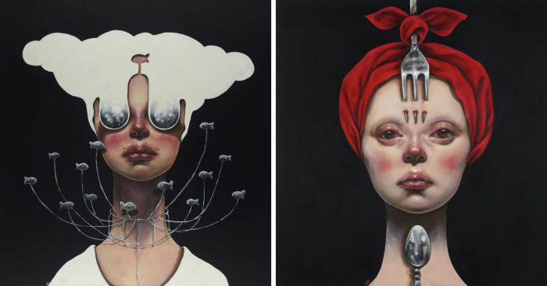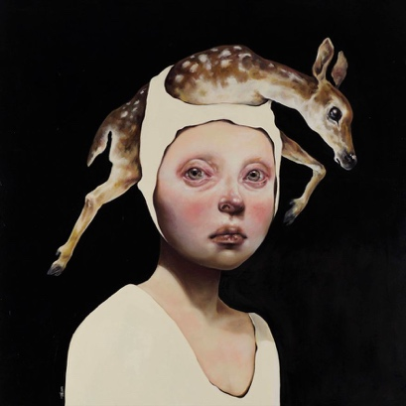
Steven Kenny
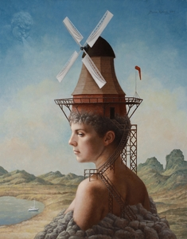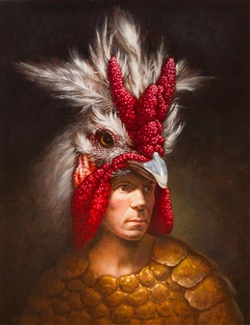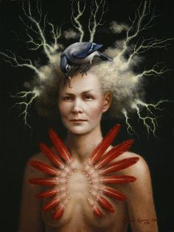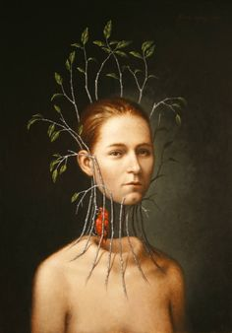
Tran Nguyen
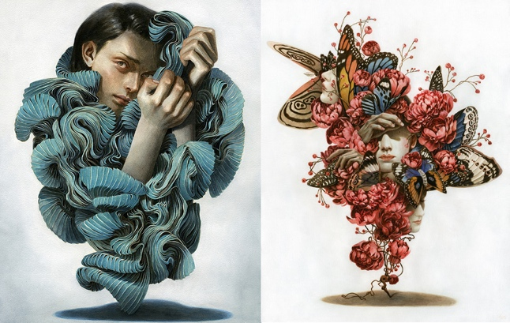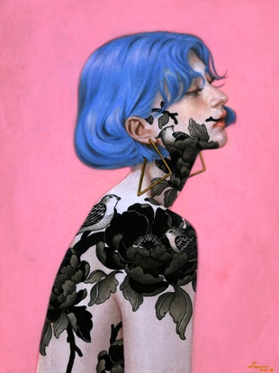
Alex Garant
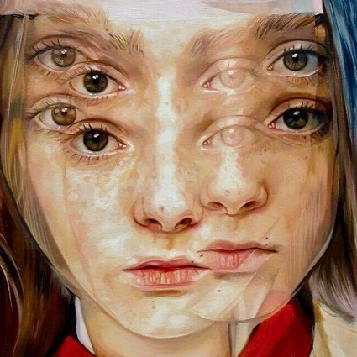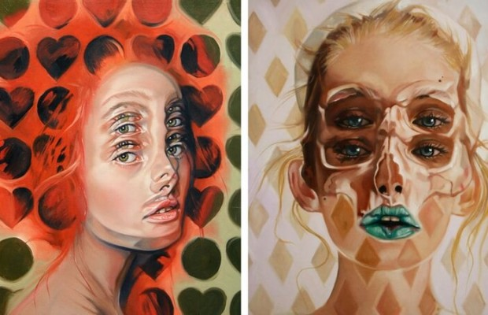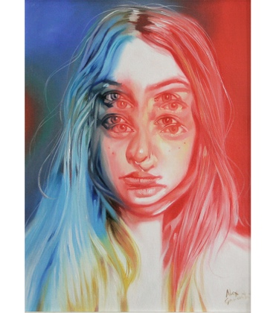
Random Artists
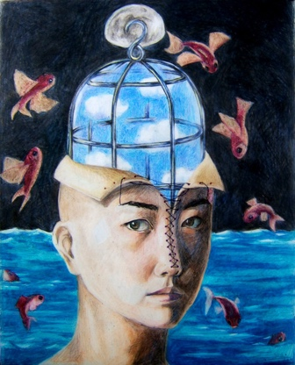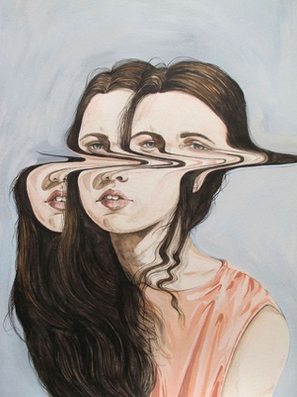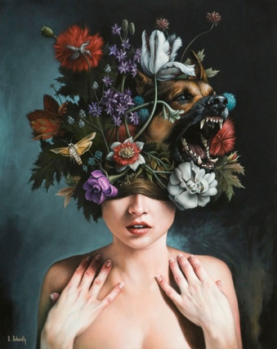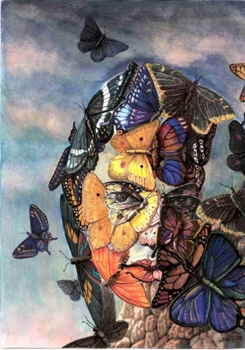

Images of Surrealism Artists

Salvador Dali
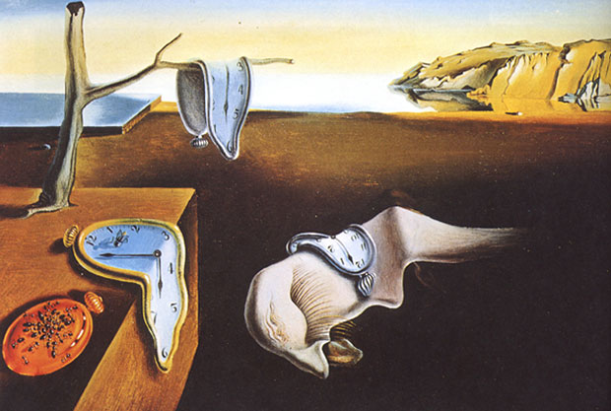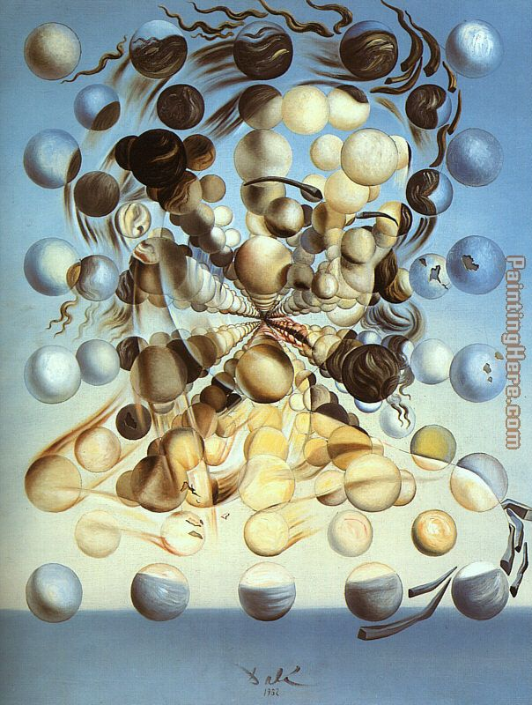

Vladmir Kush
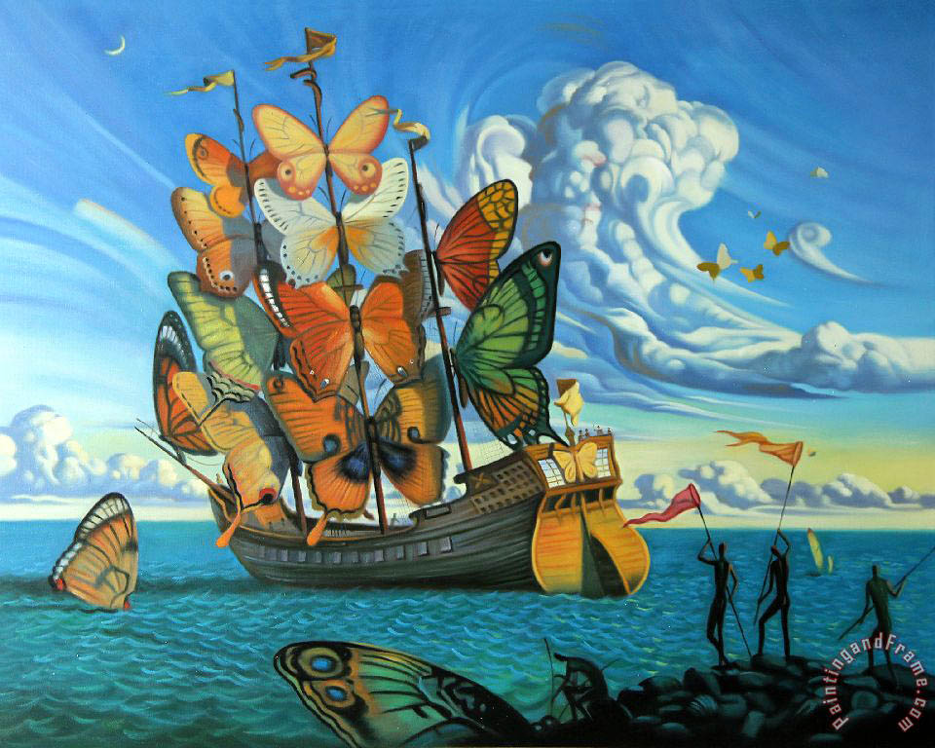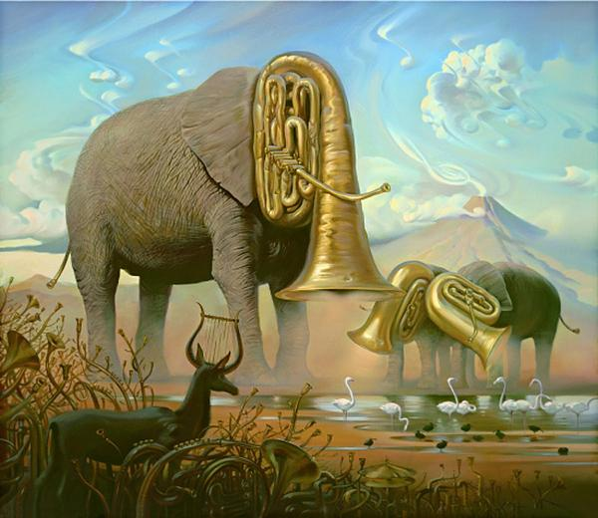

Max Ernst and René Magritte
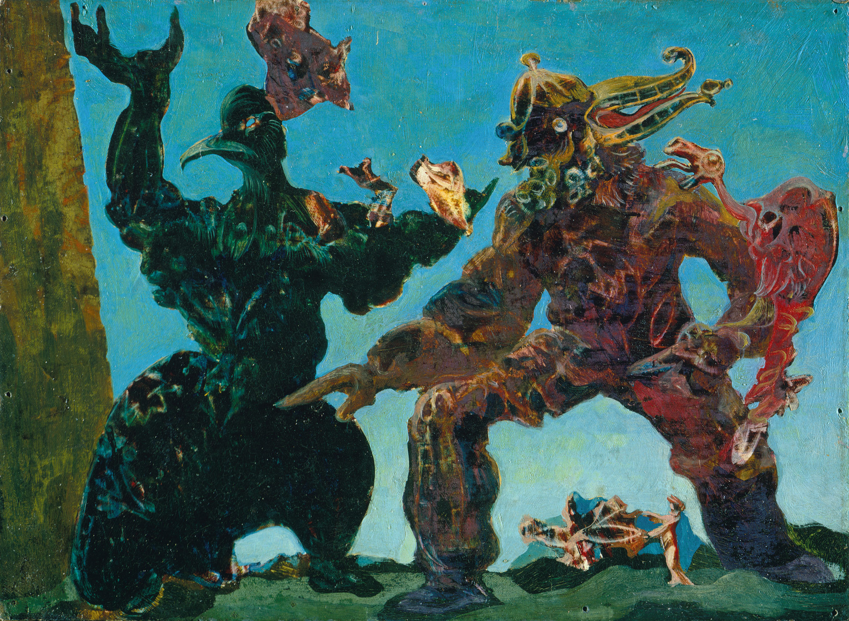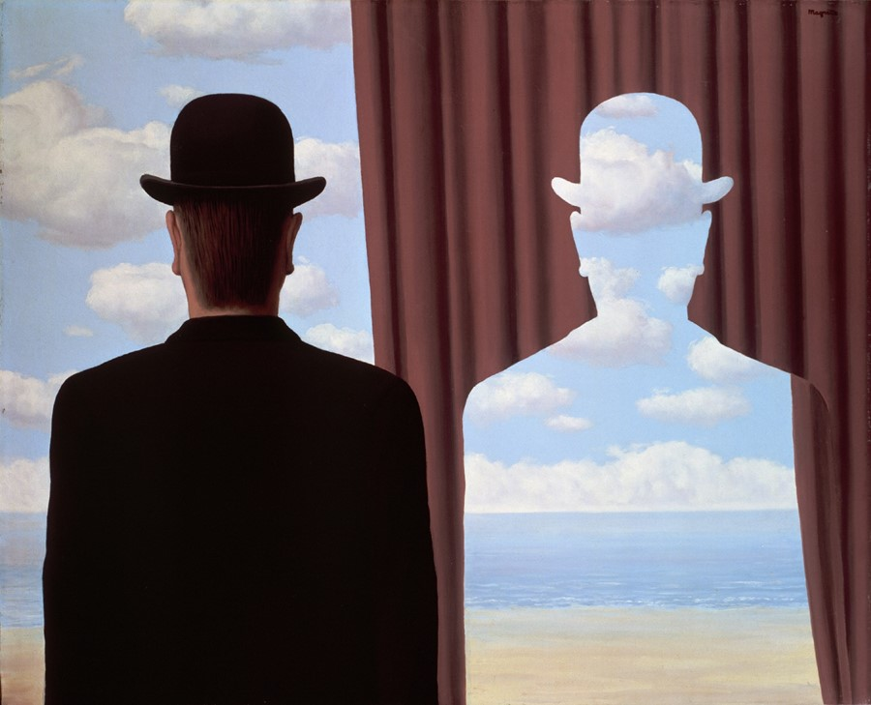

Videos on Technical Drawing:

D/P 1:
Walt Disney’s Destino: https://www.youtube.com/watch?v=y_TlaxmOKqs

How to Draw Face | Basic Proportions: https://www.youtube.com/watch?v=cdSzAOgSuew

How to Draw Heads—Dividing it Into Thirds: https://www.youtube.com/watch?v=FUJZUZRmNUE

How to Draw and Shade Lips in Pencil: https://www.youtube.com/watch?v=s3GeiAKJYI8

How to Draw a Nose: https://www.youtube.com/watch?v=DeFv3pg_Fxk

How to Draw Hyper Realistic Eyes: https://www.youtube.com/watch?v=zqNZ9df0tho

Dos and Don’ts: How to Draw Realistic Eyes: https://www.youtube.com/watch?v=J9MydkzP0DE

Do’s and Don’ts: How to Draw Realistic Hair: https://www.youtube.com/watch?v=XAjINTNo-Cg

How to Draw Hair: Male and Female: https://www.youtube.com/watch?v=PGcOEkl1coU

D/P 2:
Walt Disney’s Destino: https://www.youtube.com/watch?v=y_TlaxmOKqs

How to Draw a Face: Profile: https://www.youtube.com/watch?v=2mvSJMF3w90

How to Draw Human Head ¾ View: https://www.youtube.com/watch?v=PQQ6pI2p2r8

Drawing Faces from Any Angle: https://www.youtube.com/watch?v=QBv5z0Y2odE

Websites:

Dreammoods (dream dictionary): www.dreammoods.com

Preparation:
What do you need to prepare for this experience? List steps of preparation in a bulleted format.
- Cut the paper into 12”x16”/16”x20” sheets of paper
- Make three thumbnail sketches for each concept to show as examples for the students
- Create final portrait alongside the students.
- Create step-by-step guide for face anatomy and drawing hair, nose, eyes, and mouth for students
- Create step-by-step guide for three-quarter, profile, upturn, and downturn faces

Safety:

Be specific about the safety procedures that need to be addressed with students. List all safety issue in a bulleted format.
There are no serious safety issues or procedures with this assignment.

Action to motivate/Inquiry Questions:
Describe how you will begin the lesson to stimulate student’s interest. How will you pique their curiosity and make them interested and excited about the lesson? What inquiry questions will you pose? Be specific about what you will say and do to motivate students and get them thinking and ready to participate. Be aware of the varying range of learning styles/intelligences of your students. Some ideas might include: telling a story, posing a series of questions, role-playing, etc.
Introduction to surrealism.
- Ask students if they are familiar with the term and how they think it could be defined.
- Surrealism: a movement where artists created dream-like or unconscious imagery.
Analyzing surreal art.
- Showing different examples of surreal art (see teacher website for examples) and having the students talk in a class discussion on what they think the meaning of the work is.

Ideation/Inquiry:
Ideation is the creative process of generating, developing, and communicating new ideas, where an idea is understood as a basic element of thought that can be visual, concrete or abstract. List and describe inquiry questions and processes you will engage students in to help them develop ideas and plans for their artwork.
Students will create three thumbnail sketches of what they want the designs of their surreal self-portraits to look like. They have the option of making three portraits within one conceptual option or create one portrait for each of the three conceptual options.

- Option 1: Incorporate three unusual objects into your portrait. They can be personally meaningful or completely random. The larger and more detailed they are, the more interesting they’ll look. See if you can find creative ways to interject them into the face.
- Option 2: Pick a spirit animal and incorporate its various body parts and elements of its habitat into your portrait. Your drawing should include the animal and at least three natural objects.
- Option 3: Pick an emotion and express it through surreal means (using representational objects or abstract symbolism using the principles of design).

Instruction:
Give a detailed account (in bulleted form) of what you will teach. Be sure to include approximate time for each activity and instructional methodology: skills, lecture, inquiry, etc. Include motivation and ideation/inquiry where appropriate; including what student will understand as a result of the art experience

Week 1 | Instruction - The teacher will... (Be specific about what concepts, information, understandings, etc. will be taught.) Identify instructional methodology. KNOW (Content) and DO (Skill)  Day 1  Introduction to surrealism.  - Ask students if they are familiar with the term and how they think it could be defined.  - Surrealism: a movement where artists created dream-like or unconscious imagery.  Analyzing surreal art.  - Showing different examples of surreal art (see teacher website for examples) and having the students talk in a class discussion on what they think the meaning of the work is.  Introducing the lesson.  Work Day  - Begin working on thumbnails  Day 2  Work Day  - Continue working on thumbnails.  - When finished, students can watch YouTube videos and practice face anatomy.  Goal: finish all thumbnails and get them approved by Ms. N.  Day 3  Demo D/P 1: Front Face demonstration (basic proportions)  Demo D/P 2: Three-quarter facing demonstration  - Students should follow along with the demonstration. If there is time left in class, they can keep practicing drawing.  Day 4  Demo D/P 1: Nose and eyes demonstration  Demo D/P 2: Profile face and upturn/downturn face demonstration  - Students should follow along with the demonstration. If there is time left in class, they can keep practicing drawing.  Day 5  Demo D/P1: Mouth and Hair demonstration  Demo D/P 2: Hands demonstration  - Students should follow along with the demonstration. If there is time left in class, they can keep practicing drawing. | Learning - Students will... i.e.: explore ideation by making connections,  comparing, contrasting; synthesize possibilities for each painting technique; etc. (Be specific about what will be the intended result of the instruction as it relates to learning.) UNDERSTAND | Time  10 min.  40 min.  50 min.  50 min.  50 min.  50 min.
Week 2 | Day 1  Work Day  Clean-Up  - Put away drawing paper and pencils  Goal: Have face roughly laid out on paper. Take reference photos if necessary.  Day 2  Work Day  Clean-Up  Goal: Have all the anatomical and surreal details drawn out.  Day 3  Work Day  Clean-Up  Day 4  Work Day  Clean-Up  Day 5  Work Day  Clean-Up  Goal: have 40-50% of your drawing shaded, or have all of your face/surreal objects shaded. |  | 45 min.  5 min.  45 min.  5 min.  45 min.  5 min.  45 min.  5 min.  45 min.  5 min.
Week 3 and 4 | Day 1  Work Day  Clean-Up  Day 2  Work Day  Clean-Up  Goal: 80% of your drawing shaded.  Day 3  Work Day  Clean-Up  Day 4  Work Day  Clean-Up  Goal: Project should be completely finished.  Day 5  Critique Day  - Students receive the critique worksheet. They need to use it to analyze the surreal meaning of their classmates works.  Group discussion on the critique worksheet.  Lesson feedback and Ms. N’s lectures.  - Time for written feedback and group discussions.  - Ask the D/P 2 students if this will be appropriate for D/P 1 students. |  | 45 min.  5 min.  45 min.  5 min.  45 min.  5 min.  45 min.  5 min.  15 min.  10 min.  25 min.

Student reflective/inquiry activity:
Sample questions and activities (i.e. games, gallery walk, artist statement, interview) intended to promote deeper thinking, reflection and refined understandings precisely related to the grade level expectations. How will students reflect on their learning? A participatory activity that includes students in finding meaning, inquiring about materials and techniques and reflecting about their experience as it relates to objectives, standards and grade level expectations of the lesson.)
Students will complete an artist’s statement worksheet that answers these three questions:
- What was the concept of your portrait about? How does the objects (real or abstract) and the emotion in your self-portrait relate to your concept?
- What are some strengths about your portrait, or things that you are proud of about it?
- What are some things you would change or improve about it?

Students will also analyze and write down what they think the conceptual intent was behind three of their classmates’ work. These will most likely be table mates. Students will move to their right and assess the project they are given at their table.

Post-Assessment (teacher-centered/objectives as questions):  Have students achieved the objectives and grade level expectations specified in your lesson plan? | Post-Assessment Instrument:  How well have students achieved the objectives and grade level expectations specified in your lesson plan? Include your rubric, checklist, rating scale, etc.
Can students design three thumbnails of their surreal self-portraits using the ideation worksheet?  Can students create their surreal portraits using graphite pencils?  Can students analyze the surreal meaning of three classmates’ final projects using the critique reflection worksheet? | 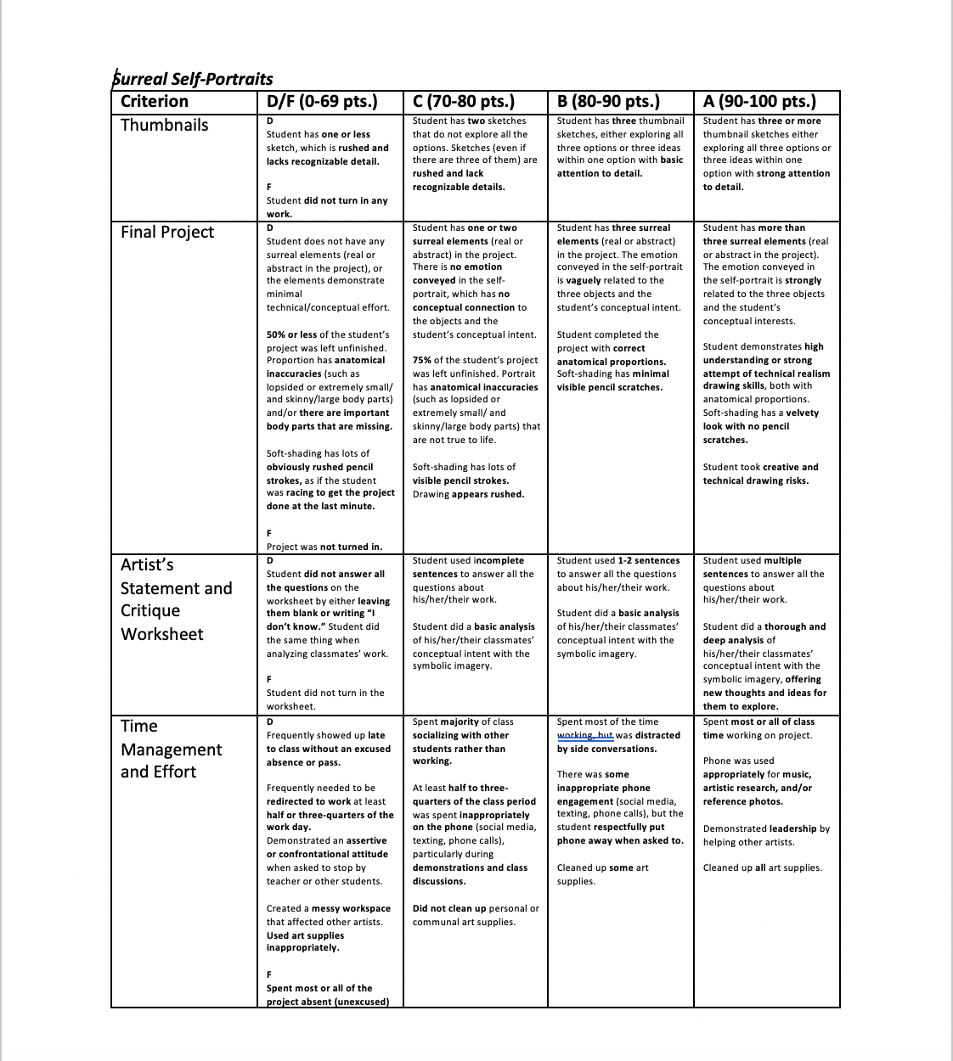

Self-Reflection:
After the lesson is concluded write a brief reflection of what went well, what surprised you, and what you would do differently. Specifically address: (1) To what extent were lesson objectives achieved? (Utilize assessment data to justify your level of achievement.) (2) What changes, omissions, or additions to the lesson would you make if you were to teach again? (3)What do you envision for the next lesson? (Continued practice, reteach content, etc.)
What Went Well

Ideation/Final Project
- Students responded well to the variety and creative freedom that a surreal portrait posed. Some students liked that there were options at all, even though some of them really didn’t like what they were or that there weren’t more to choose from. They considered the project to be “original.”
- This project pushed students out of their comfort zone when it came to their conceptual processes
- Realism grounded the project in technical skills while surrealism pushed their conceptual process.
- In my opinion, the advanced group had an easier time conceptualizing the surrealism process than the beginning group. They also had stronger technical skills. So, I felt that this project would be more appropriate for the advanced group.
- Students were able to not only make thumbnails, but also convey enough information that gets their point across. This was more effortless for them.
- This project was easily transferrable as a painting project and a drawing project. Students were successful in both realms. Students liked that they had the option to do both.

Critique
- The level of depth and analysis students went into was really well. They used a lot of complete sentences. Analysis was a lot more effortless.
- The actual critique process went really well because I was able to work out the kinks of the critique process with my beginning students.

Management
- Demos were very helpful and resonated with students. Strong demo on anatomy/proportions and shading
- Individual feedback seemed to resonate well with most students. Students liked that I touched base with supportive and honest feedback.
- Classroom management was strong. Expectations of when things were due were clearly communicated. Individualized assistance with projects.
- My fifth period class really liked the structure of my class because they felt like they were learning new technical skills and slowly improving their work.

What Didn’t Go Well/What I Would Do Differently

Ideation/Final Product
- Students asked for more time on the project, even though it took them six weeks to complete the project. It makes more sense for them to have a little bit more time on the thumbnail sketches, but I think there was more than enough time for the project.
- Students wanted more examples for the project, even though I did thumbnail sketches for the three options. I wonder if having examples on the website could make it easier for them to understand, since student work would give them better perspective. I also wonder if the formatting of the website could be changed a bit to navigate things a little bit easier.
- Students gave feedback that they didn’t want hands in the project at all, which I disagree with as it is an important skill. Others felt that there could’ve been a better demo on hands, which I could have done better using the document camera. I relied on an outside resource to teach them that, which no one really went to.
- Many students protested the limitations of three concepts and wished that they would’ve had more creative freedom to do whatever they wanted in the surrealism genre. I think rather than having those concepts as boxes, using them as examples. I also think that doing some reference image research could support them on coming up with their own idea, as long as they really understand what surrealism is. I could spend a lot more time going over that.
- Recommendation to include a background.
- Feedback for painting was easier to do one-on-one rather than doing a full demo for the entire class.

Critique
- Students were very confrontational in second period about the process being a waste of time or being flawed. They felt that it was too many questions to answer and that’s not what art class is for. This is a transitional change on their end more than something that I needed to improve. The students needed to try the process out first and then give constructive feedback before saying that it was a waste of time.

Management
- Second period students were not responsive to the structure of my teaching and wanted a lot more creative freedom, to the point where they wanted to do things their way. It was a learning curve for me to stick to my expectations and structure while also listening to student feedback and making small changes. The students didn’t want a ton of structure because they have a lot of stress from college stuff and other classes, and they see my class as a stress-free class. I can understand where they’re coming from. It doesn’t mean that they totally have full reign on how I should run the class. Lots of re-norming was needed.
- There was a lot of pushback on not being able to trace or grid. Again, this was a form of change that the students needed to adjust to.

Appendix: Include all handouts, prompts, written materials, rubrics, etc. that will be given to students.

8/9/15 Fahey

