Name:__________________________ Period:______

Value Worksheet
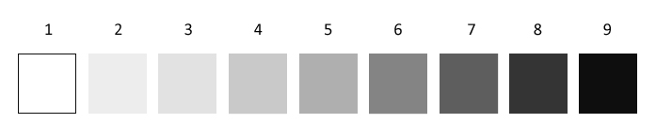

Patterned Shading:
Choose four patterns and shade them from dark to light.

White Gray Black

White Gray Black

White Gray Black

White Gray Black

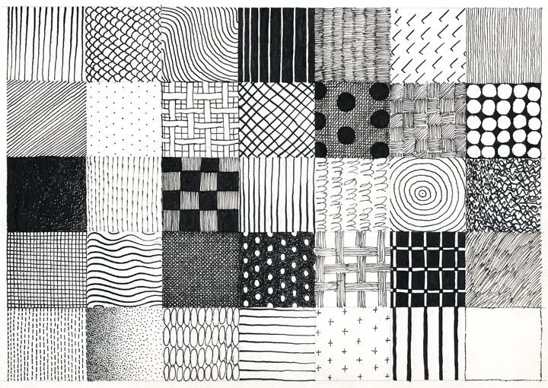
Examples of pattern shading

